17/05/2021

Minutes - Meeting of the Agents Liaison Group

Table of Contents

Introduction 1
Participants 1
1. The role of a managing agent 3
2. Nottingham Market Update 4
3. Planning for the future Owen Cosslett 5
4. Relationships with Managing Agents 5
5. Pre-action protocols – Tackling tenancy issues proactively with the council to resolve ASB, arrears and other tenancy matters 5

Introduction

The meeting organised in the form of an online conference took place on 17th May at 15:30

Pete Mitchell greeted everyone and explained that it has been decided to change the approach. During our liaison group meetings the council will be more in the position of a listener and the agents will present the current issues.

Participants

Agents and Partners:

Adam Kingswood Kingswood Residential
Dan Walker CP Walker and Son
Sarah Campbell-Dawson, Leaders
Terry Galloway Norman Galloway lettings
Owen Cosslett, Oak Student Letts
Mike Dawson, Woo Properties Ltd
Luke Pritchet, FHP Living Ltd

Nicola Brown, Unipol
Linda Cobb, DASH
Giles Inman, EMPO

Council representatives:

Pete Mitchell - Head of Safer Housing and ASB
Cllr Linda Woodings
Cllr Angela Kandola
Ceri Davies – Housing Strategy Specialist
David Hobbs, Selective Licensing Manager
Paul Greevy, Homelessness Prevention
Julie Liversidge, Operations Manager
Duncan Newbutt, Safer Housing Manager
Robert Skwierawski (minutes and actions)

The role of a managing agent

Dan Walker made a presentation where he stated that the lettings market is totally unregulated.
Agents let and manage properties, act as advisor for landlords, manage commercial properties, provide professional support. A landlord may not be accessible directly, tenants can always have accessible agent through their office and a website.

Landlords should work with agents on a professional management of the properties. In case there is hindered communication with a landlord and the issues cannot be addressed correctly, tenants’ dissatisfaction will affect an agency ranking, not a landlord. Agents have a reputation to keep. They verify what the clients are, they can quickly determine if a property is up to standard, they help landlords with all aspects of compliance like deposits, gas safety and fire safety. There are accreditation schemes introduced in Nottingham. Unipol refers to students’ properties. DASH is targeted at small scale landlords, it is not designed for larger portfolio landlords, or agents. It has been unfortunate no scheme for professional properties that agents would work with.

After introduction of licensing scheme the role of agents was not recognised. Access to discounts is not easily available if property is managed by an agent. If you are a landlord and you pay a professional agent to manage your property, this should be recognised.
Landlord training requires to be accredited, however ARLA or RICS schemes – are not recognised.
ARLA - Association of Residential Lettings Agents – covers residential lettings
RICS - The Royal Institution of Chartered Surveyors - covers all aspects of property market

Agents are not satisfied with the council licensing system, they found it overly bureaucratic and not always fit for purpose. It does not offer value for money, especially for people who live in a property where rent is higher because of licensing

Cllr Woodings requested further information regarding ARLA and RICS. Dan explained that in order to be a representative of both institutions one needs to be very highly qualified.

It was noticed that being a member of ARLA or RICSC proves the high level of your competency but it does not prove that all your properties will be up to standard so there has to be some measure to make sure your properties comply. With and DASH Unipol there are inspections of properties.

There is a question whether a landlord should be qualified or is it sufficient that he has a professional agency to manage the property – in this way the high standards are kept and such landlord should also have a discount for the license because the property is in good hands.

Mike Dawson noticed that qualifications do not guarantee that the property is up to the standard. Mike added that they are more and more involved with landlords discussing things like regulation compliance. There is a lot of involvement in educating the landlord. Other aspects of being a letting agent are evictions, ASB. There is a definite shift for agents – whether you are regulated or not you have to be savvy. Landlord less able of managing things on their own because regulations getting more and more complicated

Sarah Campbell Dawson noticed that if landlords paid for the agency to manage the property they shouldn’t personally go on further training. Some of the landlords are of older generation and not compliant with doing something online, there can be also a lack of such abilities even because of mental issues. Agency should be responsible for the property and act in their name Landlord should not do foundation works because they utilise an agent even if they did not do training themselves, they are advised by an agency

Action 1: to check whether ARLA and RICS membership can be recognised as accreditation and can the membership result in a discount or any other bonuses for landlords.
Completion: It is not possible in the current scheme. The idea will be reviewed before implementation of the future scheme
Action 2: to verify the process of landlord obligatory training - can this be taken over by an agency; and to what degree the agency, not a landlord should be made responsible for the licence compliance
Completion: It is necessary for the landlord as licence holder to be accountable for the licence compliance therefore they need to undergo the minimal required training. A managing agent can be changed during the licensing period, but the licence holder will be the same.

Nottingham Market Update

Presentation made by Adam Kingswood

There is significantly growing gap between demand and supply. Potential tenants are competing for a property. Rent going up about 7% every year, in some areas of Nottingham rent increased up to 15%
There is simply not enough housing. More landlords leaving the market than coming in. Stricter regulations regarding EPC, electric safety, increased taxation make landlords sell the properties out. People prefer to invest outside selective licensing area, even if they keep the standards they worry about the higher costs. HMO market is not effective – students prefer individual renting like studio flats. There is also more demand for people living in supported living. There are high costs of regulations, rents are increasing. We need solutions to bring more properties on the market

Cllr Woodings mentioned that the government target was to have 1500 new dwellings a year in the council, the target which we haven’t met for the last 18 years. What we observe recently is quite a big number of permitted developments. Cllr visited an office building converted into flats. There may be a problem of keeping the adequate standard considering how hot the market is at the moment. There are 8000 people on a council list waiting for council houses. Some cannot imagine the possibility of changing the location they live because of children schooling, it could be a serious problem for parents if they need to move to the other part of the city.

Dan Walker noticed that permitted development while going from commercial to residential still must comply with building regulations, they must comply with space standards, etc.
Areas outside the city are getting better – there is more use of local shops and services because people work from homes. There will be more commercial to residential developments, also extensions to existing houses.

Owen Cosslett said that there is more and more demand from landlords which does not help PRS. The risk of having a tenant is too high, you may not be able to have eviction if necessary and it is easier to have short term student tenants.

Planning for the future Owen Cosslett

Pete Mitchell suggested to have a separate meeting about it
Owen Cosslett noticed that the city strategy for development of particular areas should be made clear and PRS treated as a partner in development or restructuring of the particular areas. Permitted development should introduce more housing for people to move back to the city, we wouldn’t like to see only short term rental accommodation for students.

Ceri Davies from housing strategy and partnership team introduced herself. She admitted that student market is growing and it brings high profit, however it is very important to have affordable long term housing. There are plans about development of particular city areas which we would like to share and discuss. It has been agreed that upon receiving more feedback from the agents and having the strategy plan ready, Ceri will present the council’s plans at the next meeting.

Action 3: Presentation and discussion of the plans at the separate meeting in October

Relationships with Managing Agents

Luke Pritchet mentioned the idea of a single point of contact regarding portfolio of particular properties. Agents could provide better guidance for landlord if they had direct support from the council
Sarah reminded that when a particular person from the council took over her portfolio it was much more efficient to arrange everything. When this person was on holiday and varied different officers dealt with the properties, there was lack of consistency, some issues were bouncing back and there was different interpretation of regulations. Different people could give different answer to the same question
Pete noticed that sometimes they may not be identical interpretation of a problem, sometimes we may receive different opinion from different builders, or lawyers, however he agreed that the council should deliver more consistency and this is what we aim at. We will improve triage system to pick up complicated cases and deal with them quicker.
Owen explained that the frustration comes from the fact that the landlords pay for licensing so they expect more efficient support. Pete agreed with that and said that we work hard to avoid having backlogs, and the handling of the cases improves.
Action 4: To improve triage and minimise the time of dealing with complicated licensing cases

Pre-action protocols – Tackling tenancy issues proactively with the council to resolve ASB, arrears and other tenancy matters

Terry Galloway presented pre action protocol – actions taken to prevent issuing the eviction notice.
The process prevents homelessness and increases confidence in the agent.
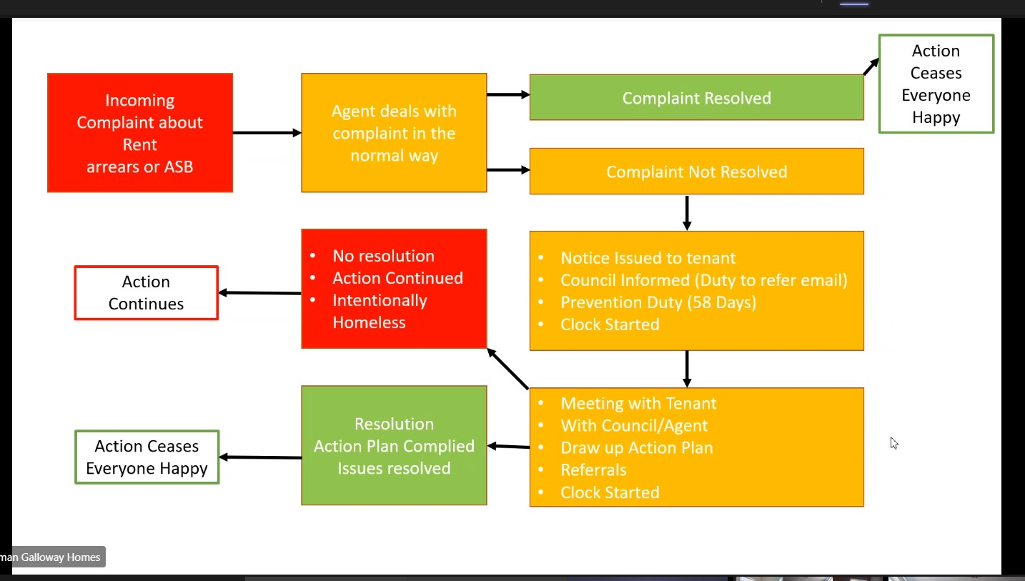

Everyone is welcome to follow the process, private landlords included. Support in following the actions can also be given by NPRAS. Contact to NPRAS is 01158761644 NPRAS@nottinghamcity.gov.uk
Cllr Woodings appreciated the process very much and will share it with the housing aid team.
Mike Dawson noticed that in order to avoid problem of homelessness the council may advise the tenants who do not pay rent or have other serious issues to stay in the property. It is the best of some departments of the council to keep such tenants in the property as long as possible therefore they can be advised to remain in the property till court decision. On the other hand the council housing aid will ask an agent to help provide housing for some other housing benefit people. The agents are asked to house the people but when things go wrong they do not receive support. As the agents it is in our interest to look at tenants’ affordability – noticed Mike. Clearly those who can afford the rent are preferred. We could be more helpful and cooperative if we knew we had support in case things start going wrong.
People who get evicted do not disappear from the local authority area, they still may get engaged in all sort of behaviour which nobody wants. We should prevent necessity of court evictions.
Landlords also would prefer to have the people remain in the property. You would much rather have people pay the rent, behave themselves rather than advertise the property on the market again.
There is also a question of intentional homelessness.

