Nottingham City Centre PSPO – Additional Guidance

Guidance in respect of the Nottingham City Centre Public Spaces Protection Order
Introduction/Background
Nottingham City Council wants all of those living in, working in or visiting its city centre to enjoy safe, clean, vibrant and attractive public spaces.
The Council has previously introduced some specific measures that help tackle anti-social behaviour in the city centre, such as a Public Spaces Protection Order (PSPO) that allows authorised officers to require the surrender of alcohol from anyone drinking in a public place.
However, evidence and complaints from a number of sources indicate that there are a variety of other behaviours happening in the city centre that, if not managed, are capable of having a detrimental effect on the experience of those living in, working in or visiting the area.
In response, the City Council undertook a public consultation exercise on a proposal to introduce a further PSPO (First Draft PSPO) to address these behaviours, between 23 August 2018 and 3 October 2018.
As detailed in a report to the Council’s Executive Board on 18 December 2018, the results of this consultation showed considerable public support for the suggested restrictions contained within the First Draft PSPO.
However, as also detailed in the above report, a number of concerns were raised regarding the overall intent of the First Draft PSPO and the potential impact that its provisions may have, particularly on vulnerable members of the community who may be homeless or rough sleeping.
Nottingham City Centre PSPO
In making the decision to introduce the Nottingham City Centre PSPO, the Council’s Executive Board, amended the terms of the First Draft PSPO to address some of the concerns raised and suggestions made in the course of the consultation. Those changes are detailed in the aforementioned report to the Council’s Executive Board on 18 December 2018.
Executive Board also recommended the publication of this additional guidance document to help clarify for Authorised Persons, who may be considering taking action under the terms of the Proposed PSPO, the policy and procedural framework within which the PSPO will sit and to provide additional safeguards with regards some of the concerns raised throughout the consultation.

Policy and Procedural Framework – General Safeguards

Enforcement action taken by Nottingham City Council is taken within a framework of policies and procedures that are designed to deliver fair, consistent and proportionate enforcement practices.

This framework will provide general safeguards for all citizens against over-zealous enforcement of the Nottingham City Centre PSPO and specific consideration will be given to the following policy and procedure when enforcing the PSPO:

Nottingham City Council Enforcement Policy

Nottingham City Council’s Enforcement Policy

https://www.nottinghamcity.gov.uk/business-information-and-support/better-business-regulation/

sets out what businesses, individuals and the community as a whole can expect from the Council’s enforcement officers. It commits the Council to good enforcement procedure.

In considering enforcement action under the Nottingham City Centre PSPO, regard shall be had, by all Authorised Officers, to the provisions of the City Council’s Enforcement Policy.

Five Stage Enforcement Process

Building on the general principles contained within Nottingham City Council’s Enforcement Policy, enforcement officers within the Council’s Community Protection Directorate work, where appropriate, to a five stage enforcement model illustrated in the graphic below

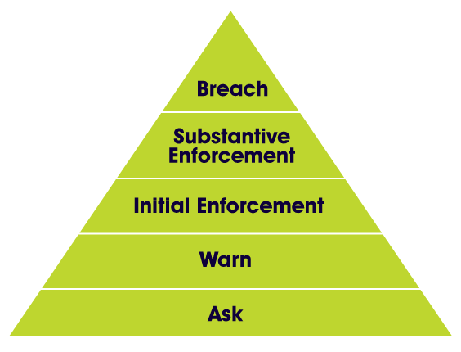

The model, recognises that most anti-social behaviour is capable of being dealt with via low level early interventions including requests for behaviours to cease (Stage 1 - Ask) and formal warnings of consequences, should those behaviours continue (Stage 2 - Warn).
Experience indicates that Stages 1 and 2 will succeed in stopping between 85% and 94% of behavioural issues and more formal enforcement action, such as the issue of a fixed penalty notice (Stage 3 – Initial Enforcement) will normally only be considered where Stages 1 and 2 have failed to resolve the issue, although in some rare cases immediate escalation to Stage 3 may be appropriate.
This ask and warn approach is specifically embedded in those provisions of the Nottingham City Centre PSPO regarding obstruction and regarding busking, with a specific requirement that Authorised Persons will first ask an individual to cease their behaviour and will warn them of the consequences of their failure to do so.
Whilst some behaviours covered by the Nottingham City Centre PSPO may merit an immediate escalation to Stage 3 i.e. public urination/defecation without reasonable excuse, all Authorised Persons will be expected to justify any specific departure from the five stage model when enforcing the PSPO.
Impact of the PSPO on Homeless and Rough Sleepers
Concerns have been raised, by a number of organisations and individuals, that the Nottingham City Centre PSPO is specifically designed to target those who are homeless or who are rough sleeping, and that this is contrary to the government’s statutory guidance issued on 17 December 2017 which states
“Public Spaces Protection Orders should not be used to target people based solely on the fact that someone is homeless or rough sleeping, as this is in itself unlikely to mean that such behaviour is having an unreasonable detrimental effect on the community’s quality of life which justifies the restrictions imposed. PSPOs should be used only to address specific behaviour that is causing a detrimental effect on the community’s quality of life which is within the control of the person concerned.”
The report to the Council’s Executive Board on 18 December 2018 acknowledged that rough sleepers are one of the most vulnerable groups in society, many having high levels of complex and inter-related needs requiring the intervention of a multitude of support networks.

However, the report also highlighted the significant work that is undertaken in Nottingham to support those who are homeless and/or rough sleeping and further highlighted the fact that the support available means that no-one need rough sleep within Nottingham.

Homeless and Rough Sleeping – Additional Safeguard

The Nottingham City Centre PSPO is designed to address the specific behaviours identified therein. None of the clauses contained therein are designed to be used to target people based solely on the fact that they are homeless or rough sleeping.

By introducing the PSPO, there is no intention on the part of Nottingham City Council to ban homelessness or to criminalise it as an act in its own right. Nottingham’s over-riding desire is to provide help, support and accommodation to those who are homeless and/or rough sleeping.

However, a person who is homeless or rough sleeping may, just as may any other person, willingly behave in such a manner so as to breach the provisions of the Nottingham City Centre PSPO and to have a detrimental impact on others in the locality.
In acknowledging the potential impact of any enforcement action on a person who is homeless, and to reflect the Council’s principal desire to support those who are homeless, this guidance introduces the following additional safeguard.
Requirement to offer support
Before any action is taken for a potential breach of the Nottingham City Centre PSPO against any person who appears to an Authorised Person to be homeless, the Authorised Person must first offer to refer that person to appropriate support services with a view to securing them accommodation.
If the offer of referral is accepted the Authorised Person shall make an immediate referral for support with a view to securing the individual accommodation.
Free Matter - Clarification
Concerns were also raised, in consultation responses, regarding the requirement for those distributing free matter to obtain the prior consent of the Council, unless otherwise authorised by law to do so.
It was highlighted by some that this requirement, taken literally, may result in the criminalisation of simple acts of kindness by a member of the public, such as the giving of a sandwich or a cup of coffee to a homeless person.
With regards the distribution of free matter the provision in the Nottingham City Centre PSPO is aimed, primarily, at commercial enterprises who distribute free matter with a view to ultimate financial gain. There is no intention to use the PSPO to criminalise simple acts of kindness between one person and another.
Authorised Officers will not take action under the terms of the PSPO, against either the person giving or the person receiving free matter, in respect of individual acts of kindness from one person to another such as the provision of a sandwich or a coffee.
However, the City Council will require those undertaking more wide scale charitable food donations to obtain the prior consent of the Council before doing so.

