**Differentiating Physical Exercise and PE Activities**

Gross Motor and Hand Eye Coordination

**Tennis**

Use lollipop drums as bats for noise, hoops with net curtains wrapped round and use balloons, small balls large bats, large balls small bats. Balls with bells for VI.

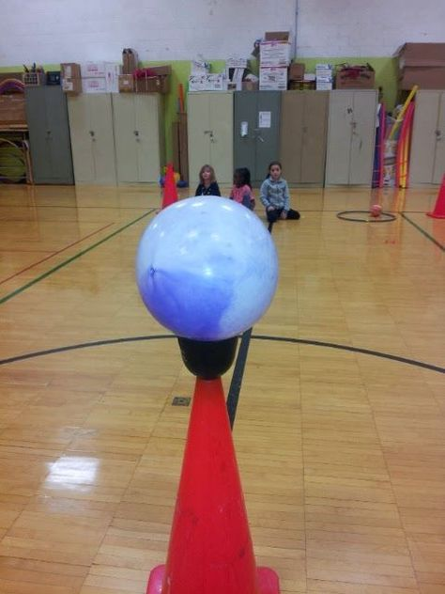 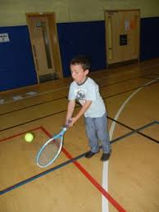  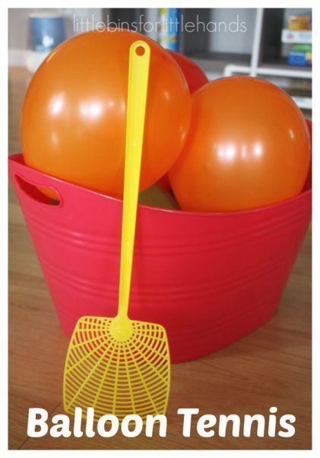

Use neon light up balloons to use in a darkened room. 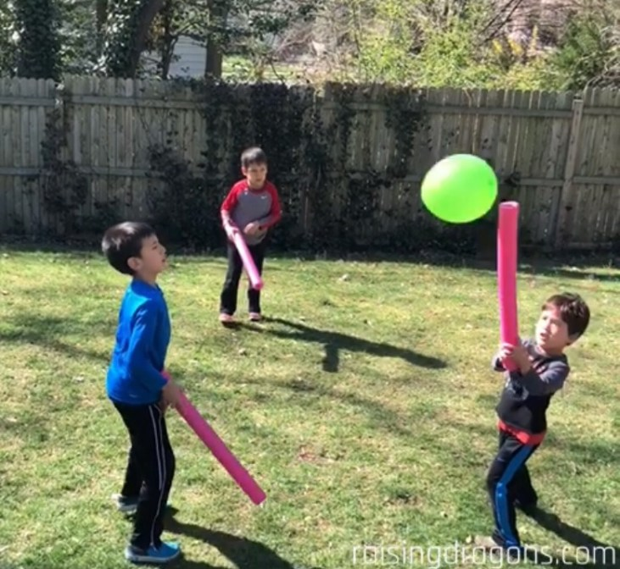

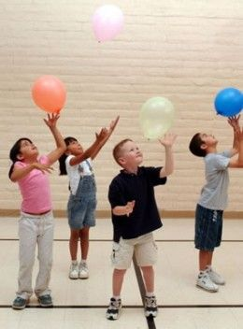

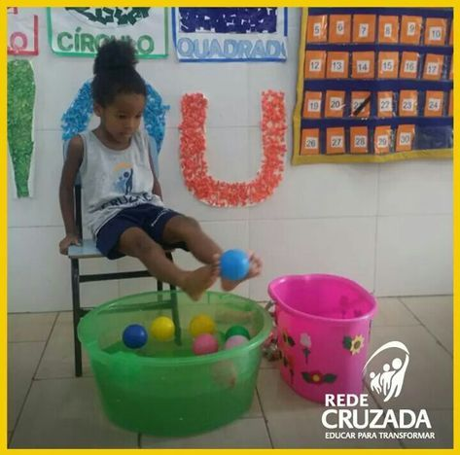No Hands use feet, No feet or restricted movement use hands seated in a chair

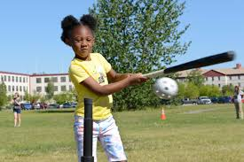

Throwing

Tie scarves to anything that can be thrown safely to make it more visible and add bells to make then noisy rockets.

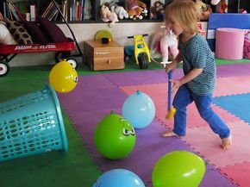 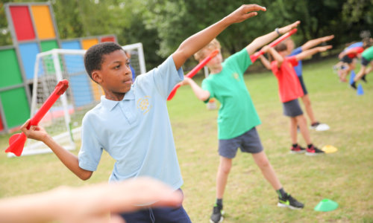

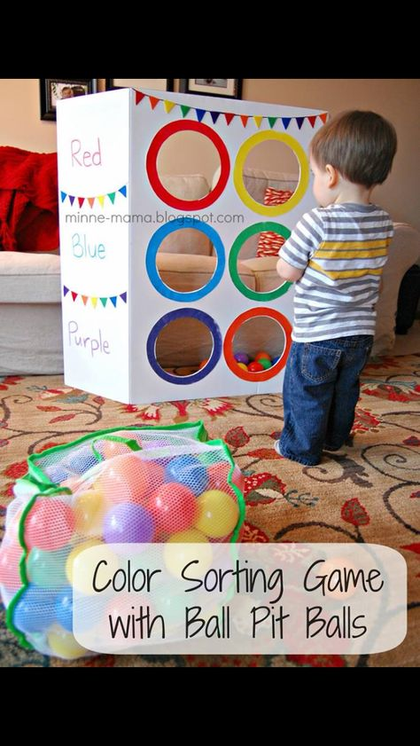

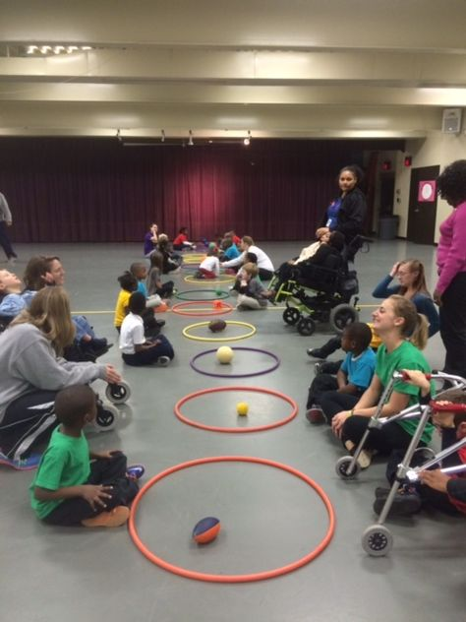

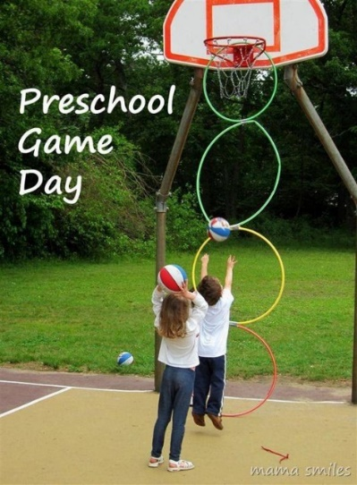

Use different size holes/hoops and balls to meet individual needs. Paint on a sheet and hang outside on a line after cutting out some holes.

**Other Activities**

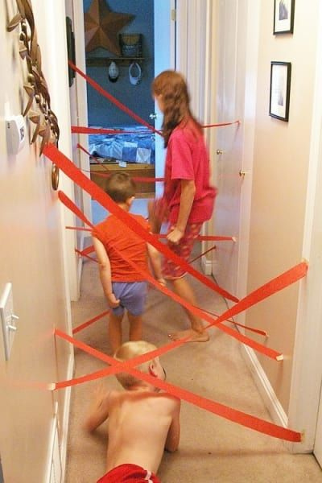  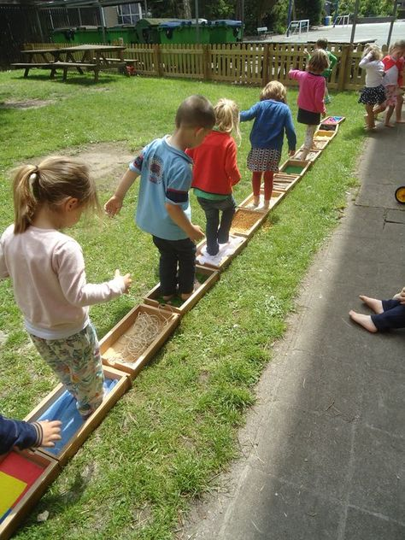

Adapt for wheelchair users making the strands higher, Use shiny paper to be more attractive to those with sensory needs.

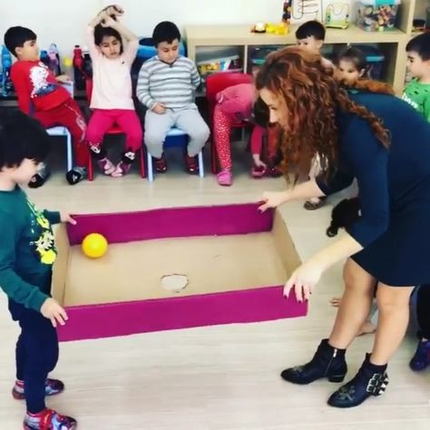  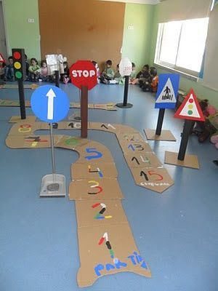

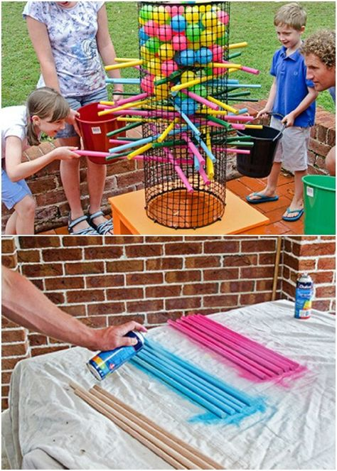 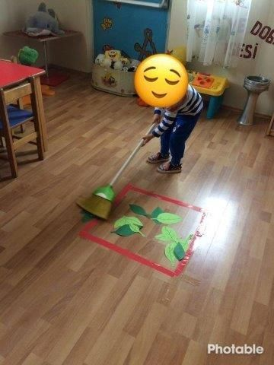

**[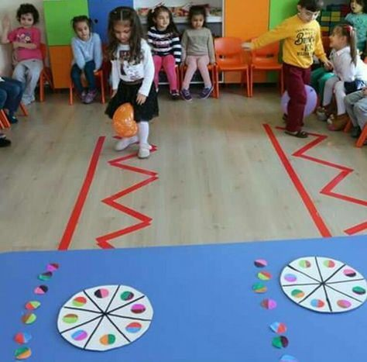](http://xboxpsp.com/ppost/402720391670815958/)** **[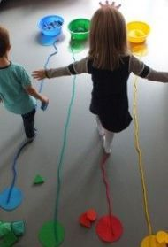](http://mamaymaestra.com/2015/02/12/actividades-para-mejorar-motricidad-gruesa-para-ninos-de-1-3-anos/)**

**[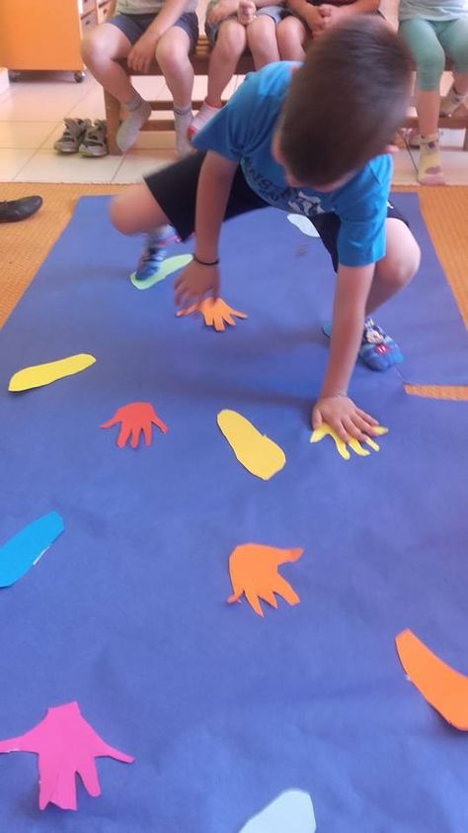](https://koitatiekana.wordpress.com/2016/05/31/%CE%B1%CF%85%CF%84%CE%BF%CF%83%CF%87%CE%AD%CE%B4%CE%B9%CE%B1-%CF%80%CE%B1%CE%B9%CF%87%CE%BD%CE%AF%CE%B4%CE%B9%CE%B1/)** **[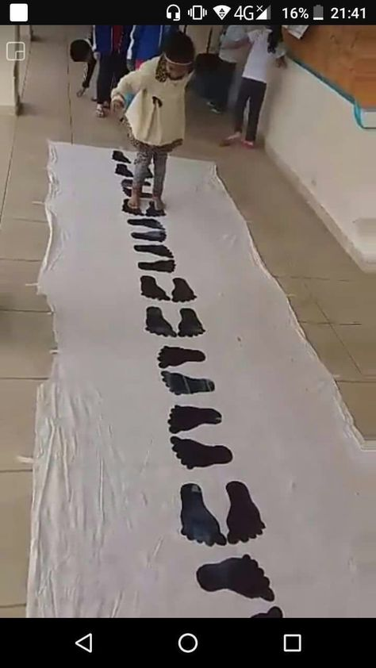](http://qosteri.com/post/get-kids-moving/299699343)**

Use shiny silver paper/ old CD’s to attract those sensory seeking ones. Place on a wall for wheelchair uses to stretch up and down if they can.

Use Mops or brushes to paint with outside to encourage large gross motor skills

**More outside games**

**[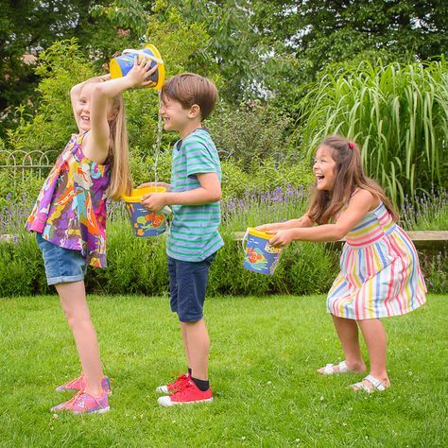](http://inspired.disney.co.uk/finding-dory-2/beckys-bucket-game/)** **[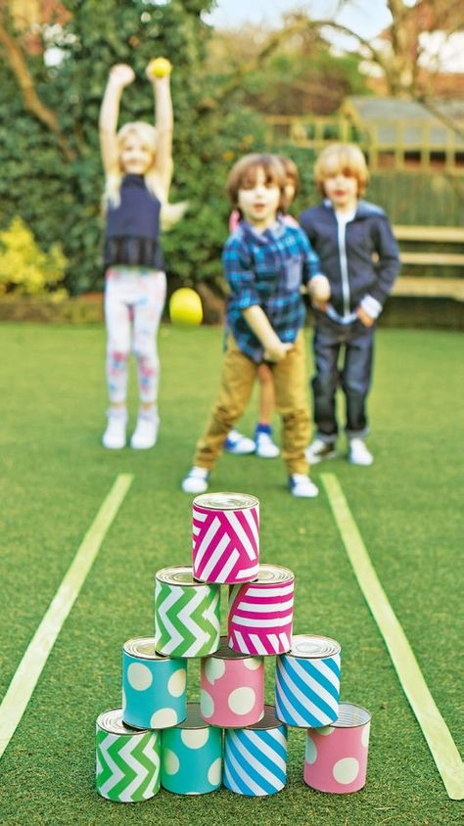](http://issuu.com/asdamagazine/docs/asda_mag_-_april/48)** **[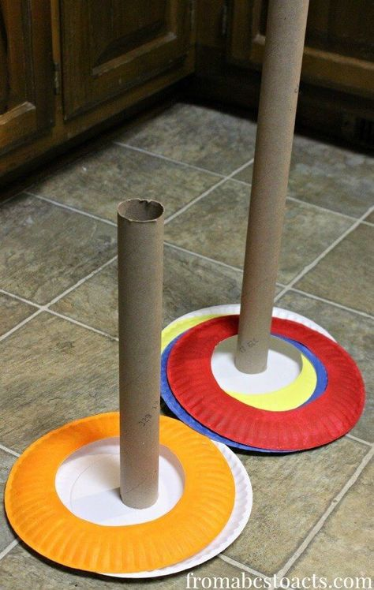](http://georginaclarkeblog.com/)**

**[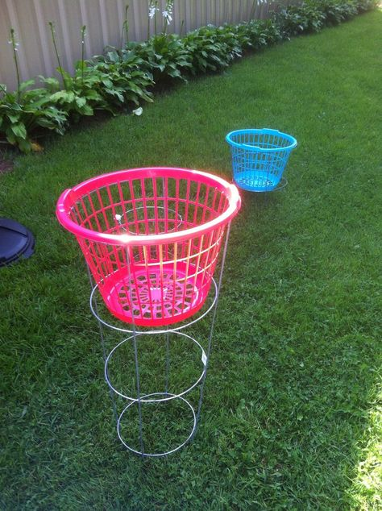](https://www.backyard.games/)[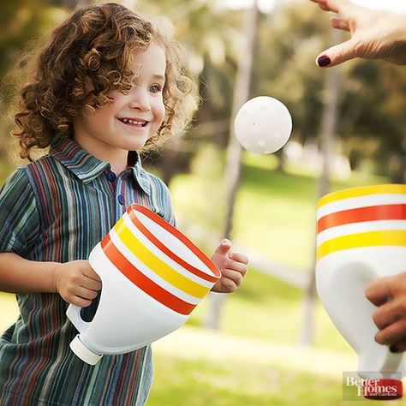](http://www.bhg.com/party/birthday/party-games/fun-outdoor-games-for-kids/#page=15)** **[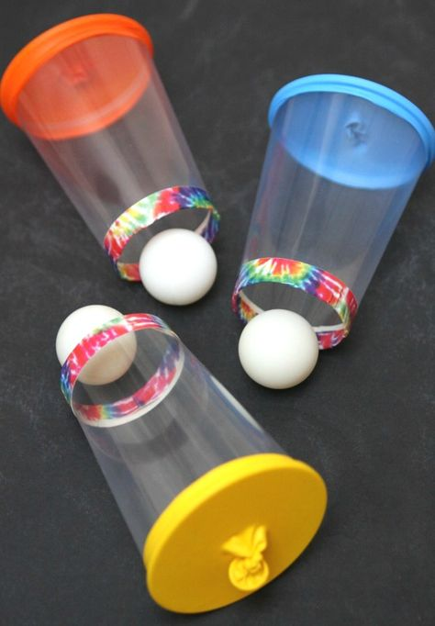](http://www.happygoluckyblog.com/2016/03/balloon-cup-shooters.html) [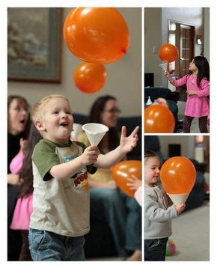](https://mail.uol.com.br/?xc=26654a67fdef24e06737b2b39303ced4#/webmail/0//INBOX/page:1/MzgwMjM)**   **[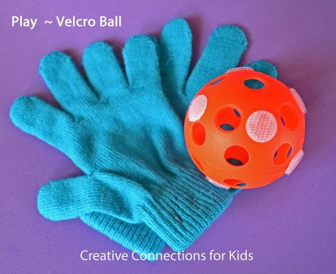](http://creativeconnectionsforkids.com/2012/01/play-velcro-ball/) [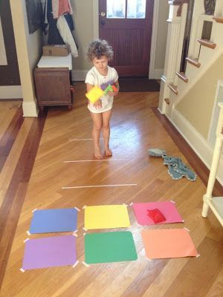](http://baby4needs.tumblr.com/?p=775431334930466)**

**Noodle Play**

**[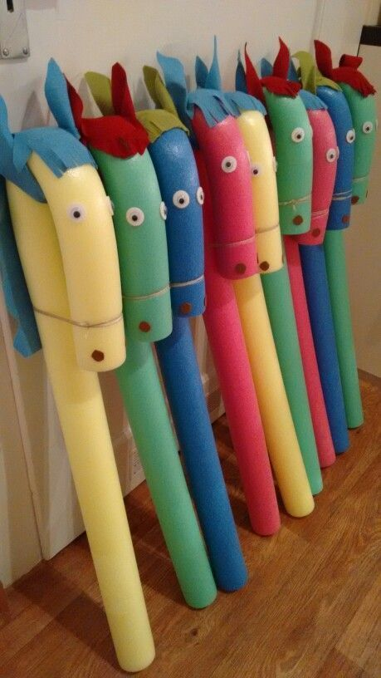](http://wooloo.ca/2016/06/07/20-idees-partir-de-nouilles-en-mousse-pour-piscine/)** **[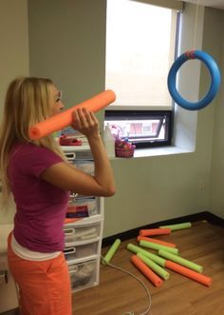](https://www.theresourcefulmama.com/lets-get-playing-20-pretend-play-activities/)**

**[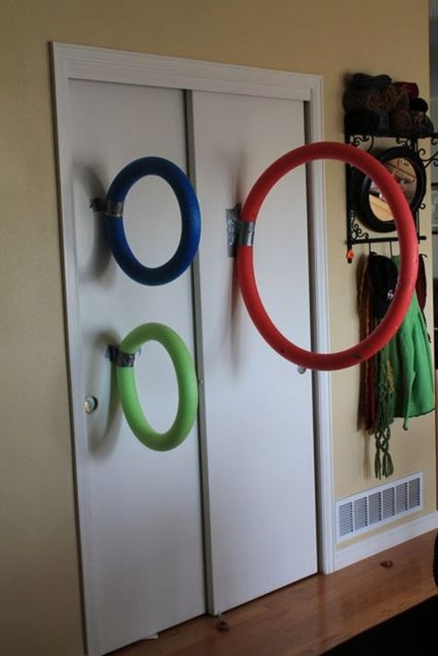](https://kids.theownerbuildernetwork.co/2015/05/25/pool-noodle-projects-to-make-with-kids/)[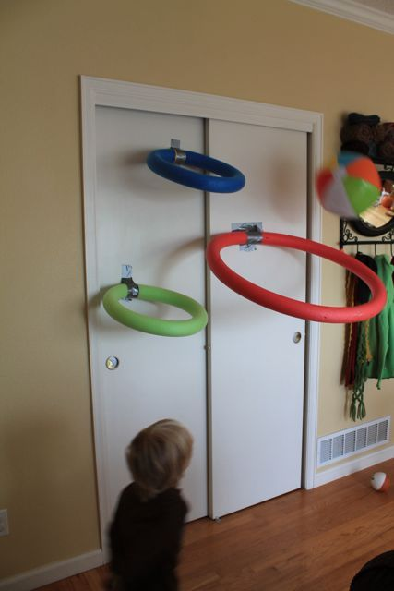](http://everneveragain.blogspot.co.uk/2013/02/indoor-basketball.html?m=1)**

**[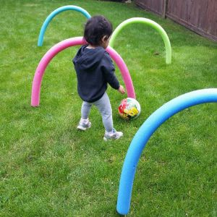](http://www.wayne-wonder.com/wonderkids/2015/7/1/summer-outdoor-fun?rq=summer)**

**Football**

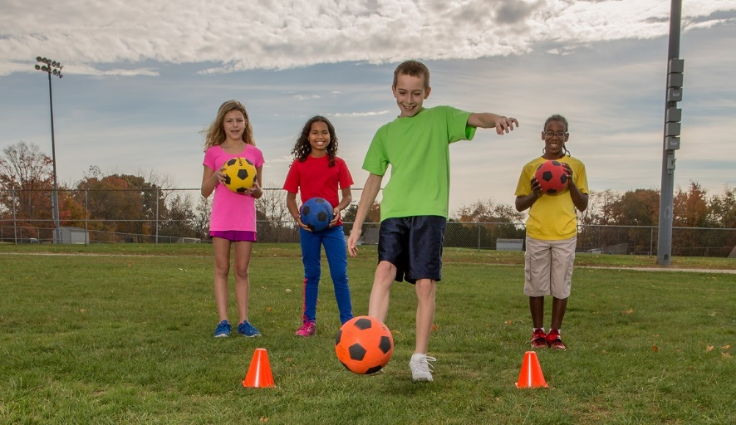

For wheel chair users Use gym balls to push using chairs for goal posts, tie a ball onto a rope so it can be pulled back by the child in a wheelchair**.** Use balls with bells in for the child with VI or black and white ones where the contrast may be easier to make out.

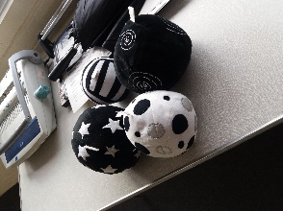 [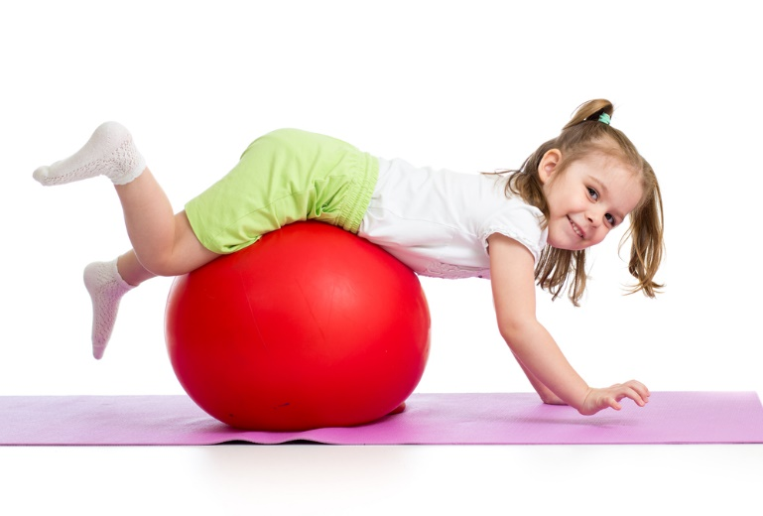](http://www.brightbeans.co.za/blog/child-development-2/strong-to-the-core-developing-childrens-core-strength-through-exercise-play/)

Running the line for children with a Visual Impairment.

Use a kitchen roll on a line of string tied to posts or held by two children, the child runs along between two ends in a safe open space giving them the opportunity to run safely. Add a red section and tie bells on a safe distance away from the ends to warn the child the end is near.

