Books about feelings ,anxiety and worries for children
Feelings: A lift-the-flap board book of emotions Board book – 2 May 2019  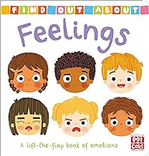  by Pat-a-Cake (Author), Louise Forshaw (Illustrator) | Find Out About: Feelings helps curious pre-schoolers get to grips with their feelings and emotions - a key topic for both them and their parents. Featuring friendly child characters and familiar situations, they will find answers and reassurance when they are feeling happy, sad, frightened, brave and everything in between. With fun flaps to lift and a memory game at the end, this is an excellent book for children and parents to share together.
This delightful book gives children the tools they need to deal with lots of different feelings - without it all ending in tears! It explores 12 common emotions, including happy, angry, excited, bored and embarrassed, and offers ideas for what children could do when they feel this way. This edition has also been fully updated with the latest guidance on developing children's emotional intelligence.  This is a great dip-in book where children can choose a feeling that relates to them and then turn to the page that provides child-friendly strategies for dealing with that feeling. Early Years and PSHE expert Molly Potter also provides notes at the back of the book for parents and carers explaining emotional literacy, and a Feelings Tracker for children to map out their emotions. | How Are You Feeling Today?: A Let's Talk picture book to help young children understand their emotions Paperback – 6 July 2023  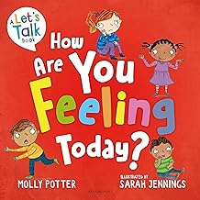  by Molly Potter (Author), Sarah Jennings (Illustrator)
Sometimes I Am Angry (Campbell Little Big Feelings, 4) Board book – 17 Sept. 2020  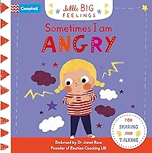  by Campbell Books (Author), Marie Paruit (Illustrator) | Sometimes I am Angry helps young children to start managing their emotions. They can lift the flaps, slide the tabs and turn the wheel to explore what anger is, why they might get angry and how they can calm their anger.  With delightful illustrations from Marie Paruit on every page, this is the perfect book for parents and carers to share with young children who may be experiencing episodes of anger and to develop their emotional intelligence. Explanations, hints and tips from Early Years expert Dr Janet Rose will provide parents with all the extra guidance they need.
Sometimes I am Worried helps young children to start managing their emotions. They can lift the flaps, slide the tabs and turn the wheel to explore what a worry is, why they might worry and how they can stop their worries from becoming too big.  With delightful illustrations from Marie Paruit on every page, this is the perfect book for parents and carers to share with young children who may be anxious about something and to develop their emotional intelligence. Explanations, hints and tips from Early Years expert Dr Janet Rose will provide parents with all the extra guidance they need. | Sometimes I Am Worried (Campbell Little Big Feelings, 2) Board book – 23 July 2020  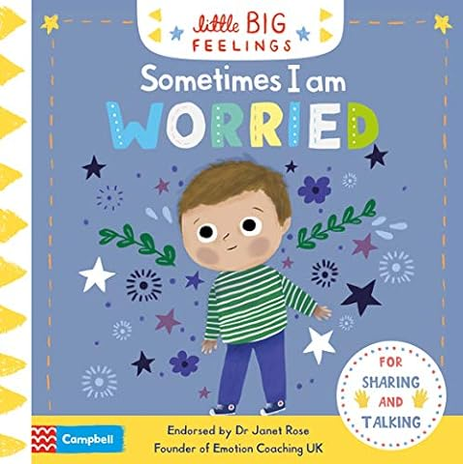  by Campbell Books (Author), Marie Paruit (Illustrator)
The EMOTIONS Book: A book about feelings for young children Paperback – 19 Oct. 2020  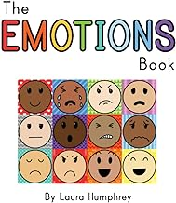  by Laura Humphrey (Author) | The EMOTIONS Book  A book about feelings for young children  •12 Facial expressions, one for each emotion.  •Chat through the examples, explore the faces, open up the discussion about feelings with your little one!  •Perfect for all young children, and a great resource for home schooling families.  •26 colourful pages, bold illustrations and colourful text.
An inspiring story about how good deeds bring joy and make us happy.  Max does not understand why you need to help others if you can just pass by. But the inspiring example of the father changes the boy's idea of kindness. Max decided to be kind and he likes it.  I Like To Be Kind - this is a fun and cheerful story that inspires children to do good deeds. After reading this charming story, the child will learn what kindness is and how any kind act, big or small, can make us happier.  This colourful book helps children become happier by showing them the amazing benefits of choosing kindness. So if you are looking for a funny and funny story about a boy who likes to be kind, then this book is for you! | I Like To Be Kind: Children's Book About Kindness for Preschool (Emotions & Feelings book for preschool) Kindle Edition  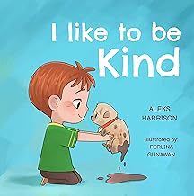  by Aleks Harrison (Author) Format: Kindle Edition
The Feelings Monsters: Children's Book About Emotions and Feelings, Kids Preschool Ages 3 -5 (Emotional Regulation) Paperback – 21 Aug. 2023  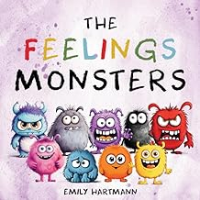  by Emily Hartmann (Author) | What do monsters feel when they are not scaring people?  Little monsters have a lot of emotions. They feel scared when they hear a loud noise, excited when they get a new toy, proud when they learn a new skill, and more.  This charming and humorous story helps kids recognize and manage their emotions.  *It is OK to feel different emotions and talk about them  *Learn how to deal with challenging emotions and find solutions  *Making friends and having fun with other monsters  *Emotions can also be a source of inspiration and imagination  This story is geared towards children ages 3-5. Perfect for toddlers, boys, girls, preschool. Excellent resource for counsellors, parents, and teachers.
How do dinosaurs deal with their emotions?  Little dinosaurs have a lot of feelings. They feel angry when someone takes their toys, anxious when they have to go to school, sadness when they miss their friends, and more.  This adorable and relatable story helps kids explore and express their emotions.  *It is OK to have different feelings and show them  *Learn how to cope with difficult emotions and calm down  *Helping your child develop emotional intelligence and empathy  *Emotions can also be a source of joy and creativity  ***** Simple, fun read, but meaningful and educational. - Lisa  ***** I adore this story! This is the perfect book about emotions and dinosaurs. - Emma  This story is geared towards kids ages 1-3 and 3-5. Perfect for toddlers, boys, girls, preschool, pre-K, and Kindergarten. Excellent resource for counsellors, parents, and teachers. | Dinosaurs and Big Feelings: Children's Book About Emotions and Feelings, Kids Preschool Ages 3 -5: 6 (Emotional Regulation) Paperback – 15 Jan. 2024  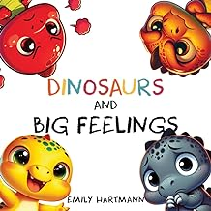  by Emily Hartmann (Author)
The Colour Monster: The Feelings Doctor and the Emotions Toolkit Paperback – 7 Dec. 2023  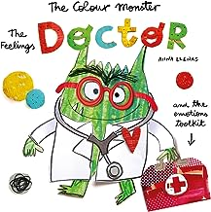  by Anna Llenas (Author, Illustrator) | The latest picture book in the bestselling The Colour Monster series, from talented author-illustrator Anna Llenas, that encourages conversations about consent, mental health and wellbeing.  One day, Nuna was in situation where she didn't know how to say no and it left her feeling strange and confused. So she goes to see Colour Monster who is now a doctor and who can help to heal emotions, especially those that are big and difficult to understand.  To begin with, Nuna cannot find the right words. But with the help of Colour Monster and his emotions toolkit, Nuna learns how to use tools and techniques that will make her feel better. Together they try things like deep breathing, arts and crafts, blowing bubbles and dancing until she starts to feel calmer. Now will Nuna be able to talk about what's bothering her?  This story addresses complex themes around consent, saying no and mental wellbeing in a sensitive, age-appropriate way. Through Anna's experience as an art therapist, she has interwoven techniques that can make these conversations easier. Including big, fold-out pages, children can look inside the emotions toolkit, making use of the ideas for themselves (with the support of a grown-up when needed).
Discover the art of patience with Maya in "Watch Me Bloom When I Learn to Wait," a vibrant 4-year-old with a deep love for the color pink, dancing, and drawing. As Maya eagerly anticipates her 5th birthday party, filled with unicorns and pink cupcakes, she confronts a challenging lesson - the art of waiting.  For Maya, who has autism, waiting can stir up intense emotions. But with the guidance of Jasmine, her Bloom Buddy, Maya learns that waiting isn't merely a delay; it's a golden opportunity to grow. Jasmine’s magical presence and practical strategies offer Maya - and every child reading a new perspective on handling the big feelings that come with anticipation. This book is suitable for all children, especially those that need a little extra support with mastering patience.  Through Maya's journey, children encounter a mirror of their own challenges with patience and anticipation. This story emphasizes the value of understanding and coping with waiting, a critical aspect of emotional development, especially for those with autism.  Help your child develop crucial emotional intelligence skills and turn those challenging moments into opportunities for creativity and joy. | Watch me bloom when I learn to wait: A coping story for children about waiting, how to practice patience and adapt to unexpected delays (Daily Bloom coping stories Book 3) Kindle Edition  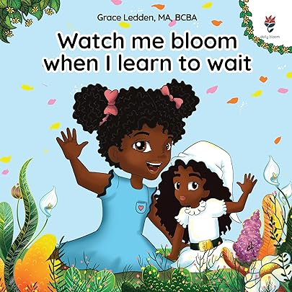  by Grace Ledden (Author) Format: Kindle Edition Does your child have challenges with patience and waiting? Do they get upset and frustrated when things take longer than they want?
Other relevant books  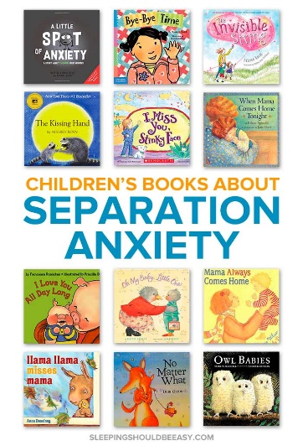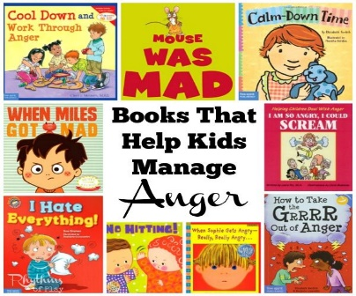 | 