Communities
Licensing
Tamar Building
Eastcroft Depot
London Road
Nottingham
NG2 3AH

My ref: JD
Your ref:
Contact: John Davis
Email: taxi.licensing@nottinghamcity.gov.uk
Dear Applicant,

New requirement for Hackney Carriage and Private Hire Drivers Licence
Applicants - Safeguarding children and vulnerable people

Everyone is becoming more aware of issues relating to Child Sexual Exploitation and Human Trafficking that have occurred throughout the country. The Licensing Authority has a duty to help the Hackney Carriage and Private Hire Trade in their understanding of such issues not forgetting that the drivers also have legal and moral responsibilities towards the safety of their passengers.

Safeguarding and promoting the welfare of children and vulnerable adults together with protecting taxi drivers within Nottingham City is paramount and depends upon good inter-agency practice, co-operation and training.

All applicants for new private hire or hackney carriage driver’s licences in Nottingham shall be required to attend a Safeguarding Awareness Course Online BEFORE A LICENCE WILL BE GRANTED. The sessions will be provided by Blue Lamp Trust as part of the application process. Please follow the link: https://bluelamptrust.org.uk/safeguarding-eLearning/

Failure to provide certificate as required could mean your application being delayed and the licence not being granted.

If you have any concerns or queries about this training, please email taxi.licensing@nottinghamcity.gov.uk .

Yours sincerely,
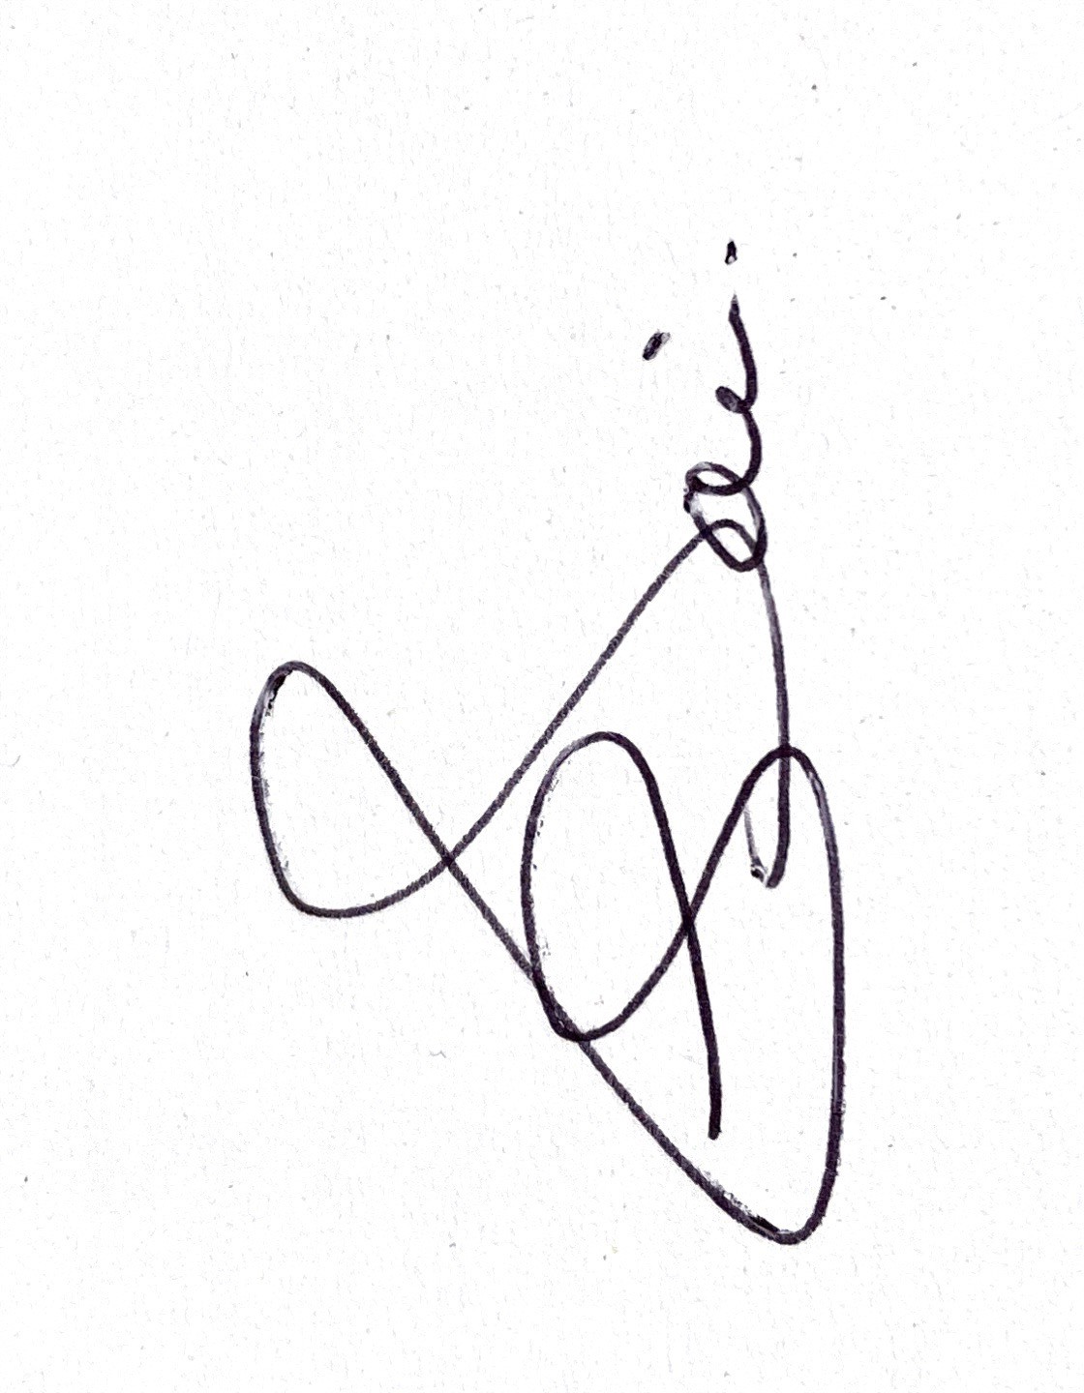
John Davis
Taxi Licensing Compliance Manager



