Books to introduce talking about getting older, grandparents, dementia and death with our young children.
Why Does Grandad Forget?
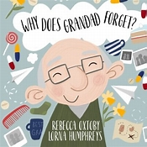
Author Rebecca Oxtoby Illustrator Lorna Humphreys
A heartfelt story to support children in understanding dementia Paperback – 16 May 2021
Why does Grandad forget? is a poignant children's book aimed to support the explanation of dementia to young children. Written by double number one best-selling author, Rebecca Oxtoby, the rhyming tale explores the journey of a little girl with her grandfather, who has begun to behave in unusual ways. The tale carefully and respectfully explores dementia in a child-friendly way, to support your little ones in understanding memory change. The colourful, warm images are beautifully illustrated by Lorna Humphreys, and prompt engagement and discussion.

Grandma
This sensitive and touching picture book helps young children understand dementia
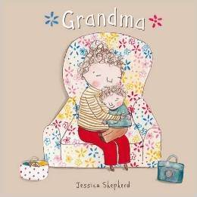
Author: Jessica Shepherd Interest age: 3+, Reading age: 4+
Oscar loves Grandma, and their time together is always lots of fun. As she becomes less able to look after herself, she has to go into a care home. More and more children are encountering dementia and its effects on their families. This touching story, told in Oscar’s own words, is a positive and practical tale about the experience. The factual page about dementia helps children talk about their feelings and find new ways to enjoy the changing relationship. Jessica Shepherd’s sensitive first picture book has grown out of her experiences in a variety of caring roles.
Grandpa you forgot your Pants
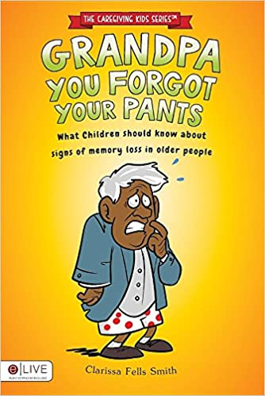 Author Clarissa Fella Smith
What Children Should Know About Signs of Memory Loss in Older People.
In this story, Janet knows something is not quite right with her grandad. She can't figure out why he went outside without his pants. Then she notices that he talks about his past life. Just when you thought that was too much, he can't even remember her! Grandpa, You Forgot Your Pants introduces children to memory in a way that leaves children asking more questions. Besides, there are so many grandparents caring for grandchildren, it was only a matter of time before this issue was brought to the forefront! You could literally take every page and discuss it over hot cocoa in front of the fireplace or at the dinner table with your family. Can children really be taught that older people who have memory loss still need love and value?

Grandma Forgets
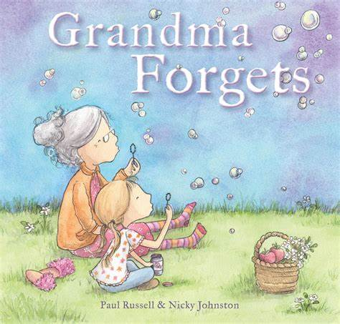
Authors Paul Russell and Nicky Johnston
Grandma Forgets is the heart-warming story of a family bound by love as they cope with their grandma's dementia. The little girl has built up a treasure trove of memories of time spent with Grandma: sausages for Sunday lunch, driving in her sky-blue car to the beach, climbing her apple trees while she baked a delicious apple pie, and her comforting hugs during storms. But now, Grandma can't remember those memories. That's alright though, because she has her family to help her. Depicted with gentle, whimsical illustrations, the little girl and her Grandma continue to share a loving relationship despite Grandma's dementia. This is a warm, hopeful story about a family who sometimes needs to remind their grandmother a little more often than they used to about how much they care.

Lost in the Clouds
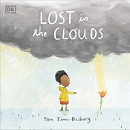 Author Tom Tin Didsbury
A gentle story to help children understand death and grief (Difficult Conversations for Children) Paperback – 6 May 2021
Children find grief difficult, and understanding where a loved one has gone can be a tricky topic to explain...
Billy misses his mummy very much. She lives in the clouds. Some days the sun is shining and Mummy's clouds are nowhere to be seen. Those are Billy's favourite days. He and Daddy would play in the garden all day long, and Billy knows that Mummy is letting the sunshine for them. But, not all days are like that. Sometimes Mummy's clouds are dark, and Billy feels sad and alone.

When Grandad had to go Away
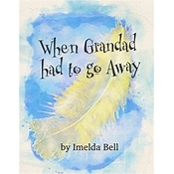Author Imelda Bell
A story for children about grief and the death of a loved one. (Big Topics for Little People) Paperback – 13 Jun. 2020
When Grandad had to go Away” is a story written in rhyme for young children about grief and the loss of a loved one. It explores the emotions and stages of grief and looks at ways to remember someone. This is part of a series of books exploring difficult topics and situations. Other books in the series include: "The Little Germ that Travelled the World - A story for children about Social Distancing" “The Nasty Beast who Wanted to Stay - A story for children about Cancer “What to Wear Instead of Hair” - A story for children about sudden hair loss

Goodbye Mog
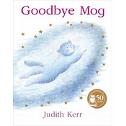
by Judith Kerr (Author, Illustrator) – Picture Book, 1 Sept. 2003
Mog was tired. She was dead tired… Mog thought, ‘I want to sleep for ever.’ And so she did. But a little bit of her stayed awake to see what would happen next.
Join the Thomas family as they say goodbye to their dear pet Mog, and get a new kitten. It could all be a disaster, but Mog is still there to help…
A touching tribute to a character beloved for fifty years, Goodbye Mog is the perfect story for a gentle introduction to the subjects of grief and bereavement, with the one and only MOG herself.
Say goodbye to MOG in this incredibly moving and stunningly illustrated story from Judith Kerr, creator of The Tiger Who Came to Tea and the MOG series.

Rosemary Rabbit and Grandpa Hopper: A Tale of Love and Dementia
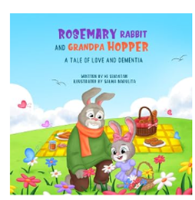
By Ki Siadatan, ISBN-13 ‏ : ‎ 979-8252778464

A Story About Kindness, Memory, and Helping Others
Rosemary Rabbit is a heartwarming story that gently introduces children to the importance of empathy, kindness, and caring for those who may be experiencing memory loss.
When Rosemary Rabbit begins to notice that someone she cares about is having trouble remembering things, she learns that love, patience, and understanding can make a big difference. Through her journey, young readers discover how compassion and small acts of kindness can brighten someone’s day and strengthen the bonds between generations.
Rosemary Rabbit is more than a story—it’s an invitation for children to discover the power of compassion and to become part of a generation that understands and supports those affected by Alzheimer’s disease and other forms of dementia.
Winston’s Wish
A useful website is which has more books available: Resources, Publications & Support Information | Winston's Wish (winstonswish.org)
Books and resources to help support bereaved children, written by experts, Winston’s Wish website has specialist books help parents, carers and professionals to support grieving children and young people after the death of someone close to them. They cover death by suicide, homicide, serious illness and in the military and are suitable for young children through to teenagers. You can see our books below and visit our shop to see all our resources including memory boxes.
