Books to support children with transitioning into Nursery or School
A transition workbook - starting school can be challenging for many children and even more so for children with ASD. The photos, words and pictures you personalise into this book, will help your child learn specific information about what to expect in their new environment and why. Visual booklets help create a sense of reliability and security during times of change and help improve their understanding of their new routine, visually. This book will also help adults and helpers around them, learn how the autistic child perceives their situation, enabling them to support them appropriately. It can also benefit any child starting school and learn about their new big school and open up opportunities for questions. Bright, colourful illustrations. | I'm Going To School - Transition Workbook:  It's all new, what do I do?  by Nikki Saunders (Author)  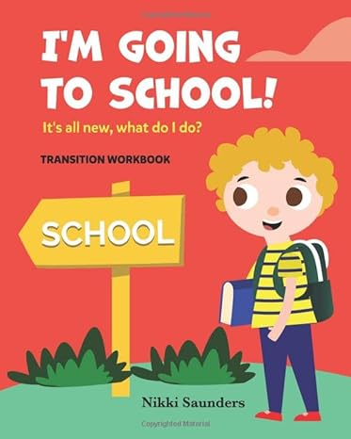
Why do I have to go to school?:  by Katie Daynes (Author), Marta Alvarez Miguens (Illustrator)  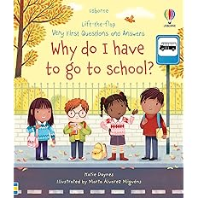 | An Empowering First Day of School Book for Children  From forming friendships to learning new skills, join a lively bunch of kids as they discover what school is really about and how to make the most of it. With delightful illustrations, inventive flaps and gentle humour, this book will help boost confidence and calm any back-to-school nerves.
Following a number of children's first experiences, this picture book takes children right from their very first day to the end of the school year. This reassuring read will support even the most nervous school-starter, exploring each emotion, from fear to excitement, with care.  Ideal for starting conversations about any pre-school nerves, this timeless classic is packed with playful illustrations and easy to understand explanations. | Starting School  by Allan Ahlberg (Author), Janet Ahlberg (Author)  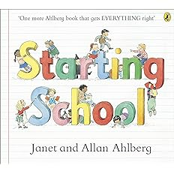
The Colour Monster Goes to School:  Perfect book to tackle school nerves by Anna Llenas (Author, Illustrator)  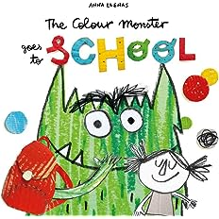 | Follow The Colour Monster on a brand new adventure, as he navigates his way through his first day at school!  Anna Llenas's popular Colour Monster is back, and this time he's heading off to school! But what exactly is school? A spooky castle filled with terrifying animals? A place in the sky, amongst the rainbows and clouds?  From music lessons, to lunchtime, to making new friends, the Colour Monster's first day of school is filled with exciting new adventures
This book gently introduces young children to the idea of going to school for the first time. The simple, reassuring text explains what to expect, and the charming illustrations by Stephen Cartwright are full of fun details to look at and talk about together. | Going to School (First Experiences)  by Civardi Anne (Author)  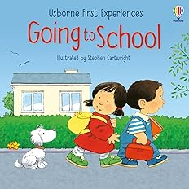
Spot Goes to School  by Eric Hill (Author)  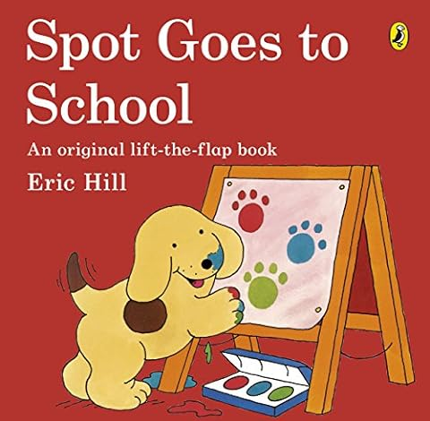 | Join Spot on his very first day at school. As the day goes on, Spot finds he's having more and more fun - and what will he learn along the way?  With fun flaps to develop fine motor skills and an adventurous story to encourage curiosity and exploration, this book is perfect for early learning and play.
Peter is excited to be going to forest school with Benjamin Bunny, they can't wait to learn all about the woodland they live in.  But when he learns that his sisters won't be there, the little bunny gets nervous. Luckily Mrs. Rabbit is there to reassure him and hold his paw on the first day.  With new, humorous illustrations of Beatrix Potter's well-loved characters, this reassuring tale mirrors young children's early experiences. This book is a perfect gift for children to prepare for their first days at school or nursery. | Peter Rabbit Tales: Starting School  by Beatrix Potter (Author)  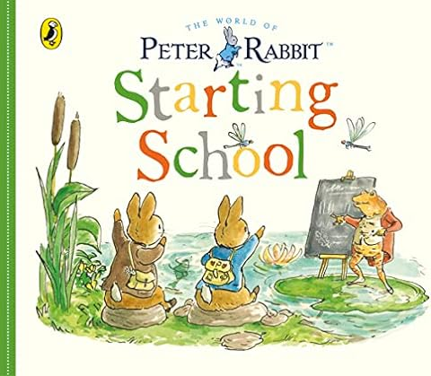
Five Minute Mum: Starting School: The Ultimate Guide for New School Starters  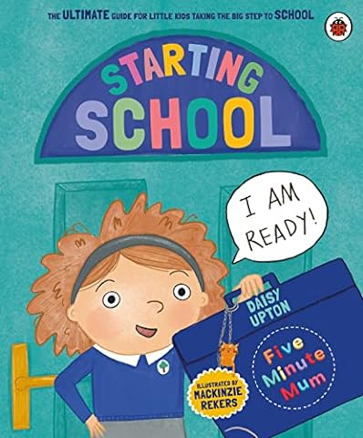 | Getting your child ready to start school can feel overwhelming, can't it? It's a big step for both of you.  Share this gentle, funny guide with your child to support them - and you! - with uniforms, meeting their first teacher, getting to school on the first day, making new friends, finding their way around, having fun at playtime, asking for help, packing their bag, learning about letters and numbers, going to assemblies, getting changed for PE, and much more.  And, of course, this book includes lots of five-minute games and activities designed by Daisy to help your child feel confident and excited about taking the big step to big school.
Start School is a perfect, reassuring picture book for children who are just about to start school. Along with favourite characters Topsy and Tim, children will learn what to expect in lessons, in the playground - even in the canteen - and, more importantly, that school can be fun! The Topsy and Tim books have been beautifully updated with contemporary artwork, but they remain instantly recognisable and trusted characters that parents will remember from their own childhoods. This edition also includes a puzzle and a map of Topsy and Tim's village that parents can use to teach their children basic map skills and directions. | Topsy and Tim Starting School gives you and your little one glimpses of all the learning they will do and all the fun they will have.  By Jean and Gareth Adamson  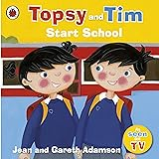
I'm Starting Nursery  by Campbell Books (Author), Marion Cocklico (Illustrator)  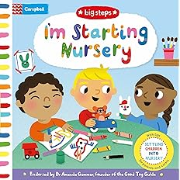 | Watch Ben and his friends play with trucks, paint pictures, dress up and listen to a story in this fun-filled novelty book with flaps and mechanisms. Each page has really helpful tips for parents and carers that are endorsed by The Good Play Guide and leading Early Years Consultant, Dr Amanda Gummer. With delightful illustrations from Marion Cocklico, I'm Starting Nursery is the perfect book to share and to reassure every little person starting nursery
Join Spot in a brand new story all about his first day at nursery school. There are lots of friends to meet and fun things to do before Mum comes to pick Spot up at the end of the day. This simple, reassuring story with bright, playful artwork is the perfect introduction to starting nursery for young children. | Spot Loves Nursery  by Eric Hill  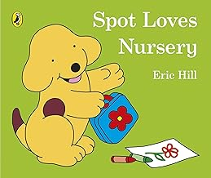
Time to Go to Nursery:  by Penny Tassoni (Author), Mel Four (Illustrator)  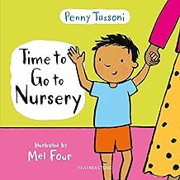 | Starting nursery is a big step, so most children will feel nervous at first. This charming book explains what the day will look like, from saying goodbye to parents to meeting other children and learning new things. It shows children what exciting activities might be on offer, like dressing up in fabulous outfits or playing outdoors on tricycles.  With simple-to-read text and delightful full-colour illustrations by Mel Four, Time to Go to Nursery helps children feel confident about going to nursery and reminds them that someone will always be there to help if they're unsure.
George's First Day at Playgroup is a colourful storybook based on the award-winning television series Peppa Pig.  It is George's first day at playgroup and Peppa doesn't really want him there. But when all of her friends want a little brother too, will Peppa change her mind? Find out in this lovely children's storybook featuring your favourite Peppa Pig characters. Read the story to help your little ones find out what it's like to have their first day at preschool, nursery, playgroup or school, with the reassurance that Peppa Pig and George did it too! | George's First Day at Playgroup by Peppa Pig (Author)  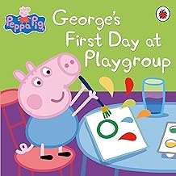
Starting Nursery: Maya's Terrific Transition by Aisha Millie (Author)  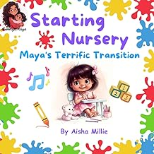 | Embark on an enchanting journey with Maya in "Starting Nursery: Maya's Terrific Transition." Maya's tale unfolds with warmth and wonder, capturing the essence of childhood innocence and resilience.  As Maya steps into her new nursery, her heart brims with both excitement and nerves, holding tightly onto her mummy's hand. But with the welcoming embrace of Miss Terry, a merry guide through colourful toys and cosy corners, Maya's world begins to change.  From tearful goodbyes to giggly snack times filled with juicy fruits, Maya navigates the challenges of her new environment with the support of her loving family and newfound best friend. Together, they embark on whimsical adventures, from potty breaks filled with laughter to moments of discovery in the nursery's garden.  Through the tears and triumphs of each passing day, Maya blossoms into a confident and radiant soul, spreading her wings within the magical embrace of nursery life.
For any child who is anxious about starting nursery, this fun-filled story, brimming with positivity, is the perfect antidote!  It is Monday and Rosa feels very big and very, very grown up. She is going to NURSERY.  She paints a beautiful picture, sings the 'Moo Moo' song without any shouting, waits to play with the cars without grabbing or pushing. All day long, she is an absolute angel. She is the BEST at going to nursery.  But now it's Tuesday. And it's nursery … AGAIN?! | Nursery? Not Today!:  by Rebecca Patterson (Author), Nikki Dyson (Illustrator)  