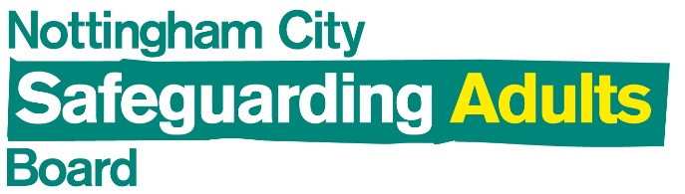 | Nottingham City Safeguarding Adults Board  Strategic Business Plan 2019 -2022

Introduction
The Care Act 2014 established an explicit legal framework for local authorities and partner agencies to work together to help and protect adults with care and support needs. The role of the Safeguarding Adults Board (SAB) is to assure itself that:
- Local safeguarding arrangements are robust
- Agencies are working collaboratively to prevent abuse and neglect
- Safeguarding practice is person centred and outcome focussed
In line with the requirements of the Care Act 2014, Nottingham City established a standalone Safeguarding Adults Board, and the Board has an independent chair. The Board has worked to an initial three year Strategic Business Plan to 2019. The NCSAB Strategic Business Plan 2019 - 2022 has developed from this and identifies the Board’s strategic priorities going forward. Annual actions are agreed and tracked through a more detailed Annual Action Plan to ensure that these responsibilities are met locally.
Strategic Priorities

The Nottingham City SAB identifies four strategic priorities.

- Prevention
To continue to identify and reduce risks of abuse and neglect to adults in Nottingham.

- Assurance
That appropriate arrangements are in place and continue to develop within and between agencies to safeguard adults in Nottingham as effectively as possible.

- Making Safeguarding Personal (MSP)
To continue to promote person centred and outcome focused work within and between agencies.

- Working arrangements for the safeguarding partnership in Nottingham
To have Board arrangements in place that member organisations see as effective and efficient.

Delivery
The strategic plan will be delivered by the implementation of an Annual Action Plan for each of the 3 years of this Plan. Annual Action Plans will build on existing strengths developed over many years of partnership working in the City in order to maximise the benefits of current opportunities whilst seeking to minimise the impact of challenges that arise for the Board and / or its partner agencies in an era of austerity and pressures on public and Voluntary and Community sector services.

The Annual Action Plans will be managed by the Board’s Business Management Group (BMG) with exception reports being provided to the full Board.

Objectives
The Board identifies core themes for these Annual Action Plans, which will evolve as work progresses.

Year 1 Initiating
In Year 1 we will engage partners and the Board’s subgroups in initiating a detailed programme of work that has drawn on the experience of partners in implementing the last Strategic Plan and the changing context of Nottingham.

Year 2 Developing
In year 2 we will build on our actions in year 1 by continuing to implement change and seek assurance on safeguarding practice to promote the delivery of excellent arrangements for the safeguarding of adults who have needs for care and support.

Year 3 Consolidating and Reviewing
In Year 3 we will consolidate progress and improvements made in years 1 and 2 and develop the next strategic business plan for safeguarding adults in Nottingham City.

