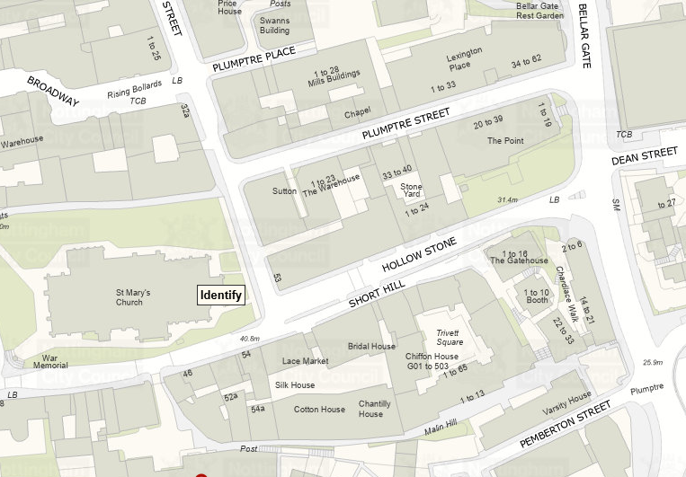
© Crown copyright and database rights 2025 OS AC0000822898. You are permitted to use this data solely to enable you to respond to, or interact with, the organisation that provided you with the data. You are not permitted to copy, sub-license, distribute or sell any of this data to third parties in any form.

