Emotions, Feelings and behaviour regulation

Balloons filled with cornflour with faces on with happy, sad, cross, worried, excited, faces

Posting box with hole in top, using coloured plain small balls with faces drawn on
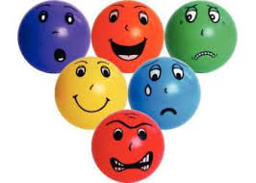

Soap bottles with faces on stickers with coloured water
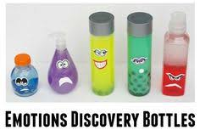

Calm down bottles with glitter and oil, red, orange, yellow, green, blue
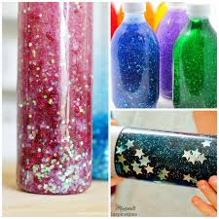
Emotion wall with coloured strips of material or paint hung on the wall to stand in front with labels saying today I am feeling blue, red, orange, yellow, green (sad, cross, worried, happy, excited)
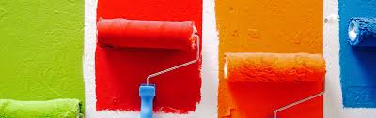
Use paint swatches to choose how you feel
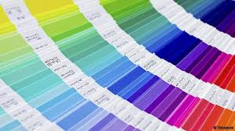
Red, amber, green fan showing too fast to too slow for ASD hyperactive or inactive
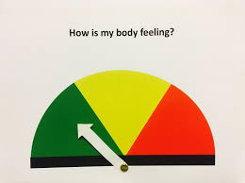
Emotion coloured circles for carpet time how are you feeling today
Personalised feeling card: 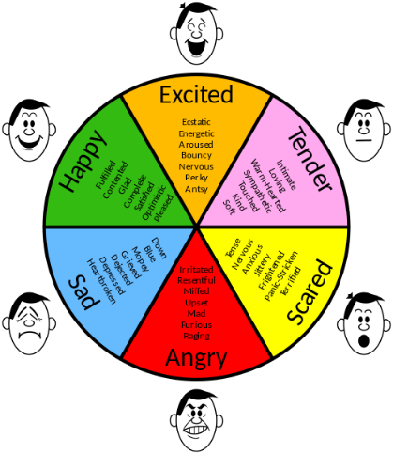
Instead of tender place a child’s face with an arrow in the centre to point to how they are feeling.
Other craft activities and ideas
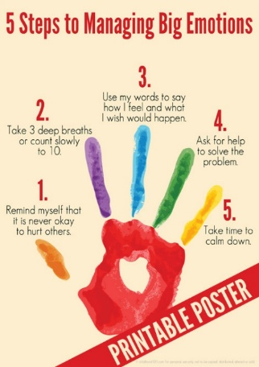
Painting activity colouring your hands/ fingers in the colour you are feeling today and then print it.

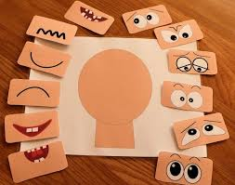
Build a face that shows how you feel and say why.

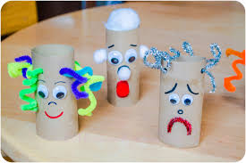

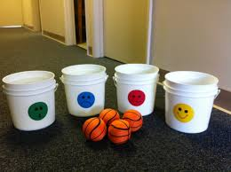
Name cards/photos for register time placed on coloured pegs when they arrive 5 emotions above
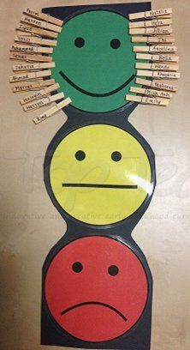
This could be used as a How are you feeling today rather than names on
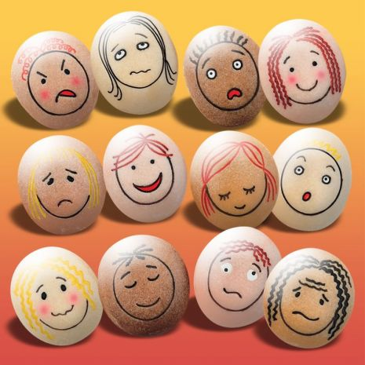
Emotion stones or make your own with Ping-pong balls.

