**Together Time**

**Box**

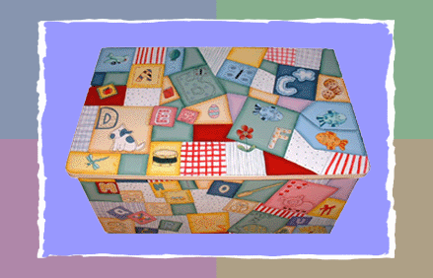

Information provided by:

Inclusive Education Service

Nottingham City Autism Team

***What is it?***

It is a small decorated box such as a shoe box, it contains items of interest to your child e.g. bubbles, floaty scarf, car, bells or shakers (you know your child best).

(Start with one or two items. More can be added gradually as the child’s interest grows)

***Who is it for?***

It is for children and young people who are experiencing significant difficulties with communication and interaction. It creates opportunities for the parent or carer to experience a special **together time**

***Why use it?***

To encourage a one to one special play-time for adult and child.

To encourage the development of early communication skills such as:

* eye contact
* attention skills (looking and listening)
* copying/imitation
* turn taking

***How to use it?***

Please refer to the **First Steps** plan

Followed by the **Session Plan** example

Remember! – This is time to have fun and enjoy time together

***Encouraging Early Communication Skills in Children***

Before language/communication can develop children need to develop **eye contact, attention skills, copying/imitation and turn taking.**

These **pre-verbal skills** are often lacking in children with communication/autistic spectrum disorders.

***Eye contact***

*Why?*Eye contact is the first skill a child needs to develop so that they become aware of people around them. From this social interaction can develop. Sustained eye contact is important to get information about language/interaction through facial expression, gesture and signs.

***Activities to encourage eye contact:***

* Bubbles
* Balloons
* Scarf (peep bo)
* Squeaky toys
* Puppets
* Tickle games
* Ready steady go games

***Strategies for adult to use:***

* Get down to the child’s eye level
* Position yourself in front of them
* Call their name before everything
* Hold objects close to your face
* Pause – give opportunity for eye contact
* Be animated – build up anticipation, exaggerate your mannerisms

***Attention***

*Why?* A good attention is needed to support the learning process.

**Activities to extend attention span:**

* Ready steady go games
* Towers of bricks
* Balloons/bubbles
* Feely boxes
* Lift the flap books

**Strategies for adult to use:**

* Running commentaries – talk about what your child is doing to keep them focused on the task for longer
* Use lots of anticipation and excitement
* Pause – give opportunities for eye contact

***Copying/imitation***

*Why?* It develops interest and awareness of others. It involves co-operation and interaction between two people which is the basis of communication.

**Activities to encourage imitation:**

* Lap play
* Faces in mirror
* Hats on/off
* Pairs of musical instruments
* Play with pairs of cars, dolls etc.

**Strategies for adults to use:**

* Set aside time in a quiet room or the corner of a classroom
* Follow the child’s lead, copy the child’s actions/sounds
* Build up anticipation, make it fun and enjoy it

***Turn-taking***

*Why?* Turn taking involves learning to listen, wait and share. It is also an important skill for conversation e.g. taking turns babbling, listening and responding and later taking turns talking and listening.

**Activities to encourage turn-taking:**

* Rolling/throwing balls
* Windup toys
* Cars
* Lap play e.g. row the boat
* Any reciprocal play
* Simple lotto games

**Strategies for adult to use:**

* The adult needs to take control of the environment e.g. away from distractions
* Limit the number of people participating. Begin with 1-1 situation and then developing into a group

***First Steps***

**Place and Time**

* Somewhere warm and comfortable
* No distractions **-** turn off TV, other children and pets to be out of the room.
* Try and make it part of a daily routine -same time, same place

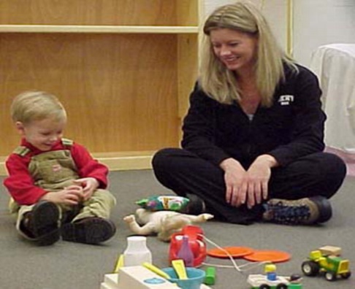

***Session Plan***

* Place unopened box between you and your child (on the table or carpet)
* **WAIT** – see if your child shows any interest in the box e.g. looking, reaching towards it
* **If not:**

**Try -**tapping the lid. **Pause** - any reaction?

**Try** - shaking the box. **Pause –** any reaction?

**Try -** lifting a corner of the lid. **Pause –** any reaction?

* If your child shows no interest remove the lid and make a big show of looking inside.
* Encourage them to share by taking the item out (squeaky toy, shaker, bubbles etc) and playing with it.
* Put the item down between you and give them the opportunity to reach and explore.
* If your child shows no interest try once more but then put it away , sign finished and then revisit next day following the same routine.
* If your child does show an interest then work on developing the **4 key skills** -

**Eye contact**

**Attention**

**Copying/imitation**

**Turn taking**

BUT remember to have FUN