BAME books to introduce children to diversity, anti-racism and empathy.
Antiracist Baby  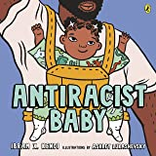  by Ibram X. Kendi (Author), Ashley Lukashevsky (Illustrator) | This is the #1 New York Times bestselling introduction to racism from award-winning author and academic, Ibram X. Kendi. Take your first steps with Antiracist Baby! Or, rather, follow Antiracist Baby's nine easy steps for building a more equitable world.  With bold illustrations and thoughtful, yet playful, text, Antiracist Baby introduces the youngest readers and the grown ups in their lives to the concept and power of antiracism. Providing the language necessary to begin critical conversations at the earliest age, Antiracist Baby is the perfect gift for readers of all ages dedicated to forming a just society.  This edition includes additional discussion prompts to help readers recognise and reflect on bias in their daily lives.
Two friends. One wish.  Mai and Rose are best friends but they're not two peas in a pod. Mai has dark hair that is curly and whirly and never stays put. Why couldn't she have perfect hair just like her best friend Rose? Rose has blonde hair, as straight as a ruler, which slips and slides whenever she tries to put it in a pony tail. Why couldn't she have perfect hair just like her best friend Mai?  When a magical coconut grants each girl their wish, and they get the hair they've always dreamt of, the friends are overjoyed. However, they soon learn that perfect hair is not everything it's cracked up to be. In fact, their hair was pretty magical and perfect the way it was before... | The Mega Magic Hair Swap!  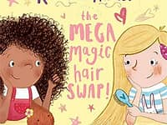  By Rochelle Humes (author), Rachel Suzanne (illustrator)
ABCs of Kindness: A Highlights Book about Kindness  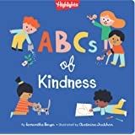  by Samantha Berger and Ekaterina Trukhan (Illustrator) | Starting with A and ending with Z, this beautifully illustrated book will show young readers the many ways they can make the world a kinder place. A diverse cast of children shows everyday acts of kindness and generosity through thoughtful and vibrant illustrations. Whether it be donating blankets to the animal shelter, helping with chores or standing up for what's right, this is the perfect book to spark conversations at home or in the classroom about the concepts of empathy and compassion. Featuring durable cardstock pages and approachable language, this book will encourage children to be their best selves wherever they go.
All people have the right to be treated fairly, no matter who they are, what they look like or where they come from. From A to Z, simple explanations accompanied by engaging artwork teach children about the world we live in and how to navigate our way through it.  Each right-hand page includes a brightly decorated letter with the word it stands for and an encouraging slogan. On the left, a colourful illustration and bite-size text sum up the concept. Cheerful people from a range of backgrounds, ethnicities and abilities lead the way through the alphabet. | An ABC of Equality  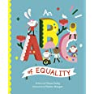  by Chana Ginelle Ewing (Author), Paulina Morgan (Illustrator)
ABC for Me: ABC What Can She Be?: Girls can be anything they want to be, from  A to Z  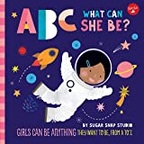  by Sugar Snap Studio (Author), Jessie Ford (Author) | ABC What Can She Be? presents a colourful world of possibilities—from astronaut to zoologist and everything in between—for all little girls with big dreams.  Not even the sky is the limit with this fun approach to learning the alphabet. In this new title from Walter Foster Jr., ABC What Can She Be? encourages young girls by presenting a colourful variety of choices for their future careers.  Talented illustrator Jessie Ford artfully pairs the letters of the alphabet with vibrant, eye-catching illustrations that paint an inspiring picture for budding trailblazers everywhere.  ABC What Can She Be? explores 26 different career paths. Each page introduces a letter of the alphabet with bright artwork and highlights a career that is fun, challenging, and makes a big impact in its own way.
'We all Belong' is a beautifully written and illustrated children's picture book that recognises and celebrates the diversity in a caring group of children.  A wonderfully flowing, rhyming poem about respect... whatever our culture, whatever the colour of our skin.  A stunning poem about inclusion, with excellent representation of different cultures. Much-needed in today's society.  By recognising differences between cultures and races, and appreciating that everyone is beautiful, children can grow up with empathy - appreciating others around them. 'We all Belong' gives young readers a safe space to see themselves and others through a diverse group of characters. The book includes an activity at the end, to help children appreciate how we are all similar in some ways and different in other ways too. | We All Belong: A Children's Book About Diversity, Race and Empathy  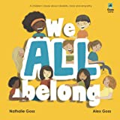  by Nathalie Goss Alex Goss (Author), Goss Castle (Author)
Skin: A First Conversation about Race  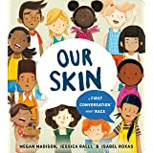  by Madison (Author), Megan (Author),  Ralli (Author), Jessica (Author),  Roxas;Isabel (Illustrator) | Developed by experts in the fields of early childhood and activism against injustice, this topic-driven board book offers clear, concrete language and beautiful imagery that young children can grasp and adults can leverage for further discussion. While young children are avid observers and questioners of their world, adults often shut down or postpone conversations on complicated topics because it's hard to know where to begin. Research shows that talking about issues like race and gender from the age of two not only helps children understand what they see, but also increases self-awareness, self-esteem, and allows them to recognize and confront things that are unfair, like discrimination and prejudice.
Discover incredible black men and women from around the world in My First Heroes: Black History! Push, pull and slide the scenes to find out about Maya Angelou, Stormzy, Rosa Parks and Nelson Mandela, and be inspired by their incredible achievements.  With scenes to explore, fun facts to learn and bright, bold illustration by Jayri Gómez, this is the perfect introduction for inquisitive pre-schoolers to these amazing heroes. | Black History: Discover Amazing People  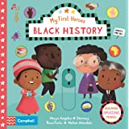  by Campbell Books (Author), Jayri Gómez (Illustrator)

