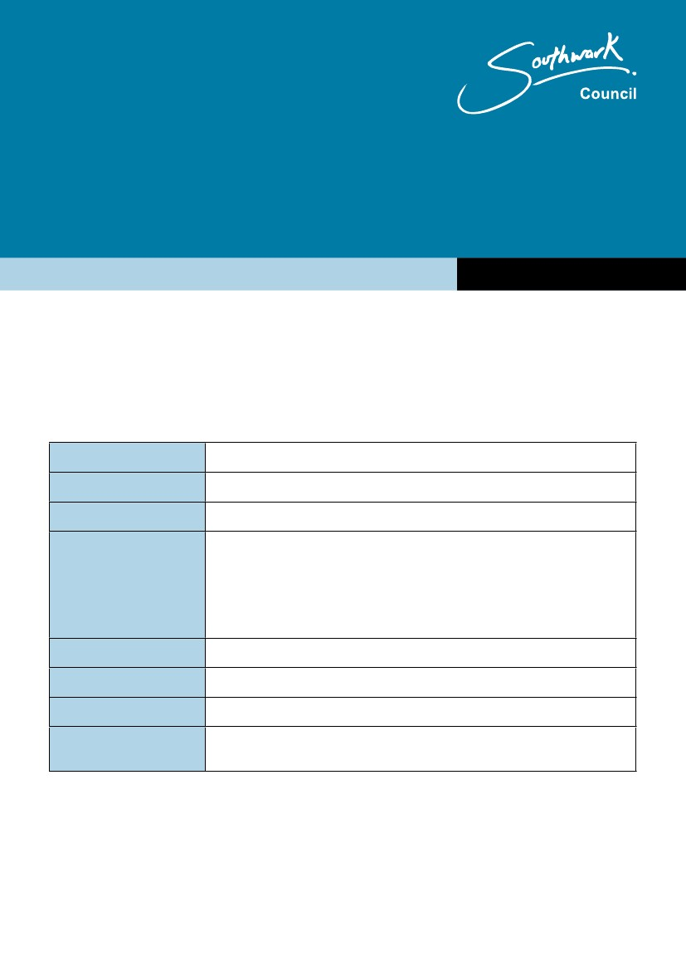
Nottingham City Council
Assets of community value
Expression of interest/intention to bid form
www.nottinghamcity.gov.uk
Only assets appearing in the council’s list of assets of community value can be subject to
expression of interest.
Submit your completed form by email to developmentmanagement@nottinghamcity.gov.uk
Part A: ABOUT YOU
Title
First name
Surname
Address
Postcode
Telephone number
E-mail address
Your relationship to the
organisation
1
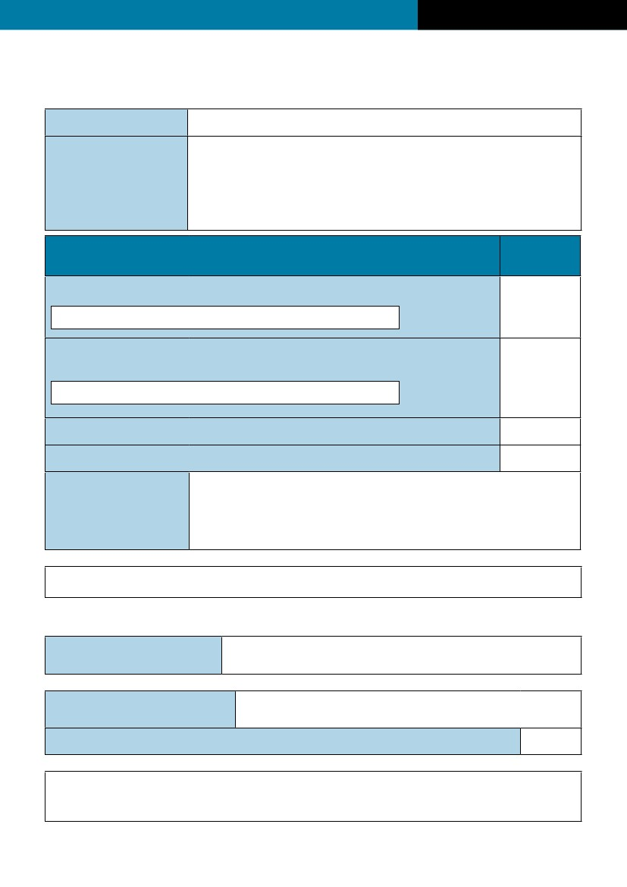
Assets of community value
April 2016
Part B: ABOUT YOUR ORGANISATION
Organisation name
Organisation address
Organisation type
A charity (include Charity registration number here)
Tick as
appropriate
A company limited by guarantee that is non profit distributing.
(include Company registration number here)
Community Interest Company
Industrial and Provident Society that is non profit distributing
Registered address of
organisation
If not a registered charity, please attach evidence of your organisation’s status such as Articles of
Association.
Part C: ABOUT THE ASSET
Name of asset
(building or land)
Address or location of the asset
Provide an Ordnance Survey plan if possible
By submitting this form we understand that we are requesting that our group be treated as a
potential bidder in relation to this asset and this may trigger the full moratorium period under
Section 95 of the Localism Act 2011
2

