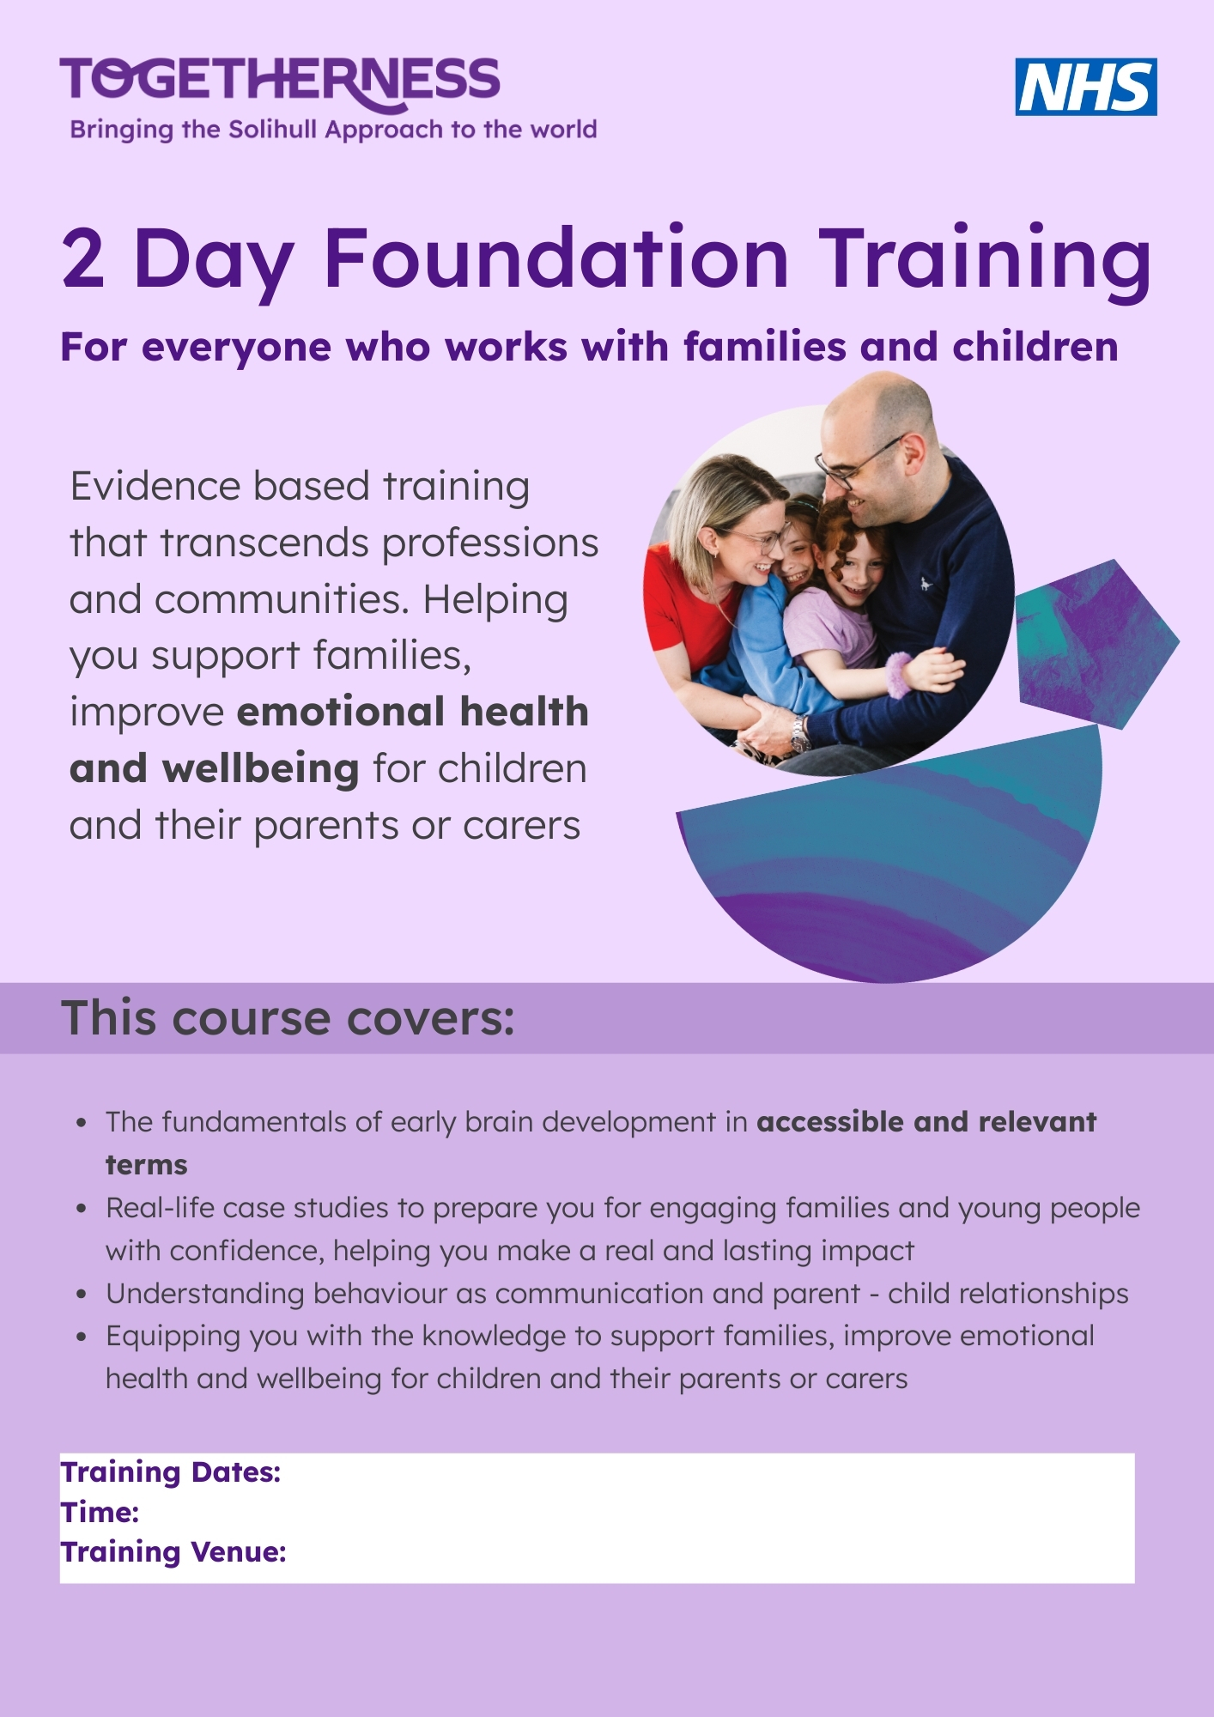
All courses are for professionals working in the Nottingham City area and focus on Early Years. Courses run over 2 days, 10am–4.30pm, in person, at Broxtowe Family Hub, The Corner House, 18 Strelley Rd, Nottingham NG8 3AP.
Please click on the dates below to take you directly to the Eventbrite Booking Page:
Monday 9th & 23rd November 2026 | Wednesday 2nd & 16th December 2026
Monday 11th & 25th January 2027 | Wednesday 20th January & 3rd February 2027
Wednesday 27th January & 10th February 2027 | Monday 1st February & 15th February 2027
For further information – contact Alison Davies on alison.davies@nottinghamcity.gov.uk

Venue Details:

