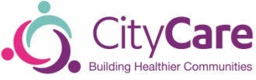

Childrens Public Health 0-19 Nursing Service
Team contact details
CDG1  Bulwell Riverside  Main St, Bulwell, Nottingham NG6 8QJ | 0115 88 33450
CDG2  Southglade Access Centre  Southglade Rd, Nottingham NG5 5GU | 0115 88 31290
CDG3  Broxtowe Children’s Centre  Bradfield Rd, Nottingham NG8 3AY | 0115 88 33355
CDG4  Mary Potter Centre  76 Gregory Blvd, Nottingham NG7 5HY | 0115 88 38229
CDG5  Sherwood Health Centre  Elmswood Gardens, Sherwood, Nottingham NG5 4AD | 0115 88 31455
CDG6  Sneinton Health Centre  Beaumont St, Nottingham NG2 4PJ | 0115 88 38620
CDG7  Wollaton Vale Health Centre  Wollaton Vale, Nottingham NG8 2GR | 0115 88 33130
CDG8  Clifton Cornerstone  Lanthwaite Rd, Clifton, Nottingham NG11 8EW | 0115 8786322

