Makaton
Learn Makaton
How to start using Makaton - About Makaton
Training in Makaton
Learn Makaton
Are you ready to take the first step and start learning Makaton? Getting started with Makaton is fun and easy. And once you've started, you'll soon want to learn more , starting with the Core Vocabulary. We look forward to welcoming you to the Makaton family soon!
Find training
Already know which training you're looking for? Use our quick and easy search tool to find a workshop near you - online or face-to-face!
Please Note: the workshops advertised here are organised and run by our network of freelance Licensed Tutors; The Makaton Charity cannot take bookings or payments for them.
To book a place on any workshop, please contact the organising Tutor direct.
Find a workshop today!
Makaton Training in your workplace
Makaton training is a fun and engaging way for you and your colleagues to start or continue your Makaton journey. Learning takes place in group workshops, either online or face to face at your workplace, to suit your needs. Makaton training in your workplace enables your staff to communicate confidently with people who have communication difficulties and needs.
Discover more!
Frontline Training in your workplace
Frontline Training, where clear communication is accessible to all. Our tailored training programs are designed to equip frontline workers, from all backgrounds and industries, with the essential skills to effectively communicate with individuals facing learning and communication difficulties.

BBC Mr Tumble
Getting started with Makaton - CBeebies (bbc.co.uk)
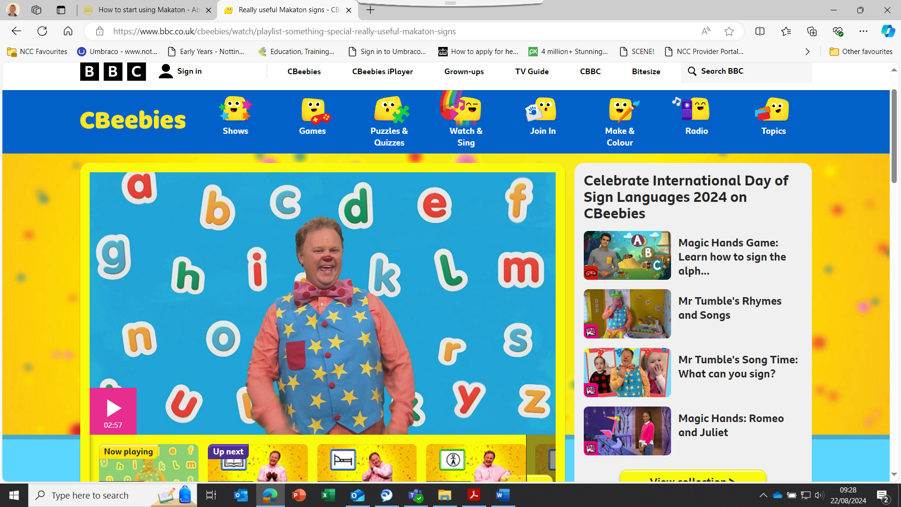

Top tips for signing with your child:
- Make sure you always speak when you sign – this can help to promote speech development.
- Face your child so that they can see your hands, the signs and your facial expressions.
- Use clear, short sentences and use the sign or symbol for the important word in the sentence.
- Guide your child’s hands so they can feel what it’s like to perform the sign.
- Give your child lots of opportunities to practise the signs – try to work them into your daily routine.
Things to do together:
- Learn some really useful Makaton signs
- Make it fun! Practise more signs by joining in with the songs and nursery rhymes from Something Special
- Find out more about Makaton through The Makaton Charity, which exists to ensure everyone living with learning or communication difficulties has the tools and resources they need to communicate.
Really useful Makaton signs
Have a go at our collection of really useful Makaton signs.
Learn more signs with Makaton Quizzes
- The Great Outdoors
- Holidays
- Animals
- Food
- Travel
- Hobbies
Do you want to know more about what Makaton is?
Find even more fun quizzes, puzzles and songs on the Something Special page.

Mr Tumble’s Alphabet song Alphabet
https://www.bbc.co.uk/cbeebies/watch/playlist-something-special-really-useful-makaton-signs#playlist

