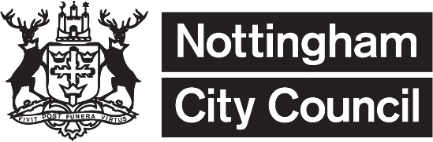
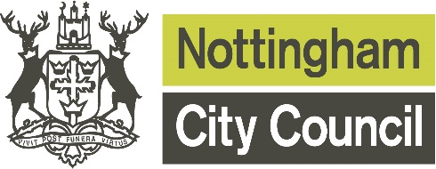
Ward Budgets
Criteria and Further Information for Applicants

Each local ward is allocated an annual budget to be applied within the operating principles approved by the Council. When applying for funding you must demonstrate how your project meets the needs of the local area and/or adds value.

You may apply to more than one ward, but you must state how many people will benefit from each ward. Your funding application is more likely to be approved if you adjust the amount requested from each ward appropriately. For example: If your project costs £100 and 10 people will benefit – 6 from Berridge and 4 from Basford, you should consider requesting £60 (60%) from Berridge Ward and £40 (40%) from Basford.

The use of funds is likely to vary from one area to another, in part reflecting the diverse nature of Nottingham City’s communities and at times there are additional funding resources available, so please give as much information as you can to show why you need the funding.

Who can apply?

Most community and voluntary organisations, groups and statutory organisations that work within the city boundary are eligible to apply for funding.

They must also have the following in place:
- A constitution or Articles of Association. These are sets of written rules which set out your aims and objectives. This must also contain a dissolution clause or asset lock that states any assets purchased with grant funding will be kept for community use should the group come to an end or close.
- An Equality, Diversity and Inclusion policy or statement.
- A Safeguarding Children and/or Vulnerable Adults policy (if working with children and young people or vulnerable adults).
- A bank or building society account in the group’s name with at least two unrelated signatories.
- Annual accounts for groups over 12 months old or a 6-month cash flow for groups under 12 months old showing predicted income and expenditure and bank statements.
- Disclosure and Barring Service Checks (for people working with children or vulnerable adults).

Documents

Copies of each of the relevant documents (1-5 above) must be enclosed with each application an organisation makes to Nottingham City Council per financial year. (Governing documents and policies can and should be refreshed and any new versions included in subsequent applications).

What can I apply for?

The funds will support costs like the examples below. In all cases the costs must relate directly to the activity the group are providing.

Rent The cost of using premises to deliver your project or to hire a venue for an event

Equipment Purchase of materials and / or hire of equipment to deliver your project / event

Publicity Production of a leaflet or newsletter to advertise the activities you are undertaking

Expenses Travel / parking for staff and volunteers delivering activities (specified pence / mile)

Training Necessary Courses that you intend to offer volunteers and / or staff

Admin costs Insurance and membership costs, general stationery for running the activity
Staffing costs Staffing costs for additional hours / new posts to deliver the activity (inc. recruitment)

Support Additional specific support that may be needed (e.g. translation costs)
Transport So participants can access an event or activity within the UK

What can’t I apply for?

The fund cannot be used to support:
- Individuals
- Activities where making profit is a primary aim
- Private businesses
- Activities where the primary purpose is to promote religious beliefs or where people are excluded on religious grounds. We can fund religious organisations to work with others and to develop community cohesion.
- Political groups or groups promoting political activities
- Groups / organisations where the majority of the membership live outside the City Council boundary (Groups may be required to produce a statistical breakdown of their membership by area)
- Costs the group owed or promised to pay before the application was approved (retrospective)
- Projects that will take more than 12 months to complete
- Grant making bodies applying for funding to redistribute to individuals or groups
- Costs associated with foreign travel

When should I apply?
You can apply at any point during the year, but where possible, please allow a minimum of two months for your application to be processed. Funds cannot be spent before you have been notified that your application has been approved.

How much should I apply for?
There is no limit on how much you can apply for, but each ward usually has between £5000 and £7,500 to allocate over the whole year, so you are more likely to be successful if you apply for smaller amounts. Consider how much your own organisation could contribute to the project, or if fundraising or applying for other grants would also be an option.

Approval and Monitoring of Allocations

Any funding shall be dependent upon the recipient(s):
- Formally agreeing to spend the funding on the activity/scheme specified in the application form
- Acknowledging funding sponsored by local ward councillors in all publicity
- Returning any unspent budget which the organisation hasn’t used for the specified project
- Completion of a monitoring form to identify success including photos with consent where appropriate. The monitoring form will be sent out for completion within 6 weeks of the completion of the project or activity, or after 12 months, whichever is the soonest. If this is not completed it may prevent any future funding applications being considered.

All funding approved including Part 1 of the application form is made available for public inspection on the Council’s website, https://www.opendatanottingham.org.uk/dataset.aspx?id=108 and an
Annual Report/Statement will be produced for monitoring purposes.

Returning your application form

Checklist | Tick
Have I signed the person completing form box in section 2?
Have I added the correct bank details to section 2?
Has the Treasurer and Chair Person signed section 2?
Documents Required:
- Constitution or Articles of Association
- Equality, Diversity and Inclusion Policy or Statement
- Annual Accounts (or 6 months of accounts for new groups)
- Safeguarding Policy (if you are applying for funding for a project working with children, young people or vulnerable adults
- Quotes for any single item over £250

Once completed, please send your application form with the accompanying documents to one of the following email addresses:

If you are applying to Bulwell, Bulwell Forest, Bestwood, Basford, Aspley, Bilborough or Leen Valley - email: northresidentdevelopmentteam@nottinghamcity.gov.uk

If you are applying to Sherwood, Berridge, Hyson Green & Arboretum, Castle, Radford, Lenton & Wollaton East or Wollaton West - email centralresidentdevelopmentteam@nottinghamcity.gov.uk

If you are applying to Clifton East, Clifton West, Mapperley, Meadows, St Ann’s, or Dales - email southresidentdevelopmentteam@nottinghamcity.gov.uk

If you would like to post your application, please call 0115 8838469 for the relevant address.
Once received, your application will then be checked, reviewed and you will be notified whether it has been successful within 6 weeks.

