Body Awareness Books for using with Early Years Children
Everybody Has a Body  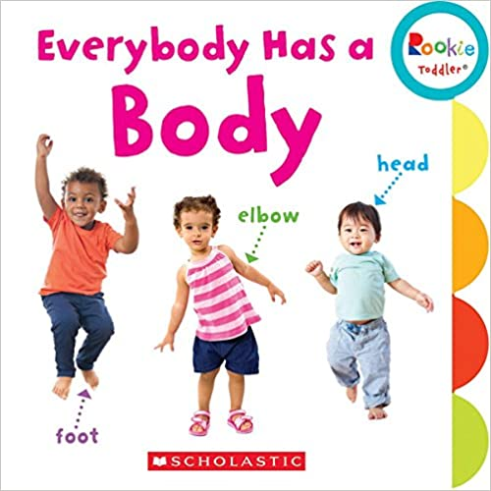  Author Janice Behrens Board book – 1 Sept. 2018 | Rookie Toddler books offer fun ways to engage with little ones during story time and play time. Each book includes story-related tips that help extend the reading experience and emphasize key learnings. Engaging photographs and illustrations will delight your toddler while encouraging a love of reading.
This brightly coloured, illustrated title explains to children about body privacy and why private parts should be kept private. Children will learn that their body belongs to them and they can say 'no' if they don't want anyone to touch their body. Children will, discover what is inappropriate, and be encouraged to speak up if they are uncomfortable with how other people treat them. It also covers the topic of secrets, and when you should not keep a secret.  The book looks at respecting each other's boundaries and becoming aware that some children, particularly those with autism or anxiety, may find hugging or any kind of touch, unbearable.  It also covers bullying, such as pinching or kicking, and shows children the best way to speak out to help stop these things happening.  Written by Louise Spilsbury, the text explains, simply and clearly, without scaremongering, why body privacy is important. | It's My Body: A Book about Body Privacy for Young Children  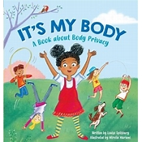  Author Louise Spilsbury
My First Body Book:  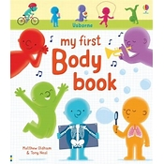 Author Matthew Oldham and Illustrator Tony Neal | Find out what's inside your body and how it all works in this fascinating book, full of bright pictures and facts that grown-ups and children can talk about together. A delightful introduction to muscles and how we move, our brain and senses, eating, growing up and more. Includes links to carefully selected websites with videos and activities.
A curious toddler Human Body Picture Book for Kids Paperback  This book is a great way to introduce little ones to the parts of the body vocabulary. Our picture book boasts more than 30 delightful images with fun characters that vividly illustrate the meanings of words, and encourages little ones to explore the parts of their body. | My First Word Book About Body Parts  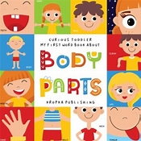  Author Kropka Publishing
My Amazing Body Parts  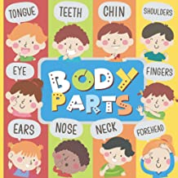  Author Misio Publishing | A Human Body Parts First Picture Book for Toddlers 0-3. Very Easy and Exciting Exploration for Youngest Readers. Big Colourful Pictures Paperback – 1 Feb. 2022  A friendly book for a curious toddler about body parts. Exciting exploration for youngest readers  The toddler learns to recognize body parts easily✅  Big colourful pictures and simple explanations will help him in this having 20 body parts inside  Important features: Premium colours, It's a great baby book for 0-3 years old, Simple layout: body part + short explanation, May 2022 update: improved interior & cover, This is an educational, fun, and interesting book for a curious toddler.
Recommended for children ages 2 and up, this book was created to help parents and caregivers introduce or reinforce the concepts of privacy and body safety to children learning for the first time and for those not quite ready to handle a longer book and/or more complex concepts like secrets, tricks, and intuition. In ten short pages children are taught: 1. Their bodies belong just to them 2. Some parts are private 3. Private is a word that means its not meant for sharing 4. Proper terminology for genitalia 5. It is a rule that privates are not for looking, touching or playing games. We hope you will use this book as a launching point for talking about body safety, it is printed in a sturdy board book format so that even the youngest of readers can hold and turn pages on their own. Proceeds from the sale of this book will support non-profit organization, The Mama Bear Effect in our mission to raise awareness and educate for the prevention of child sexual abuse. | My Body is Special and Private  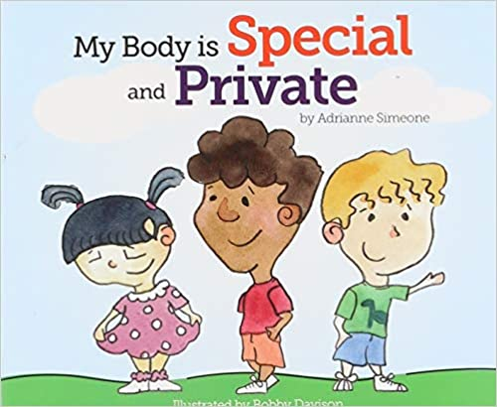  Author Adrianne Simeone and llustrator Bobby Davison
Why Boys and Girls are Different  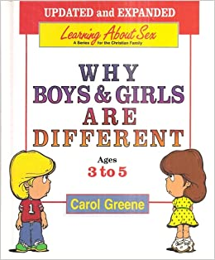  Authors Carol Greene | For Boys Aged 3-5 - Learning About Sex (Learning about Sex (Hardcover)) Kindle Edition  An honest, Christian approach to the body, relationships, and sex. Why Boys and Girls are Different is the first book in the Learning About Sex series for boys. The book guides readers in the often-difficult task of introducing and explaining human sexuality. Through simple, age-appropriate text and pictures, boys ages 3 to 5 discover that the similarities and differences between boys and girls are created by God for specific reasons.

