water

orange juice

apple juice

blackcurrant juice

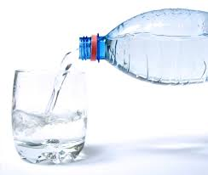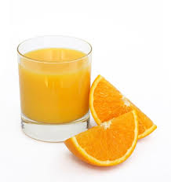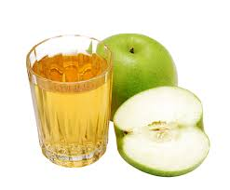

orange

grapes

strawberry

toast

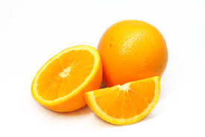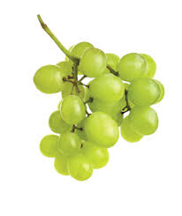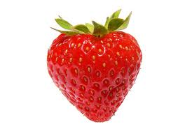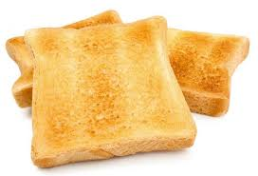

pear

carrot

cucumber

apple

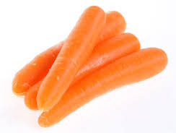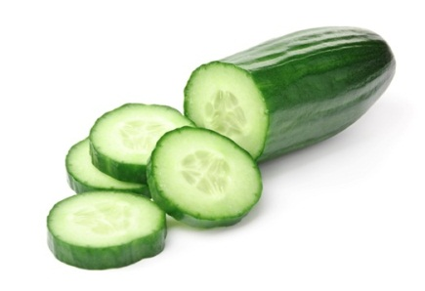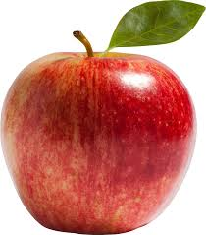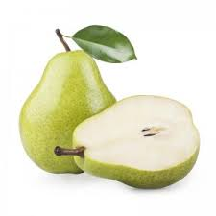

crisps

breadstick

biscuit

cracker

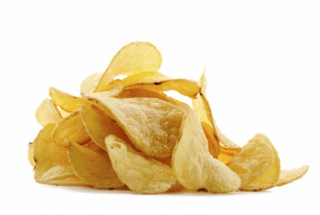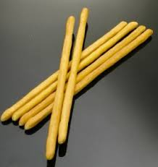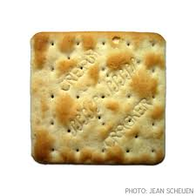

[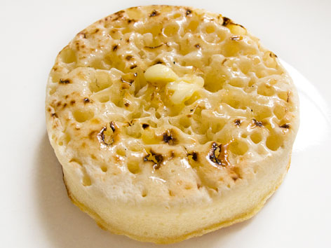](http://www.google.co.uk/url?sa=i&rct=j&q=&esrc=s&source=images&cd=&cad=rja&uact=8&ved=0ahUKEwijjv2p_PbSAhVGwxQKHcA2BfgQjRwIBw&url=http://eatyourworld.com/destinations/europe/england/london/what_to_eat/crumpets&bvm=bv.150729734,d.ZGg&psig=AFQjCNE2CVl8QYqwrqpq-MK7B-zaOQGaQw&ust=1490713936237726)

Crumpet

[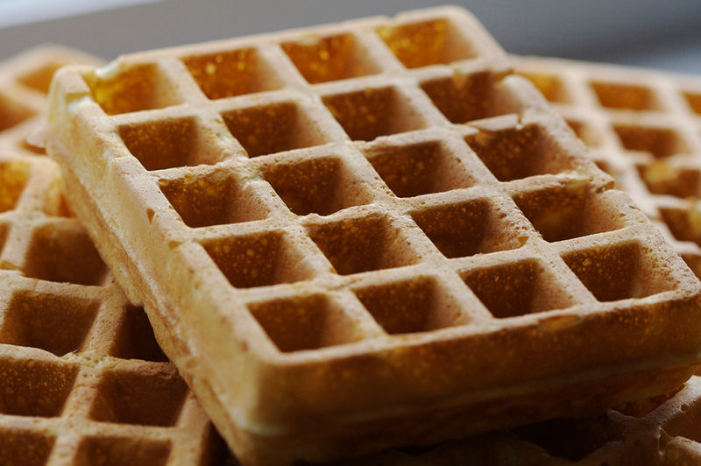](http://www.google.co.uk/url?sa=i&rct=j&q=&esrc=s&source=images&cd=&cad=rja&uact=8&ved=0ahUKEwip94j2-_bSAhVMHxoKHa0OAcwQjRwIBw&url=http://www.uniqueeventadditions.co.uk/waffle-bar&bvm=bv.150729734,d.ZGg&psig=AFQjCNFVvdAL6KyydKOJsRe4hpX5Qzkmzw&ust=1490713829361825)

Waffle

[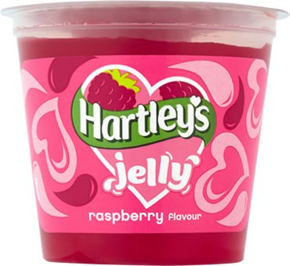](http://www.google.co.uk/url?sa=i&rct=j&q=&esrc=s&source=images&cd=&cad=rja&uact=8&ved=0ahUKEwiEw5G9-_bSAhUGVxoKHQjkD14QjRwIBw&url=http://www.hartleysfruit.co.uk/our-range/hartleys-jelly/hartleys-jelly-pots/&bvm=bv.150729734,d.ZGg&psig=AFQjCNEprsuscnqNax8c4-ULRUfO5uF2tQ&ust=1490713708689961)

Jelly

[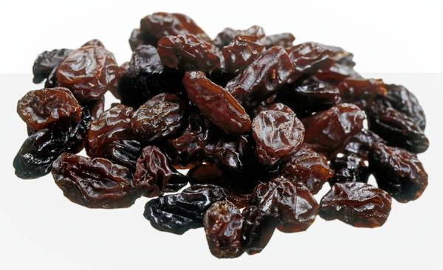](http://www.google.co.uk/url?sa=i&rct=j&q=&esrc=s&source=images&cd=&cad=rja&uact=8&ved=0ahUKEwjW5qPg-vbSAhWDlxoKHeftB6AQjRwIBw&url=http://www.srisakthichemicals.com/rsg/rsg-export-import.php&bvm=bv.150729734,d.ZGg&psig=AFQjCNHojjK-MDCKXd9tJLq9NIeaXnk6Qg&ust=1490713514091328)

Raisins

[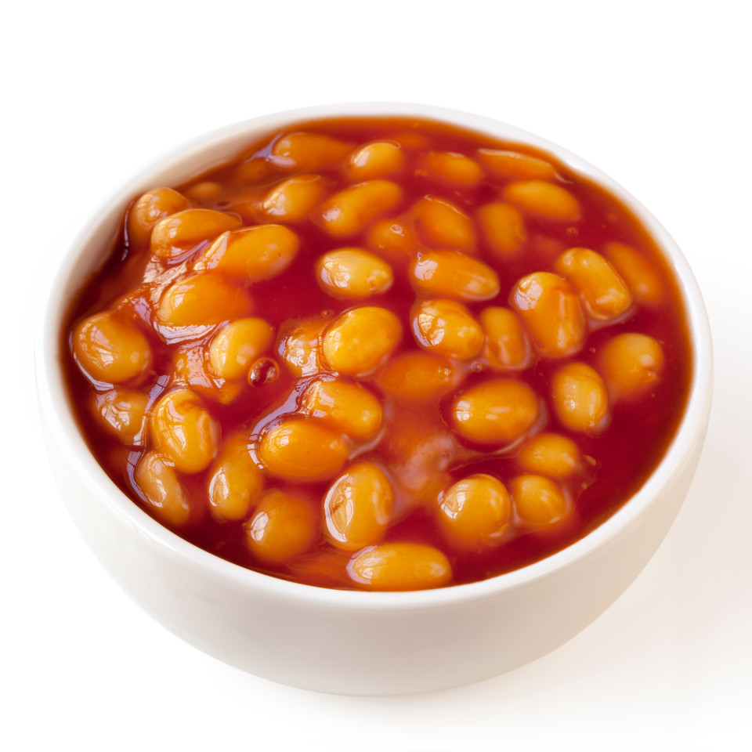](https://www.google.co.uk/url?sa=i&rct=j&q=&esrc=s&source=images&cd=&cad=rja&uact=8&ved=0ahUKEwizs8v7taHVAhVBShQKHeqtAt4QjRwIBw&url=https://www.thesun.co.uk/news/1549266/eat-baked-beans-and-bananas-to-beat-asthma-say-boffins/&psig=AFQjCNECshrgK8KZrFq3a7nRXFlulwwS1Q&ust=1500968614046946)

Beans

[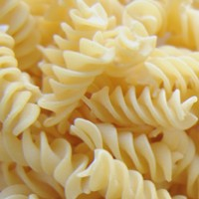](http://www.google.co.uk/url?sa=i&rct=j&q=&esrc=s&source=images&cd=&cad=rja&uact=8&ved=0ahUKEwjNtcertqHVAhVBPRQKHTx9CewQjRwIBw&url=http%3A%2F%2Fdanilospasta.co.za%2Fproducts%2Fplain-fresh-pasta%2F&psig=AFQjCNGyd6t-bX9TNdj_-iiVapQ6iMZHNg&ust=1500968707739476)

Pasta

[](https://www.google.co.uk/url?sa=i&rct=j&q=&esrc=s&source=images&cd=&cad=rja&uact=8&ved=0ahUKEwj_t9XGtqHVAhVDWxQKHWKDDLcQjRwIBw&url=https://www.wegmans.com/products/pizza/fresh-made-pizza.html&psig=AFQjCNEzv86E3jWhJVasGa7kSNbOWHd70g&ust=1500968768806321)

Pizza

[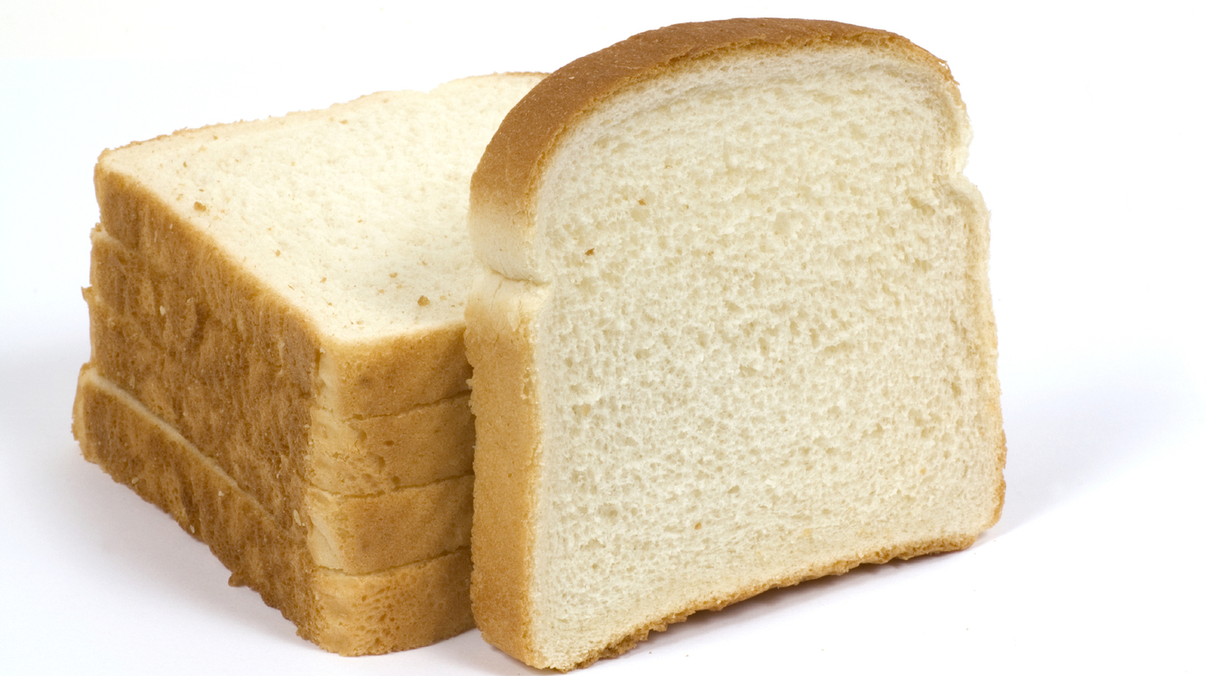](http://www.google.co.uk/url?sa=i&rct=j&q=&esrc=s&source=images&cd=&cad=rja&uact=8&ved=0ahUKEwj6mczrtqHVAhXHVRoKHeX4Bj0QjRwIBw&url=http://www.npr.org/tags/147825038/bread&psig=AFQjCNHrWoU8D6-Y_xqIRAEl2pSocHUluQ&ust=1500968847069808)

Bread

[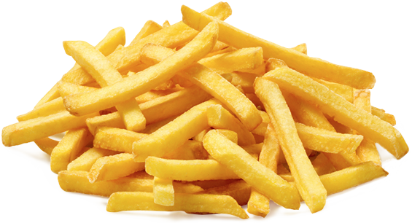](http://www.google.co.uk/url?sa=i&rct=j&q=&esrc=s&source=images&cd=&cad=rja&uact=8&ved=0ahUKEwi1kMCst6HVAhVDuBQKHSO_CCoQjRwIBw&url=http://burtonkebab.co.uk/Products/Browse/?cid%3D90%26tp%3Dcollection&psig=AFQjCNE9GLXdC-BEqcxPeFKeLtml50ebGQ&ust=1500968982033057)

Chips

[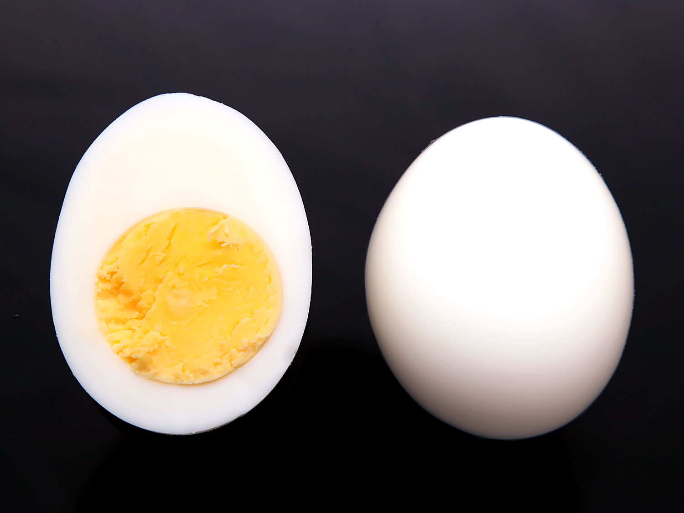](http://www.google.co.uk/url?sa=i&rct=j&q=&esrc=s&source=images&cd=&cad=rja&uact=8&ved=0ahUKEwjaj8LPt6HVAhWCXRQKHTTzBfoQjRwIBw&url=http://www.seriouseats.com/recipes/2009/10/perfect-boiled-eggs-recipe.html&psig=AFQjCNFyJlRzy3e9nmASYIsvw01P2nL2IQ&ust=1500969051238562)

Eggs

[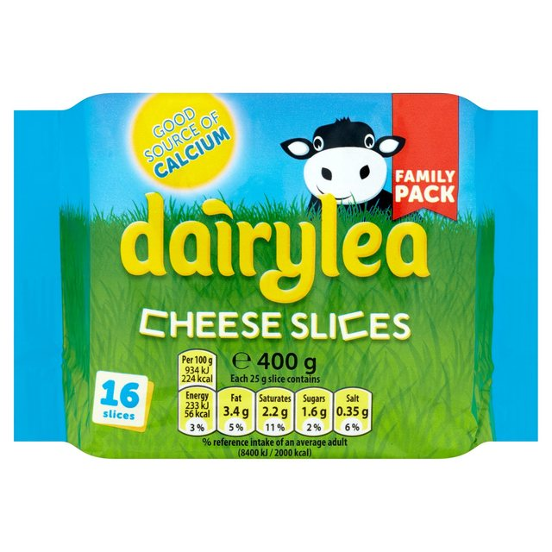](https://www.google.co.uk/url?sa=i&rct=j&q=&esrc=s&source=images&cd=&cad=rja&uact=8&ved=0ahUKEwi_idv3t6HVAhVKkRQKHSMQAoEQjRwIBw&url=https%3A%2F%2Fgroceries.morrisons.com%2Fwebshop%2Fproduct%2FDairylea-Cheese-16-Slices%2F211581011&psig=AFQjCNG3O1zXUzAdXUSzvtmFxR81xe1PvA&ust=1500969106199616)