Discovery bottles
Health and safety: The bottles Must be clean and dry and only have been used for edible or drinks. They must be clear and of various sizes. Remove any labels and wash thoroughly. When filled apply glue to the cap and allow to dry before giving it to a child. Wipe with antiseptic wipes if being shared with other children.
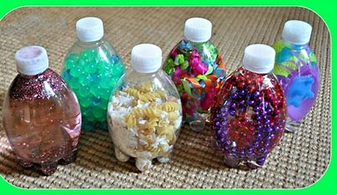
1. Early discovery bottles for babies
Black and White: buttons, pompoms, pipe cleaners, felt shapes, small cows, lego bricks,
Glitters: shiny sequins’ glitter, gold stars, coloured stars, food colourings,
Squeeze and smell: lavender, perfumes, lemons, cinnamon, coffee beans, herbs and spices, soaps.
Shake rattle and roll: pasta, lego, buttons, stones, beads, paper clips, rice, lentils, keys,
Colour collections: red, blue, green and yellow various items from around the nursery/home.
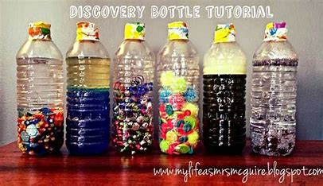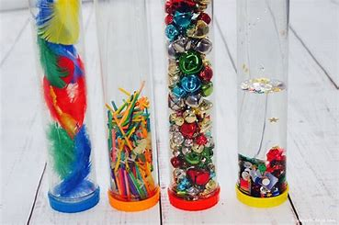
2. Moving and shaking toddlers
Pipe cleaners, buttons, pompoms, small beads or bricks, artificial flowers.
Swirly whirly: shaving foam or squirty cream.
Pitter patter raindrops: cocktail sticks, lollipop sticks, tooth picks, for thunder use stones and for snow use confetti snowflakes.
What’s that noise: fill bottles with any of above and then cover the bottles with socks so the children have to listen and guess what’s inside.
I spy: fill the bottle with fine sand or rice then put in a collection of 10 small items and get them to find them and make a list.
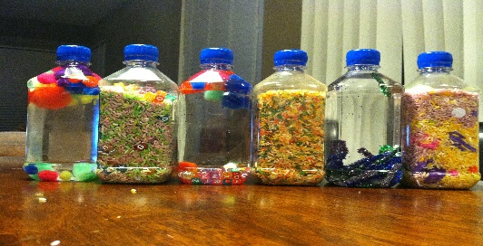
3. Foundation stage 3-5yrs
Alphabet bottles: choose items to put in the bottle that start with the letter of the week ie C for car.
Sizing them up: use various sized bottles and fill with coloured water at different levels don’t put the bottles in order for example the smallest quantity of water could be in the largest bottle.
Floating and sinking: collect items that float or sink have 2 bottles for floating and sinking or mix them up.
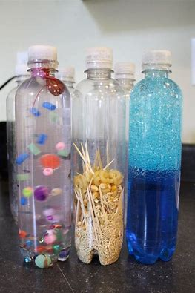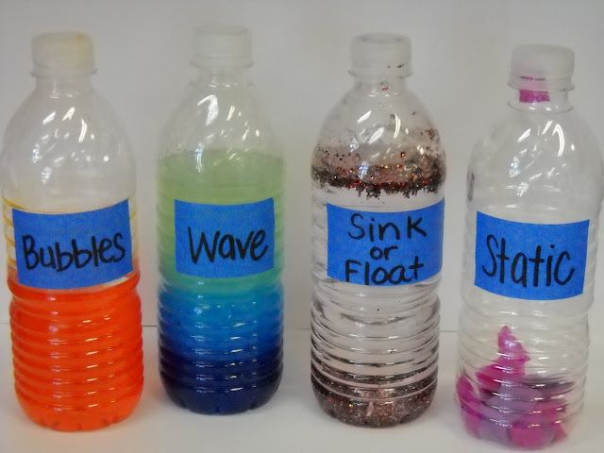
4. Songs and Rhyme bottles:
Incy Wincy plastic spiders from Halloween put a few pebbles in the bottom of the bottle.
Five little ducks: 5 small ducks, plastic greenery from aquarium and water. Have 5 more ducks to play with.
Twinkle Twinkle: fill the bottle with silver stars and water. Use small bottles so they can be lifted easily above the head.
Taken from ‘The little discovery book of Discovery Bottles’, Featherstone Education
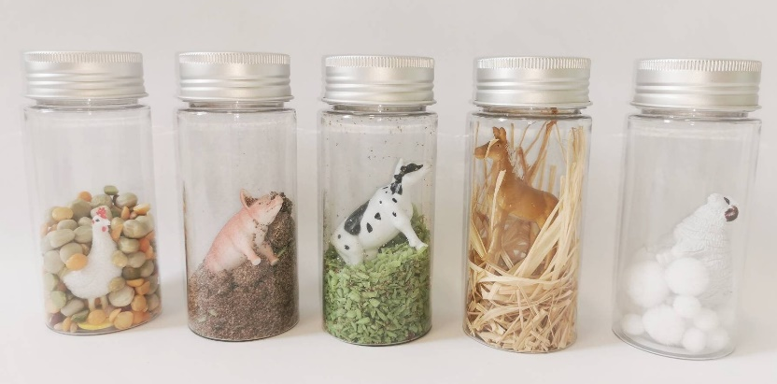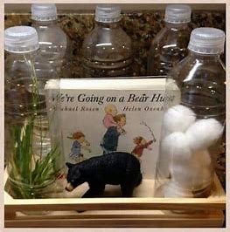
Treasure Boxes
Theme or topic, Resources, Exploring, Asking questions, Seeking, Understanding, Reflecting, Evaluating
Treasure boxes are useful for exploratory play and investigation. They are a good way of involving parents in a child’s education by getting them to collect items to contribute to treasure boxes or weekly theme. If you have families from different cultures or countries, you could ask for items familiar to those children especially when they are new to a setting.
There are four main types of treasure baskets and these can Adult led, child initiated or family treasure boxes:
The Toolbox
Collections of: spoons, forks, mixing or whisking, kitchen tools, tools with holes, shiny tools, ladles, tools that squash, shape things, press or grate, sieve or separate. Spoons from different parts of the world.
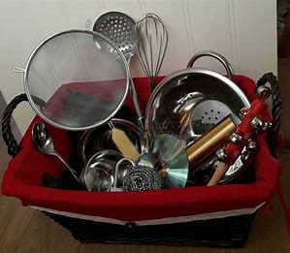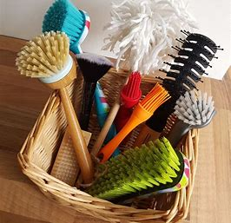
The Natural box
Collections of; leaves of different sizes, shapes or textures, pine needles, pine cones, bark, twigs, wood, fruit, those that are sweet or sour, round or not, and vegetables of different size , shape or that come from trees or out of the ground. Vegetables that can be made into soups, seeds of different size and shapes: rocks pebbles, stones, sand, soil, shells or things found on a beach, scented leaves, hairy leaves.
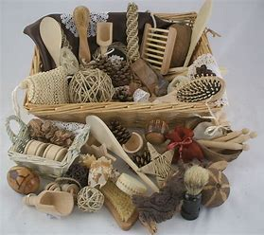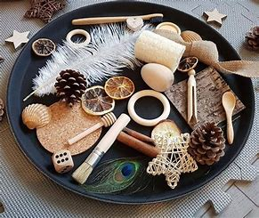

The Shoebox
Collections of shoes: shoes of different materials, colours, size, shoes for different seasons, flip-flops, sandals, wellies, boots, made of leather, rubber, wood and fabric, special shoes for dancing, sport, and working. Those with laces, buckles, slip ons, party shoes, wedding shoes, slippers. Adult shoes, baby shoes.
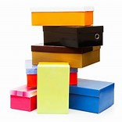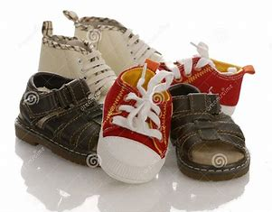
The Toy box
Collections of toys: toys that move, talk, roll, stretch, pull, from different culture or countries, toys that fly or float or make a noise, old toys new toys, toys with wheels, cars , dolls, furry toys, balloons, squirty toys, toys that roll. Toys for one child or toys that need more than one. Music boxes. Toys that shake or rattle. Sensory toys.
(Taken from ‘The little discovery book of Treasure Boxes’, Featherstone Education)
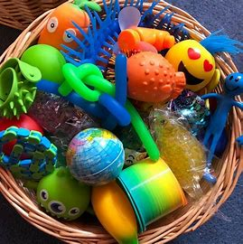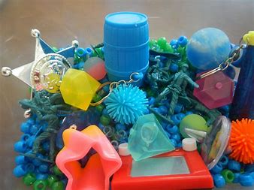
SEN Boxes
All of the above may be suitable for children with SEND but you could also consider having a collection of sensory boxes specifically for individual children. Choose toys, objects that the child likes, and is motivated to find.
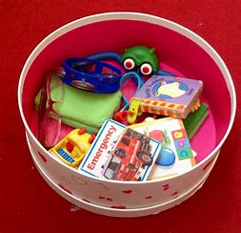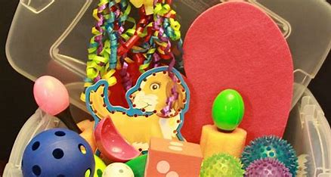
Sensory Boxes : flashing balls, Balls with bells, chewy chews or toys that can be chewed, bubbles, musical toys, ready steady go toys, , textured toys, toys with bells, cause and effect toys, balls of various shapes, textures and sizes that are easy to hold, feathers, scarves, pipe cleaners, ribbons, shiny materials, brushes, lollipop drums and fiddle toys.
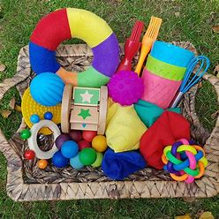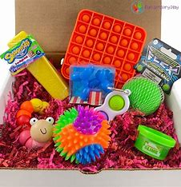
Curiosity Approach Collections
