Let's Brush our Teeth  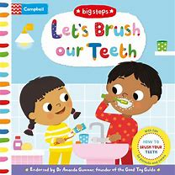 | The Big Steps series is designed to help little ones cope with everyday experiences and important milestones. In Let's Brush Our Teeth, meet two cousins as they learn all about how to best brush their teeth!  Follow the ups and downs of their journey, brought to life with fun flaps and mechanisms. Each page has helpful tips for parents and carers that are endorsed by The Good Toy Guide and leading Early Years Consultant, Dr Amanda Gummer. With delightful illustrations from Marie Kyprianou, Let's Brush Our Teeth is a brilliant first toothbrushing book, introducing it in a fun and relatable way.
A Rhyming Children's Hygiene Book | How to Brush Your Teeth  "...And if you don't want  your breath to smell  don't forget your tongue!  Try to brush it well.  Brush your tongue back and forth,  and brush it up and down,  and brush it in circles  going round and round."  This charming picture book teaches young children how to properly brush their teeth! It guides them through 5 rules to achieve a clean smile. Perfect for parents who struggle to get their kids to brush, this book shows little ones that dental hygiene can be fun. | Boys and Girls Brushing Your Teeth Is Fun  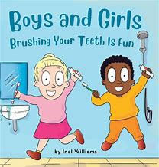
How to brush your teeth with snappy croc  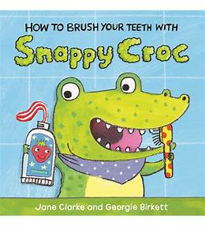  Author: Jane Clarke Illustrator: Georgie Birkett  Publisher: Red Fox (Penguin Random House) | How to Brush Your Teeth with Snappy Croc  Snappy Croc has been munching and crunching all day, so now it's time for her to brush her teeth. But she's not so sure about having to do that... Can you help her?  The little girl in this delightful board book takes Snappy Croc through each teeth-cleaning step: from squeezing out the toothpaste to brushing round and round, and showing off her sparkling smile at the end.  The two characters look like they're having a lot of fun sharing this task. Written in very simple language, but with a subtle rhythm and rhyme, this is a lovely read-aloud story that will undoubtedly encourage clean and shiny teeth.
Why Should I Brush My Teeth? (Very First Lift-the-... by Katie Daynes Board book  Why don't animals have toothbrushes? And why do baby teeth fall out? Should everyone brush their teeth? Curious young children can discover the answers to these questions and many more in this entertaining book, with over 30 flaps to lift, gentle humour and easy-to-understand text on every page. | 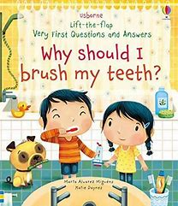
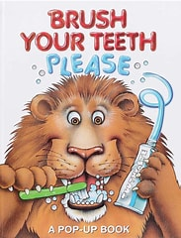 | Brush Your Teeth, Please: A Pop-up Book (Volume 2)  Pidgeon, JeanWhat child can resist imitating a chimp brushing its teeth back and forth? Or a shark that flosses everyday? Youngsters will have lots of fun learning about proper dental hygiene is this delightful pop-up book.
Brush Your Teeth Everyday  A Children Book About Oral Hygiene: Brush Your Teeth Daily  While reading this story your child will learn;  1. The importance of brushing their teeth.  2. What could happen if they don't brush their teeth?  3. How many times should they brush their teeth a day? | 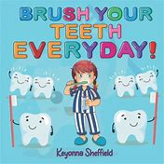
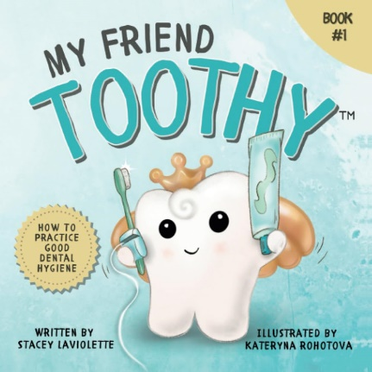 | My Friend Toothy: How to Practice Good Dental Hygiene  My Friend Toothy is more than just a children's storybook – it's your secret weapon for cultivating a lifetime of healthy smiles.  Join Toothy on an exciting journey to discover the magic of dental care. Say goodbye to dental visit anxiety as Toothy makes it an exciting experience. Start building impeccable oral habits from an early age.  Familiarize your child with brushing, flossing, and dental visits through engaging visuals.  Unique Tooth Tracker: Record the arrival and loss of baby teeth, creating a cherished keepsake of your child's growth.
Brushing teeth isn’t always a fun topic for children. But books are an excellent way to learn and make brushing more fun. The following books are a great way to encourage reading and get children comfortable with their mouths and brushing.  Ages 0-2 Brush, Brush, Brush by Alicia Padron  Ages 2-4 Brush Your Teeth, Please by Leslie McGuire and Sesame Street – Ready, Set, Brush  (Both of these are pop up books with great diagrams)  Ages 4-6 Sugarbug Doug: All About Cavities, Plaque, and Teeth by Dr. Ben Magleby | Brush your teeth  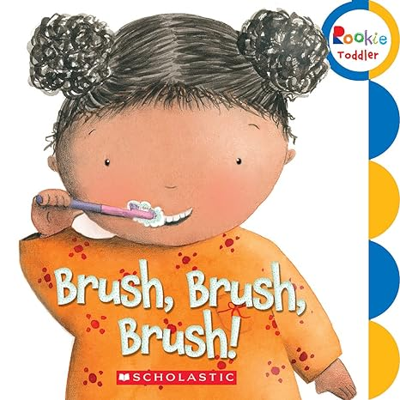
We're Going to the Dentist: Going for a Check-up  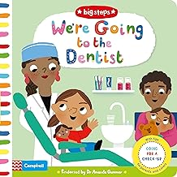 | In We're Going to the Dentist, meet Nancy and Teddy, who go for a dental check-up for the first time.  Explore the waiting room, sit in the dentist's chair and learn about how to brush your teeth in this sweet story, brought to life with fun flaps and mechanisms. Each page has really helpful tips for parents and carers that are endorsed by The Good Play Guide and leading Early Years Consultant, Dr Amanda Gummer. With delightful illustrations from Marion Cocklico, We're Going to the Dentist is a brilliant way to prepare children for a dental check-up in a fun and relatable way
An alligator who snaps, becomes an alligator who th-naps in this hilarious, heart-warming story of making new friends and discovering who you really are.  Meet Alan, an alligator with a secret. Famed for his big, scary teeth, he sneaks into the jungle every day to scare the jungle animals ... “I’m big, scary Alan! Fear my razor-sharp teeth!” But after a long day of scaring, Alan likes nothing better than to run a warm mud bath and take out his false teeth, which nobody knows about! That is, until his teeth go missing. What will Alan do now? Scaring is the only thing he knows how to do! Can he still be scary without them? A goofy comedy of self-discovery, witty, warm-hearted storytelling and bright graphic art will make this (and Alan!) a firm children’s book favourite. | Alan's Big, Scary Teeth by Jarvis (Author, Illustrator)  