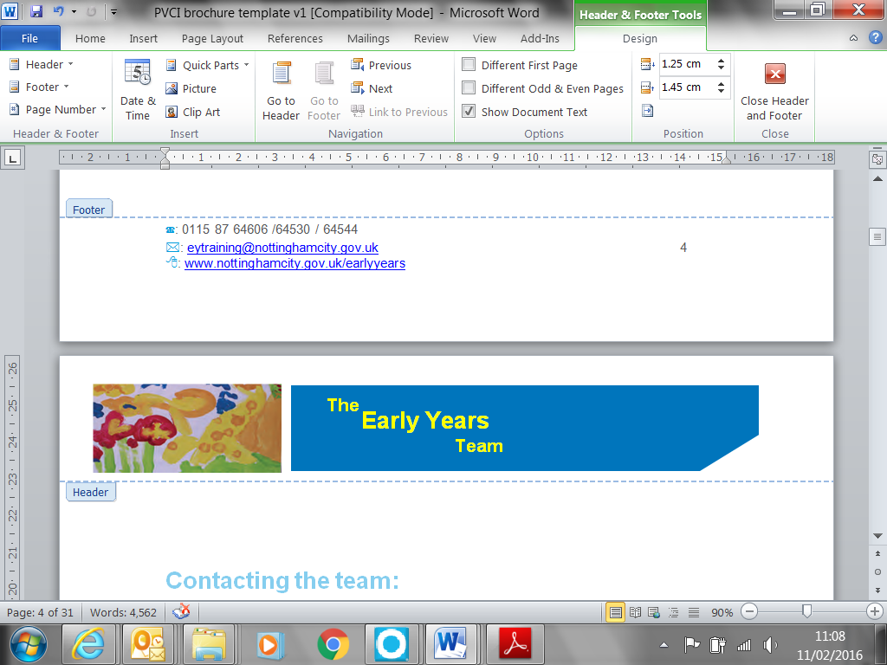





**Preparing for your Ofsted Inspection: Information pack**

Reviewed August 2024

**Put together by:**

**Nottingham City Early Years**

**EYFS Support Workers**

This pack of documents has been put together to support Childminders to prepare for their Ofsted inspection.

It is not exhaustive; it is a reference to guidance and materials linked to the Early Years Foundation Stage with the Nottingham City Agendas.

Information can also be found on the Early Years Website <https://www.nottinghamcity.gov.uk/earlyyears>

|  |  |
| --- | --- |
| **Document and electronic link** | Date& sign when done |
| **Early Years Foundation Stage**  Statutory Framework for Early Years Foundation Stage 2021  <https://www.gov.uk/government/publications/early-years-foundation-stage-framework--2>  The current statutory framework for all Ofsted registered Early Years provision  Development Matters  Non-statutory curriculum guidance for the early years foundation stage  <https://www.gov.uk/government/publications/development-matters--2>  Birth to Five Maters  Non-statutory curriculum guidance for the early years foundation stage  <https://www.birthto5matters.org.uk/> |  |
| **Continuing Professional Development (training)**  Recent inspections have highlighted Ofsted’s expectations around CPD (training). To get or keep a Good inspection grade Ofsted inspectors expect to see evidence of continuing training over and above the statutory safeguarding children and paediatric first aid.  Information about training offered through the Nottingham City Early Years Team can be found on the early Years website at <https://www.nottinghamcity.gov.uk/earlyyears/section-pages/cpd-training/cpd-opportunities-20242025/>    PACEY <https://www.pacey.org.uk/> , Childcare.co.uk <https://www.childcare.co.uk/> and Moreton Michel <https://www.mortonmichel.com/> also offer training, some of it free, to their members  The Home Office have free online training including Prevent Duty <https://www.elearning.prevent.homeoffice.gov.uk/screen3> , Female Genital Mutilation (FGM) <https://www.fgmelearning.co.uk/> and Awareness of Forced Marriage <https://www.virtual-college.co.uk/resources/free-courses/awareness-of-forced-marriage>  The Food Standards Agency (FSA) have free online training and resources around allergens <https://www.food.gov.uk/business-guidance/online-food-safety-training> |  |
| **Teaching and Learning**  Do childminded Children’s learning journals/development folders show   * a baseline assessment of their development as they started in your care * a progress check completed between the child’s second and third birthday, have you shared this progress check with parent/carers and sent a copy to the child’s health visitor * are you aware of where children are developmentally, their next steps and confidently share this verbally with parents and outside agencies including Ofsted inspectors |  |
| **Safeguarding and welfare requirement audit**  This audit can support you to check what you have in place and anything that you may need to review.  PACEY and Morton Michel have updated policies available to their members.  A copy of a safeguarding and welfare requirement audit is sent with this information pack |  |
| **Early Years Inspection Handbook**  This online only document can be found at <https://www.gov.uk/government/publications/early-years-inspection-handbook-eif/early-years-inspection-handbook-for-ofsted-registered-provision-for-september-2021> Part 1 of the document has information about Ofsted’s inspection process.  Part 2, the evaluation schedule, starts at paragraph 167, and gives a clear list of what the Ofsted inspector will look for and the evidence they need to see for each section of the inspection and each grade awarded |  |
| **Evidence of reflective practice (self-evaluation)**  There is a legal requirement to show evidence of reflective practice. Ofsted have withdrawn the Self Evaluation Form (SEF form) from their website, you could choose to update an existing SEF adding the date and your signature to any new information or use a different way of recording this evidence.  A sample evidence of reflective practice form is sent with this information pack. This sample form includes the 4 areas of inspection and space for planned priorities for improvement |  |
| **Ofsted information, education inspection framework and trends** Information in the recent trends document gives a picture of common themes from recent Ofsted inspections  <https://www.nottinghamcity.gov.uk/earlyyears/section-pages/the-early-years-foundation-stage-statutory-framework-and-quality-improvement/ofsted/> |  |
| **Useful Web links for Safeguarding Children and Families linked to Nottingham City Safeguarding Children Partnership.** <http://www.nottinghamcity.gov.uk/ncscb> |  |
| **Early Years Funding (9 month – 23 month,2,3 and 4 year olds)** If you are interested in finding out more about delivering funded places for 9 months – 23 months, 2, 3 and 4 years old please see the information on the funding page of the Early Years <https://www.nottinghamcity.gov.uk/earlyyears/section-pages/early-years-funding/> |  |
| **Provider Support Framework for the Early Years (PSF)**  This is the support offered to any Ofsted registered Early Years setting in receipt of Early Years Funding  <https://www.nottinghamcity.gov.uk/earlyyears/section-pages/the-early-years-foundation-stage-statutory-framework-and-quality-improvement/provider-support-framework/> |  |
| **SEND Equality and inclusion** Information to support childcare providers working with children with SEND including information about specialised training and support strategies/tools  <https://www.nottinghamcity.gov.uk/earlyyears/section-pages/equality-and-inclusion/> |  |
| **Ask Lion**  Find out about activities and support in Nottingham with **the** Ask Lion **directory**. You can also update your setting details on view  <https://www.asklion.co.uk/kb5/nottingham/directory/home.page> |  |
| **Disclosure and Baring Service (DBS) checks**  Anyone who lives or works with a childminder should have a DBS check in place, for more information about who needs a background check and how to access them please see the online guidance <https://www.gov.uk/guidance/get-a-background-check-if-you-live-or-work-with-a-childminder> |  |

Working Together to safeguard children 2023 -

[Working together to safeguard children 2023: statutory guidance (publishing.service.gov.uk)](https://assets.publishing.service.gov.uk/media/65803fe31c0c2a000d18cf40/Working_together_to_safeguard_children_2023_-_statutory_guidance.pdf)

Website link – Pre inspection support –

[Early Years - Nottingham City Council](https://www.nottinghamcity.gov.uk/earlyyears/section-pages/the-early-years-foundation-stage-statutory-framework-and-quality-improvement/pre-ofsted-inspection-support-and-safeguarding-welfare-requirements-tool-kit/)