Books on Autism, Asperger’s and ADHD for professionals
Behaviour Solutions for the Inclusive Classroom  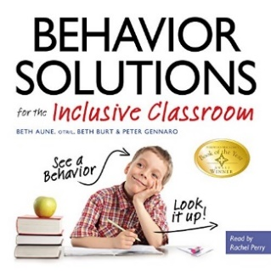  by Beth Aune, Beth Burt, et al. | A Handy Reference Guide That Explains Behaviours Associated with Autism, Asperger's, ADHD, Sensory Processing Disorder. Why won't he stay in his seat? Why does she flap her hands? And what should I do? As inclusion becomes the norm in general education, teachers are faced with behaviours they have never seen before. Special needs educators may recognize the tell tale symptom of a sensory need or a textbook-case of an avoidance behaviour, but this is all new territory for the general crowd! Written by Director of Special Education Peter Gennaro, occupational therapist Beth Aune, and special needs mum and advocate Beth Burt, this book illuminates possible causes of those mysterious behaviours, and more importantly, provides solutions! Teachers can quickly look up an in-the-moment solution and learn about what the child is communicating, and why.
The Reason I Jump  You have never read a book like The Reason I Jump. Written by Naoki Higashida, a very smart, very self-aware, and very charming thirteen-year-old boy with autism, a one-of-a-kind memoir demonstrates how an autistic mind thinks, feels, perceives, and responds in ways few of us can imagine. Parents and family members who never thought they could get inside the head of their autistic loved one at last have a way to break through to the curious, subtle, and complex life within.  Naoki answers even the most delicate questions that people want to know. Questions such as: “Why do people with autism talk so loudly and weirdly?” “Why do you line up your toy cars and blocks?” “Why don’t you make eye contact when you’re talking?” and “What’s the reason you jump?” (Naoki’s answer: “When I’m jumping, it’s as if my feelings are going upward to the sky.”) | The Inner Voice of a Thirteen-Year-Old Boy with Autism  by Naoki Higashida, K.A. Yoshida and David Mitchell (Translators)
Autism and Solution-focused Practice Paperback – Illustrated, 21 Jun. 2017  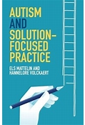  by Els Mattelin and Hannelore Volckaert (Author) | Solution-focused practice is founded on a firm belief that the full potential of every human being can be realized. This concise, pragmatic guide explains how the practice can be effectively adapted to help clients on the autism spectrum find solutions to their problems, by addressing autism not as a disability but as a different way of thinking. The first section is a helpful introduction to how solution-focused practitioners can gain an understanding of autism by viewing it from a 'different culture' perspective; the second part offers handy rules and tips for applying knowledge respectfully and creating successful conversations with clients.
Autism and Managing Anxiety:  This easy-to-use resource is a compilation of theoretical background and concrete approaches designed to increase understanding and outline strategies to support autistic children and young people who experience anxiety in the school environment. This resource also has practical application for parents, carers and professionals across a range of educational and community-based settings.  Using real life examples and case studies, the book explains and explores the different forms of anxiety and their impact across the school environment. Each chapter offers practical information and strategies that may help reduce the negative symptoms of anxiety and help support emotional resilience across home and school environments. | Practical Strategies for Working with Children and Young People  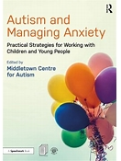  by Middletown Centre for Autism (Editor)
A Multi-Disciplinary Perspective (Understanding and Treating in Autism)  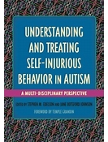  Foreword by Temple Grandin Stephen M. Edelson and Jane Botsford Johnson (Editor) | Understanding and Treating Self-Injurious Behaviour in Autism  A complete guide to understanding and treating self-injury in autism (ASD). With contributions by top experts, the book explains various causes and forms of self-injury, discusses the treatment options available, including medical, psychiatric and nutritional treatments, and considers the effectiveness of multidisciplinary approaches.
Secrets to Success for Professionals in the Autism Field Gunilla Gerland's extensive personal and professional experience of the autism spectrum means she is expertly placed to offer a fresh perspective on working with autism as well as a wealth of effective tools and interventions to use in practice. In a highly readable style, with many inspiring examples, this book offers original explanations of the impairments associated with autism, showing how to discover the root cause of behaviours that are challenging, not just how to manage them superficially. It looks objectively and non-judgementally at the common pitfalls and difficulties that autism professionals may encounter, explaining how to deal with these and transition to more effective working relationships. An important section on ethics and reflection equips the reader with the knowledge and skills needed to grow professionally in the field. Packed with original insights and practical, hands-on tools and strategies, this is essential reading for teachers, teaching assistants, support workers, counsellors, social workers and anyone else working with individuals of any age on the autism spectrum | An Insider's Guide to Understanding the Autism Spectrum, the Environment and Your Role  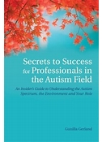  by Gunilla Gerland (Author)
Autism: A New Introduction to Psychological Theory and Current Debate  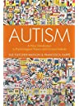  by Sue Fletcher-Watson (Author), Francesca Happé (Author) | The authors summarise what is known about the biology and behavioural features of autism, and provide concise but comprehensive accounts of all influential psychological models including ‘Theory of Mind’ (ToM) models, early social development models and alternative information processing models such as ‘weak central coherence’ theory. The book also discusses more recent attempts to understand autism, including the ‘Double Empathy Problem’ and Bayesian theories. In each case, the authors describe the theory, review the evidence and provide critical analysis of its value and impact. Recognising the multiplicity of theoretical views, and rapidly changing nature of autism research, each chapter considers current debates and major questions that remain for the future.
All Cats Have Asperger Syndrome  This book takes a playful look at Asperger Syndrome (AS), drawing inspiration from the feline world in a way that will strike a chord with all those who are familiar with Asperger.  Delightful colour photographs of cats bring to life familiar characteristics such as sensitive hearing, scampering at the first sign of being stroked, and particular eating habits.  Touching, humorous and insightful, this book evokes the difficulties and joys of raising a child who is different and leaves the reader with a sense of the dignity, individuality, and potential of people with Asperger. This engaging book is an ideal, gentle introduction to the world of Asperger. | By Kathy Hoopmann Author
by Kathy Hoopmann | All Dogs Have ADHD  All Dogs Have ADHD takes an inspiring and affectionate look at Attention Deficit Hyperactivity Disorder (ADHD), using images and ideas from the canine world to explore a variety of traits that will be instantly recognisable to those who are familiar with ADHD.
Can I tell you about Autism? Meet Tom - a young boy with autism. Tom invites readers to learn about autism from his perspective, helping them to understand what it is and explaining the challenges he faces with issues such as social communication, sensory overload and changes in his routine. Tom tells readers about all the ways he can be helped and supported by those around him. This illustrated book is ideally suited for readers aged 7 and upwards, and will be an excellent way to increase understanding about autism, in the classroom or at home. It also includes clear, useful information for parents and professionals. 13 black & white illustrations | A guide for friends, family and professionals  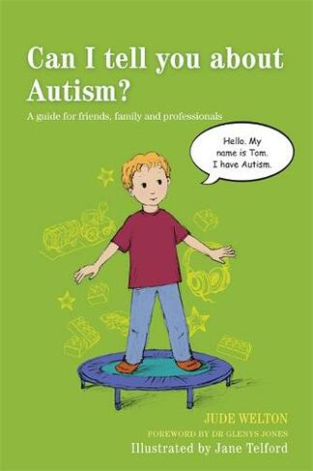  Authors Jane Telford (Illustrator) Jude Welton (Author) Glenys Jones (Contributor):
A guide for friends and family (Can I tell you about...?)  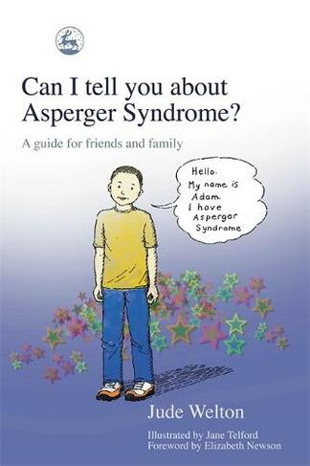  Jude Welton (Author) Jane Telford (Illustrator) Elizabeth Newson (Contributor) | Can I tell you about Asperger Syndrome?:  Meet Adam - a young boy with AS. Adam invites young readers to learn about AS from his perspective. He helps children understand the difficulties faced by a child with AS - he tells them what AS is, what it feels like to have AS and how they can help children with AS by understanding their differences and appreciating their many talents. This illustrated book is ideally suited for boys and girls between 7 and 15 years old and also serves as an excellent starting point for family and classroom discussions.

