

Executive Board – 21 October 2025

Subject: | Draft Budget and Medium-Term Financial Plan 2026/27
Executive Member(s): | Cllr Ethan Radford, Exec Member for Finance & Resources
Corporate  Director(s)/Director(s): | Stuart Fair, Corporate Director for Finance & Resources, Section 151 Officer
Summary of issues:

This is the draft Budget and Medium-Term Financial Plan for 2026/27. It is being presented to be released for consultation from 21st October 2025 to 2nd December 2025. The final report will go to full Council on 25th February 2025 and final figures will not be known till we have the December local government financial settlement and the September CPI numbers. As such, it is subject to change.

As currently constituted, the 2026/27 Budget formulation and associated MTFP position illustrates a positive pathway towards a fully balanced budget being achieved and prepares a foundation for stability over the course of the MTFP with opportunity to take out any future structural deficit and allow, where possible additional investment opportunities and will improve service delivery outcomes.

As with any financial strategy exercise, there is an appreciation of risks and contingency required for unknown events. The Budget formulation process is underpinned with robust assumptions and requires an appreciation of the ability to absorb a wide range of possible outcomes that will affect the actual financial performance of the Council. This latest position represents a detailed approach to the incorporation of the most reliable and up-to-date information and assumptions.

As Section 151 Officer it is my considered opinion that the latest modelling represented in this report constitutes a robust financial budget setting position, upon which members can reliably use to fully inform required budget decisions.

Recommendation(s):
1 Recommend that the Executive Board approve the attached proposals and methodology to be consulted on the Draft Budget from 21st October 2025 to 2nd December 2025 as detailed in Appendix 5.
2 To note the provisional council taxbase of 72,244 Band D equivalents and the continued assumption of a maximum increase of 4.99% for 2026/27. For Nottingham City Council, the Band D equivalent (for the Council’s share of the bill would be £2,375.80, which would represent an increase of £112.92.

3 To note the CPI +1 % increase for social Housing rents, which is statutorily set on September inflation data but is provisionally based on July data 4.8% or an average of £97.12 per social housing dwelling in the Housing Revenue Account.
4 To consider the proposed Medium Term Financial Strategy (MTFS) and Medium Term Financial Plan (MTFP) that will be agreed in February as part of the budget setting process.

- To note the Fees and Charges rises being open to consultation (Appendix 6) and that the majority of fees and charges will either increase by inflation or in line with cost recovery except in a rare number of instances as noted in paragraph 6.16.

- To agree to write out past year savings as detailed in Appendix 1.

- To note the proposed investment proposals in Appendix 3

Relevant Council Plan Core Mission: 1. 2. 3.

1. A Renewed Council 2. Delivering for local 3. Leading Nottingham people forward
- Fostering governance • Empowering safe • Revitalising the transparency and communities economy
innovation • Providing safe, • Celebrating cultural
- Financial stewardship affordable housing heritage
- Adopting a ‘One • Healthy and safe • Improving
Council’ approach residents infrastructure and
- Enhancing education connectivity and skills • Championing
sustainability
If a Key Decision, state the reason:
- Expenditure Income Savings of £750,000 or more taking account of the
overall impact of the decision
- Significant impact on communities living or working in two or more wards in the City Does this report contain any information that is exempt from publication?
No

1. Reasons for Recommendations

1.1 This report is the draft Medium Term Finance Plan (MTFP) for Nottingham City Council and represents the future financial trajectory of the authority as it seeks to end the use of Exceptional Financial Support (EFS) to the budget. EFS is the use of capital resources (or borrowing) to fund revenue and is only allowable with Government agreement.
1.2 This paper contains the additional savings proposals developed by officers for 2026/27 to 2029/30. Tight financial management led to 85% delivery of savings in 2024/25. However, a larger proportion of 2025/26 savings have experienced delays and with need to move away from any dependency on exceptional financial support there is a greater need to focus on the delivery of savings and existing transformational activity rather than on starting new difficult savings initiatives.
1.3 The new savings are largely efficiency savings not policy decisions except for the Council Tax increase, dwelling rent increases and the fee and charges changes and as such, they do not have to be put out to public consultation. Nonetheless, the council believes in the importance of transparency and intends to consult publicly on the principles behind the budget and the investment opportunities for the authority.
1.4 The overarching objective of our budget strategy is to ensure that the Council sets a sustainable and realistic budget over the medium term supported by robust savings delivery plans and without the need for additional government support in the form of EFS. However, it must be recognised that the Council still faces significant financial headwinds from social care. Moreover, there is some uncertainty around Fair Funding 2.0, which was about ensuring all councils have a fair share of resources to deliver statutory services.
1.5 As the Council seeks not only to balance its budget without EFS and the resources to invest in growth and community improvements that residents want, it needs to transform the way it delivers services and do some things differently. Ultimately, it is about achieving best value (reducing our comparator unit costs), that we can release resources to invest into those things our residents tell us are important to them.
1.6 In this context this report sets out the Draft General Fund Medium Term Financial Plan with the decisions upon which the council is consulting. Capital, Treasury and the Housing Revenue Account papers will be produced separately. The final Budget will include an integrated package of documentation and will be submitted to full council in February.

2. Background

2.1 Whilst the council set a balanced budget in 2024/25 using £41m of EFS, it only needed £7.7m. The 2025/26, this budget was set with a requirement of £20.8m of EFS. In 2026/27, the intent is to extinguish the dependency on EFS entirely and the table below demonstrates the savings requirement that must be satisfied before the inevitable pressures and funding changes.

Table 1: Reduction in Base Budget due to removing EFS
£m
Current 2025/26 Net Revenue Budget 352.593
Removing EFS (20.793)
Net Revenue Budget without EFS 331.800

2.2 There is still a savings delivery risk in the existing budget as some of the savings plans put forward in prior years were not as robust as they should have been. As a matter of principle, where a saving has been put forward by a service, but subsequently turns out to be non-deliverable, then the requirement is that they will identify an alternative measure. Some services have traditionally used ongoing known underspends to offset savings and part of this year’s strategy is to ensure that these underspends are captured as permanent reductions in net expenditure. This is both important for transparency and for ensuring that all services deliver value for council taxpayer money.
2.3 Due to the timing of the financial settlement taking place in December, alternative savings will be explored should the macro-economic situation require a material change in resource allocations. However, if these further potential options were not needed as expected, they could form part of the basis for future year savings or to free up revenue resources for other purposes.

Implications of Section 114 Notice

2.4 There is a natural tendency to focus solely on the use of EFS when a Section 114 notice is served but it has wider considerations. Moreover, this council has welcomed the input of the commissioners and notes the cooperative relationship established to support the improvement journey. It is not just the move to monthly monitoring and a more rigorous budgetary process, but a deeper analysis on service performance that has supported the council in understanding where it can achieve greater value for money. A culture of financial management and budget holder accountability is being gradually embedded across the authority as it transitions to internally generated continual improvement. Further work is needed on this.
2.5 NCC has also benefitted from the opportunity afforded by having local government leading experts challenge internal practices and processes to help identify opportunities for further efficiencies and improved service. NCC is working towards a fully balanced budget for 2026/27 and a consolidation of an already sustainable reserve position.
2.6 Therefore, NCC is now concentrating on ensuring it is financially stable on an ongoing basis. This requires both a mature reflection of its challenges and opportunities and the development of continuous improvement plans and regular progress reviews.

Economic Context

2.7 Both the global economy and the UK economy are relatively weak. Combined with August inflation running at 3.8%, the UK fiscal position is challenging. The Office of Budget Responsibility has informed the Chancellor that it will downgrade its productivity numbers. For every 0.1% reduction in UK productivity, this would increase the fiscal gap by approximately £9 billion.
2.8 As long as the current UK fiscal rules are in place, this means the Chancellor would need to put forward tax rises or expenditure cuts to fill the gap. A 0.4% reduction in productivity would create a £36 billion gap. It is not clear that the Government will be able to deliver this entirely from changes to tax unless it abandons its manifesto commitment to not raise the three largest taxes that affect working people. It is therefore possible that there will be additional saving requirements across Government departments.
2.9 The graph below indicates the level of volatility in all forecasts, as inflation has been volatile after a long period of extremely low levels. These affect our contractual commitments putting pressure on revenue budgets. Equally, the Bank of England interest rates reached 5.25% for the 1st time since 2008 and has reduced to 4%.

Table 2: CPI Inflation (blue) versus Bank of England MPC Interest Rates (red)
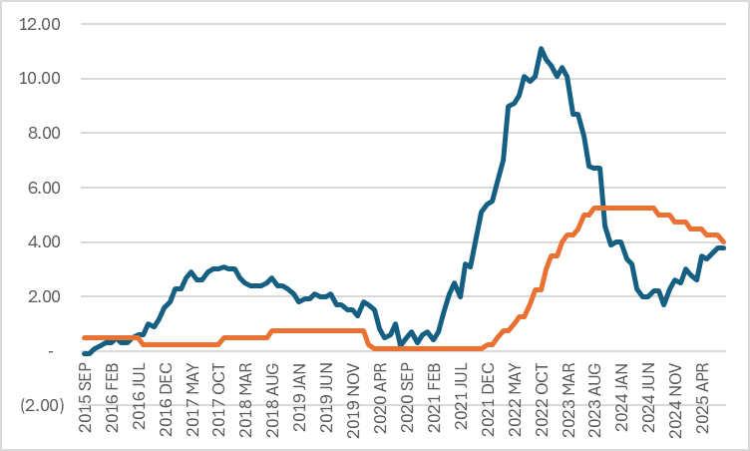

Local Government Outlook & Challenges

2.10 The spending review saw the Government develop a funding envelope that would increase direct grant funding of £2.348bn between 2025/26 and 2028/29 into local government. It is important to recognise that the majority of growth in the £9.894bn core spending power change is from the assumptions that Council Tax will grow at the maximum level possible as expected by MHCLG.

Table 3: Projected Local Government Core Spending Power (£m)
Cumulative
Funding Source | 2025/26 2026/27 2027/28 | 2028/29 Change
Council Tax | 38,312 40,678 43,190 | 45,858 7,546
Grant Funding  Core Spending | 31,094 32,522 32,910 | 33,442 2,348
Power (CSP) | 69,406 73,200 76,100 | 79,300 9,894
% CSP Increase
from Council Tax | 62% 87% 83% 76%

2.11 Local government has seen Section 114s across the country but also a gradual deterioration of reserves. From this perspective, Nottingham City Council, despite being in external intervention, seems better placed than many of its core city comparators with its General Fund reserves growing from £220m as of 31st March 2024 to £256m as of 31st March 2025 as per the draft Accounts. While much of these resources have restrictions around use, this reflects an overall resilience that most councils lack. Nottingham’s deficit in 2024/25 was also the third lowest in core cities, even discounting for EFS, evidencing a gradual but sustained turnaround in its financial management.

Local Government Reorganisation

2.12 Under the Local Government and Public Involvement in Health Act 2007, the UK Government formally invited council in two-tier areas and small neighbouring unitary authorities to submit proposals for reorganisation into unitary authorities. A number of proposals are being developed by the councils within Nottinghamshire and are due for submission 28th November for consideration by Government.
2.13 Despite the upfront costs and administrative complexity of breaking up, merging and creating new local government bodies, there are significant potential opportunities to exploit for the benefit of local residents. Economies of scale, closer reflection of the city boundaries to the economic and social footprint of the city will enable services to be delivered more efficiently and effectively.
2.14 The challenges to the MTFP from Local Government Reorganisation (LGR) are three-fold:
- Producing the original business case for the model. This is partially supported by a limited amount of support from Central Government. Nonetheless, the resource requirement is being managed within existing budgets and by officers supporting this on top of their existing workloads.
- Activities required to be ready to go live on Vesting Day. While some services will merge by May 2027, the majority will not. For the new legal entity to come into being, there are a number of legal, financial and electoral requirements. Costs will likely be in the low millions of pounds for these activities.
- Development and embedding of the new operating models. In practice, some services due to contract provisions may take several years post Vesting Day to be finalised. This is from where the majority of costs and savings will come.
2.15 LGR costs will be funded from reserves and within existing budgets where possible. Once, detailed estimates are known, the MTFP will be updated accordingly.

3. Fair Funding 2.0

3.1 The Council continues to face significant future year budget pressures and uncertainty. The Spending Review was tight but the promised reallocation of resources under Fair Funding 2.0 benefits core cities. Nonetheless, the final results will only be known in the local government financial settlement, which, with the delay to the November Budget, is only expected to be released in December. It is also expected that a multi year settlement based on the revised allocations will provide some valued certainty for financial strategy setting.
3.2 In considering the MTFP, the council has taken a prudent approach in compiling the estimates and has not incorporated the full estimated benefit of Fairer Funding into the base budget to reflect the uncertainty in the national economy and potential implications for the Autumn Budget.

3.3 It is worth noting that a £1 billion reduction in the overall funding settlement for local government has approximately a £10m impact on Nottingham’s settlement position and this would be manageable for the council in the immediate term. Anything above a £2 billion reduction in the local government funding envelope would require a more fundamental reconsideration of the council’s financial options that would lead to additional savings proposals. Whilst this scenario might be possible, such a material change in Local Government funding is considered to be unlikely given the likely significance on service delivery impacts across the sector.
3.4 Table 4 below sets out the funding streams included in the estimates. It is worth noting the vast majority of the growth in the base budget relates to the consolidation of grants previously including within the services and therefore do not represent additional resources overall. These grants include Social Care Grant (£42.768m), Market Sustainability & Improvement Fund (£6.781m), Domestic Abuse Accommodation Grant (£1.132m) or £50.681m in total. This is on top of the already rolling in and ending of existing grants (such as the £11.115m Recovery Grant and the £3.877m Employer National Insurance Contributions Grant).
3.5 Below are the indicative funding changes as identified by funding experts, Pixel, specific Government detailed announcements and council tax estimates produced internally. Pixel has built these estimates based on direct conversations with MHCLG but the Council has chosen to hold back 30% of
growth besides holding £20.574m in contingencies overall due to the scale of uncertainty. Appendix 4 explores this in more detail.

Table 4: Indicative Funding Changes
 | 2025/26 | Uplift under current methodology | 2026/27 without fair funding | Fair  Funding  Changes | 2026/27  Post Fair  Funding
 | £m | £m | £m | £m | £m
NNDR | (65.710) | (1.314) | (67.024) | (2.995) | (70.019)
Top Up Grant | (38.037) | (0.761) | (38.798) | 5.398 | (33.400)
Revenue Support Grant | (32.685) | (11.769) | (44.454) | (111.550) | (156.004)
S.31 Reliefs | (30.818) | (0.616) | (31.434) | 27.168 | (4.266)
Risk Adjustment Factor  Non-Council Tax  Council Tax |  |  |  | 9.033 | 9.033
Risk Adjustment Factor  Non-Council Tax  Council Tax | (167.250) | (14.460) | (181.710) | (72.946) | (254.656)
Risk Adjustment Factor  Non-Council Tax  Council Tax | (160.805) | (1.269) | (162.074) |  | (162.074)
CTAX Increase |  | (8.088) | (8.088) |  | (8.088)
CTAX Surplus | (2.333) | 2.333 | 0.000 |  | 0.000
NNDR Deficit  Council Tax & Collection Fund  Core Funding/ Net Revenue Budget  LA Better Care Fund | (1.412) | 1.412 | 0.000 |  | 0.000
 | (164.550) | (5.612) | (170.162) | 0.000 | (170.162)
 | (331.800) | (20.072) | (351.872) | (72.946) | (424.818)
 | (20.482) |  | (20.482) |  | (20.482)
New Homes Fund | (1.148) | 1.148 | 0.000 |  | 0.000
Social Care Grant | (42.768) |  | (42.768) | 42.768 | 0.000
Market Sustainability & Improvement Fund | (6.781) |  | (6.781) | 6.781 | 0.000
Domestic Abuse Safe Accommodation Grant | (1.132) |  | (1.132) | 1.132 | 0.000
Recovery Grant | (11.115) | 11.115 | 0.000 |  | 0.000
Children’s Services Prevention Grant | (3.688) | 0.237 | (3.451) | (0.242) | (3.693)
Employer National Insurance  Contributions Grant  Other Core Spending Power Items  Total on like for like basis | (3.877) | 3.877 | 0.000 |  | 0.000
 | (90.991) | 16.377 | (74.614) | 50.439 | (24.175)
 | (422.791) | (3.695) | (426.486) | (22.507) | (448.993)

4. Budget Changes between 2025/26 and 2026/27

4.1 The waterfall model below visually explains the movement in the budget between 2025/26 and 2026/27. It moves from a structural deficit of £20.8m, which is the element of the budget funded by capital receipts through the EFS mechanism, through inflation, service growth and the writing out of service grant budgets before taking account of savings and the various funding changes to arrive at a highly provisional overall General Fund surplus.
4.2 The benefit from Fair Funding is significant but the majority of the growth in the core budget is the consolidation of funding and is presentational. The resources have changed their categorisation but over time the benefit from the flexibility over how resources are deployed in the service should lead to better localised decision making over Whitehall driven prioritisation.

Table 5: Net Revenue Budget Changes: 2025/26 to 2026/27

4.3 The next table details the various changes to the elements over the life of the Medium-Term Financial Plan.
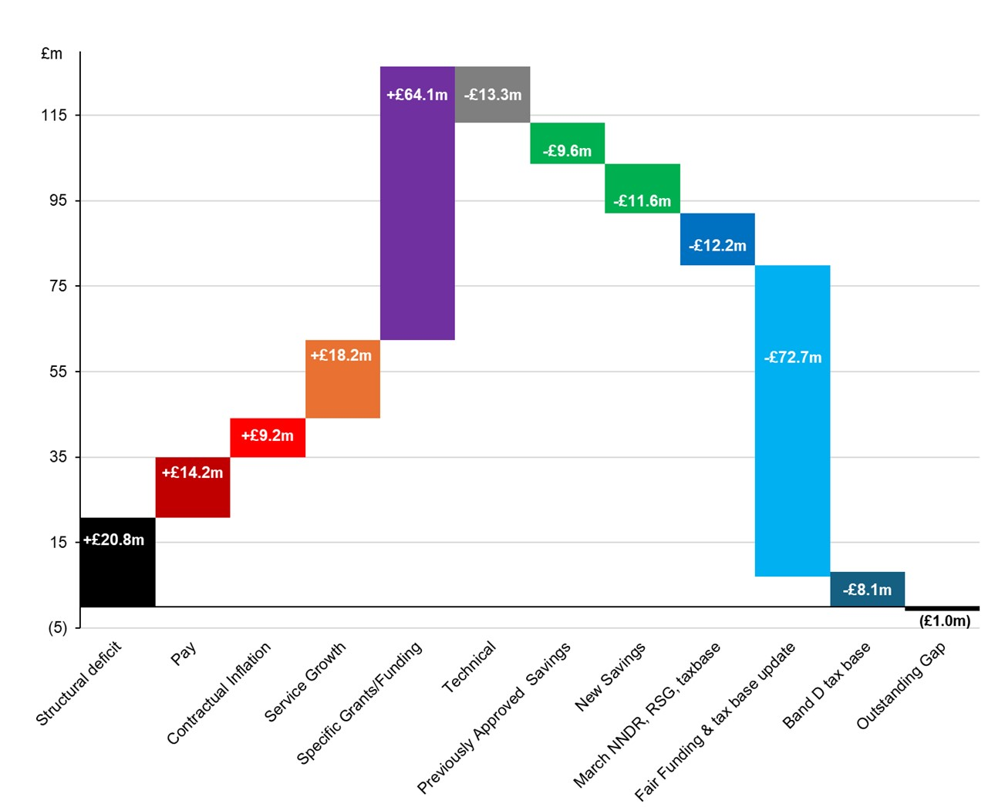

Table 6: Net Revenue Budget Changes over the MTFP 2026/27 through 2029/30
 | 2026/27 £m |  | 2027/28 £m |  | 2028/29 £m |  | 2029/30 £m
Net Budget brought forward | 352.593 |  | 423.816 |  | 441.775 |  | 462.760
Pay | 14.209 |  | 10.746 |  | 11.176 |  | 11.759
Contractual Inflation | 9.155 |  | 9.227 |  | 7.841 |  | 8.039
Service Growth | 18.235 |  | 0.749 |  | 1.938 |  | 2.525
Specific Grants/Funding | 64.121 | 0.000 |  | 0.000 |  | 0.000
Technical Adjustments | (13.286) | (0.626) |  | 0.800 |  | 0.000
Previously Agreed Savings | (9.600) | (0.670) |  | 0.105 |  | 0.000
New Savings | (11.495) | (1.468) |  | (0.876) |  | 1.700
New Fees & Charges | (0.115) | 0.000 |  | 0.000 |  | 0.000
Total: Budget Adjustments | 71.224 | 17.959 |  | 20.985 |  | 24.023
Projected Net Budget | 423.816 | 441.775 |  | 462.760 |  | 486.782
Settlement (Retained Business Rates, Top-up, S31 Grants & RSG) | (254.657) | (273.564) |  | (293.116) |  | (297.819)
Council Tax | (170.162) | (171.497) |  | (172.835) |  | (174.172)
Collection Fund | 0.000 | 0.000 |  | 0.000 |  | 0.000
Projected Core Funding | (424.819) | (445.061) |  | (465.951) |  | (471.991)
Cumulative Budget Gap | (1.002) | (3.286) |  | (3.191) |  | 14.791
Incremental Budget Gap | (1.002) | (2.284) |  | 0.095 |  | 17.982

4.4 It is important to recognise that many of the elements of growth and inflation are educated estimates. As a principle, the council does not provide for general inflation and expects directorates to manage within existing cash envelopes unless it is specifically requested and is contractually agreed. Traditionally, NCC has over-provided for pay inflation but this benefit is rolled forward into future years protecting the council taxpayer from any sudden adjustments. The existing detail is provided in Appendix 4.

5. Overarching Strategy

5.1 Until a balanced budget is set without use of EFS and the Section 151 Officer can have confidence on budget sustainability, demonstrated through multiple budget monitoring reports that the council can manage without use of reserves to balance off overspends, spend controls will remain in place. The existing budget strategy objectives remain:
- Set and deliver a balanced budget ensuring delivery of best value
- Establish financial resilience to ensure the Council’s long term financial health and viability is sound
- Establish robust and credible delivery plans
- Ensure effective early intervention and prevention across all service areas
- Maximise the transformation and change programme to redesign the Council to deliver continuous improvement which effectively manages and delivers services within existing means. (This includes being able to demonstrate that they meet best value by comparison to unit costs from comparable neighbouring authorities)
- Redefine our service offer aligned to the available financial envelope
- Ensure financial resources are effectively monitored and managed, in a high accountability environment

6. Budgetary Process & Savings Plans Development to Date
6.1 A series of directorate driven star chambers were set up throughout June on a directorate by directorate basis that brought early proposals and potential
growth bids through for internal review by political leadership, senior officers and input from commissioners.
6.2 Expectations were set by political leadership, policy proposals were challenged for their credibility and Corporate Directors were requested to return with fully worked through proposals.
6.3 During July, an early estimation of the savings gap was identified after detailed reviews of service pressures, with expert advice on future funding streams after the publishing of the consultation on Fair Funding 2.0.
6.4 August began with a review of updated savings proposals through a second round of Star Chambers, additional options and more detailed reviews of service pressures and existing savings delivery. The finalisation of these proposals have been modelled into savings options, allowing for the production of the draft Medium Term Financial Plan as the gap appears to be closed subject to the caveats around funding estimates. Nonetheless, there is work underway between October and December to ensure that the savings models have actionable delivery plans so that the savings are in delivery mode by April 1st 2026.
6.5 Even after the Draft Budget is under review, the position is subject to change and therefore, the council will consider contingency options in case the economic situation worsens and the Government considers alternative options. Moreover, with the need for continual savings to meet pressures that regularly are greater than Council Tax growth, already consideration needs to be given to 2027/28 and beyond, especially with the timing of Local Government Reorganisation, leading to less capacity during the merger period.

Budgetary Consultation

6.6 The council has a robust approach to consultation, which it presented at Corporate Scrutiny Committee on 24th September 2025 and this is explored in more detail in Appendix 5.

Approach to 2026/27 Budget

6.7 While the overriding strategy for the 2026/27 budget process is to extinguish the need for EFS, the council must also look to the future when it needs to stand on its own capabilities without the support of commissioners and that extra degree of challenge from which it currently benefits. Over 2025/26, the strategy is to demonstrate that it can be sustainable not just in setting a fully balanced budget but in how it can reinvest in the future while operating in very challenging financial environment.
6.8 Overall, the 2026/27 savings are more modest than those in 2025/26 approach, as it was deemed more important to stabilise the council’s finances by delivering on the existing savings. It is important to recognise that there are potential risks to the current year budget as £11.2m of the expected savings have slipped and are now expected to be delivered in 2026/27. In addition, it is necessary to write off £1.6m of Adult Social Care savings as these are undeliverable. Details are set out in Appendix 1.
6.9 Between £11.4m of new 2026/27 savings and £10.1m previously approved 2026/27 savings, there should be sufficient savings to balance the budget subject to the caveats that:
- Fair Funding 2.0 is broadly at the level that is expected
- Existing savings are delivered and
- The risk from the Integrated Care Board’s (ICB) reduction for care packages and joint placements does not significantly increase
  - These are significant challenges but that is why the Council has healthy contingencies to manage the level of risk. Using the latest P4 savings position, adjusting for savings anticipated to be written out, reviewing the saving tracker for deliverability, and reviewing existing and new 2026/27 savings, it was identified that a minimum £11.5m contingency was required. This is explored in more detail in appendix 4. The continuation of the £15m contingency is therefore considered to be prudent in light of risks and uncertainties already highlighted above.
  - It is important to appreciate that contingencies are not created to offset savings; rather they are to manage the risk from savings delays or non-delivery, while alternative measures are developed.
  - There are three strands of the current budget:
Delivering on the current savings and Budget Housekeeping

  - The council has £21.5m of 2026/27 savings (planned and already approved) and £10.5m of 2025/26 delayed savings to be delivered in 2029/30. By delivering on the relatively straight forward savings proposals, the council should achieve a balanced budget without EFS. By not using reserves to balance the budget or EFS, the council gives itself the space to deliver on the more challenging longer term transformational activities that will be necessary for future sustainability.
  - Due to the complexity of budgeting practices, emerging underspends have been offsetting undeliverable savings. In 2026/27, releasing these underspends and simplifying budgets makes it easier for budget holders to manage their budgets.
  - Overall, all the new 2026/27 budget savings proposals are considered to be efficiency measures in nature or recognition of underspends, not policy changes. Details can be found in Appendix 1. Before the new calendar year, the council is prioritising the development of service delivery plans that can be formally actioned from the moment the Budget is approved at full Council in February.
  - Except where fee and charge growth was consulted on in prior years, fees and charges have largely been kept at CPI or on a service cost recovery basis. Garden Waste charges, Bulky Waste fees and Cemeteries and Crematoria fees have been frozen pending the results of the December Local Government Financial Settlement. Fee changes outside this range mainly relate to rounding. Details are to be found in Appendix 6. As such additional fee growth in 2026/27 is not anticipated to be significant.

Transformation & Investment

  - The council has been gradually moving into the space of transformation. It has so far been targeting the low hanging fruits of transformation:
- Centralisation of support services and gradual rationalisation of operational activities into central hubs allow for economies of scale and greater professionalism of service delivery. In the long run, combined with more effective use of technology this will generate even more savings.
- Property rationalisation, where the council is gradually selling assets for which it has no more need is generating cash that can either be invested or be used to pay down debt. This in turn reduces the savings requirement upon the council.
- Reducing high-cost placements, over provision and prevention in Social Care. By reviewing provision and ensuring that the council is not overproviding, the council has been able to produce savings. Children Social Care have been particularly successful at preventing children going into care and moving children into better quality but lower cost placements.
- Maximising income generation opportunities without changing the underlying business model. Much of the savings for the 2025/26 budget were delivered in this fashion after CERS overperformed its income targets in 2024/25.
  - However, second order change/transformation requires a shift in approach and operating models and the development of new skills. Achieving best value for local residents and optimisation of outcomes requires new ways of working and new skills. The Finance Service is in the process of strengthening business partnering to support service redesign and internally invest in developing modelling skills. Benchmarking of performance and identification of suboptimal delivery capability will lead to better informed decisions on transformational change. Financial sustainability comes out of transforming the service, getting the basics right first time every time.
  - There are a few key enabling strands of activity that will drive the generation of savings opportunities for 2027/28, when LGR takes full flight:

- Corporate Property Estate goes beyond the current improvements in the management of the Property Estate. It is about maximising the full benefits of the estate. This starts with a full review of the entire corporate property estate and maps it against the organisational requirements, before incorporating a cost/benefit review of retaining the assets, any strategic benefit that individual assets may hold and considers the current approach to facilities management.
Moreover, it requires investment upfront in project management and financial modelling as well as resulting/future capital investment. The asset management plan will be brought alongside the budget to full Council in February with a profiled capital project plan. The primary benefit to the council beyond more attractive workplaces and lower capital liabilities is likely to be the cash investment returns/debt reduction savings.
- Digitisation/AI is an enabler, from automating processes to rationalising systems. The council’s Digital Strategy, which articulates the case for a consistent digital by design framework, will help identify opportunities across the organisation. This will require investment and project management to deliver a leaner more responsive operational model. One major caveat is that some savings generated will be needed to meet existing workforce savings targets. Improved systems integration will also be pivotal to both the visibility and the integration of performance data.
- Commercialisation. Parts of the council have already moved from income maximisation into commercialisation but the next stage involves the requirement for greater investment. This also requires the council to take a more strategic view of its companies and the activities it undertakes.
- Commissioning and Procurement. Procurement-wise it is less about efficiencies and more about aligning procurement across the council to achieve economies of scale and having far earlier conversation about contract specifications, so the council does not rollover existing contracts or over specifying new ones. Moreover, by starting the conversations upstream of the original timeline, one gets into the realm of commissioning – what is the purpose behind the service and what is trying to achieve. Are there more effective ways to achieve the same outcome?
- Social Care Transformation. Both directorates are developing new Targeting Operating Models (TOMs) to ensure that they are set up for success. The implementation of the new Adults Operating Model will improve pathways and outcomes for citizens with a greater focus on prevention and neighbourhood model delivery. Children’s continued delivery of improvement will deliver better outcomes for children in line with our Improvement and Transformation plan and in turn reduce high cost spend. Prevention and getting it right first time is not only better value but it saves money in the long run that can be reinvested in the quality of services.
- Data Analytics. An enabling activity rather than a savings one per se. This is about getting better at using internal finance and performance data both for unit costing and benchmarking outcomes. What is the extra value generated by an extra pound of spend? While Public Health are already successful at benchmarking, the investment in Performance should support us make better use of existing data sources to transform service provision.
  - One major caveat to these larger activity drivers is that the one of the biggest improvements that the organisation can make is in the management of staff and their empowerment to make local improvements, especially to workflows. Some of the biggest improvements will be about streamlining process workflows and undertaking value added analysis to identify what is necessary and what is not, freeing up officer time for more value-added work.
  - Many of these activities require upfront investment to be successful and this means part of this journey is having a wider consideration about the resources that are available to utilise to improve public services. There will need be a greater focus on complex financial modelling of scenarios and options
appraisals. It also means that the Capital Programme needs to be viewed as enablers or outputs from the prioritisation of outcomes driven by the Corporate Plan and the MTFP.
  - It is important to focus on the difference between spending and investment, as the former consumes resources with little to no future return, while investing uses resources to create future value or ongoing income streams. Spending satisfies immediate service consumption (typically recurring revenue spend), while investing generates new assets or skills with the expectation that they will generate growth, community wealth or investment returns or cost base reduction that will sustain Nottingham City Council services.
Balance Sheet Management

  - An organisation’s assets are held on its balance sheet and maximising value of these is important for the overall health of the organisation. The strategy includes:
- Reducing legacy debt levels effectively. The council has a Voluntary Debt Reduction Policy and has paid down its most expensive debt and interest rates, leading to significant revenue savings.
- Incorporating a holistic view of assets linking back to Corporate Landlord, maximising their use.
- Improving working capital. Improving debt collection rates, freeing up resources tied up in Bad Debt Provisions. In local government, this also means ensuring the council paying its local creditors quickly.
- Making targeted investments through using existing balance sheet resources (Capital Receipts, Grant monies and the like).
- In collaboration with the City’s External Auditor work towards the Final Statutory Accounts acquiring unqualified status. This will strengthen the assurance across partners, customers, suppliers and Central Government and will also assist with access to new opportunities for large scale city investment opportunities.
- Understanding the assets and liabilities in a much detailed and holistic manner allowing it to project the position forward, so that the implications of possible decisions are fully understood by all stakeholders in terms of the council’s underlying financial position.
6.24 By making all of these improvements, Nottingham would be able to take the full benefit of Local Government Reorganisation, which should expand the City Boundaries closer to the economic footprint of the city. While borrowing is something that the City might consider in the future, particularly in relation to the Housing Revenue Account, currently, the priority is to de-leverage the balance sheet.

Debt Reduction

6.25 Already the council has committed to de-leveraging its balance, Nottingham has reduced its debt level by £440m between March 31st 2020 and August 31st 2025. The council continues to review the opportunity to reduce its debt levels, therefore the current position is likely to be lower than at present. Indeed, it repaid £89m of its debt in August.

Table 7: Reduction in Debt (£m) since March 31st 2020

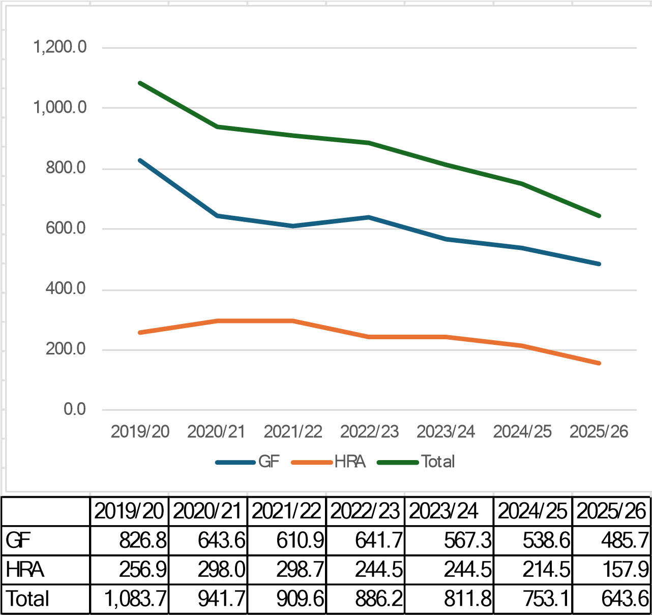

Table 8: Provisional Impact of Funding, Savings & Growth on the MTFP

Directorate | 2026/27 £m | 2027/28 £m | 2028/29 £m | 2029/30 £m | Cumulative  Impact £m
Adult Social Care & Health | 29.429  16.759 | 5.480  2.184 | 7.303  1.758 | 7.610  2.316 | 49.822  23.016
Children & Education Services
Communities, Environment & Resident Services | 1.018 | (0.533) | (0.299) | 0.338 | 0.525
Growth & City Development | (0.127) | 0.588 | 0.311 | 0.000 | 0.772
Finance & Resources | (2.666) | (0.176) | (0.357) | 0.000 | (3.198)
Chief Executive | 0.274 | (0.806) | 0.000 | 0.000 | (0.532)
Companies | 0.092 | 0.071 | 0.000 | 0.000 | 0.162
Corporate | 26.445 | 11.151 | 12.269 | 13.759 | 63.624
Projected Budget | 71.224 | 17.959 | 20.985 | 24.023 | 134.191
Core Funding | (93.019) | (20.243) | (20.889) | (6.041) | (140.192)
Exceptional Financial Support | 20.793 | 0.000 | 0.000 | 0.000 | 20.793
Outstanding Gap | (1.002) | (2.284) | 0.096 | 17.982 | 14.792

6.26 As noted previously, the biggest movements in the MTFP relate to the increase in the core funding at the expense of the service specific grants. This has led to a big growth in Adult Social Care and Children’s Social Care. The growth in Corporate primarily relates to the ending of the separately identified grants that have no conditions but are not part of core funding, as well as the annual pay award. The rest of the movements relate to the various growth and savings items, discussed in the various appendices.

6.27 The Reserves position of the Council is a key parameter in the formulation of the full budget setting process. In the interests of complete transparency, the latest reserves position is outlined below. Movement within the current financial year will be reflecting with the final 2026/27 budget modelling. There are no indications that the quantum positions will materially change in a way that will affect final budget decisions as, effectively, the current EFS application does not require any movements to fund net expenditure within current plans.

Table 9: Reserve Position - 2024/25

Reserve Category | 31 March 2025 £m
General Fund | (63.540)
Earmarked General Fund Reserves | (192.514)
HRA | (76.661)
HRA Earmarked Reserves | (0.673)
Capital Grants | (74.191)
Major Repairs Reserve | (48.670)
Capital Receipts | (0.622)
Total | (456.871)

6.28 All of this leads to the draft budget. Once the final December settlement is known and that may include further changes to the grants rolled into base budgets, this table below will be further updated.

Table 10: Revised Budget & MTFP

Directorate | 2026/27 £m | 2027/28 £m | 2028/29 £m | 2029/30 £m
Adult Social Care & Health | 125.533  105.347 | 131.013  107.531 | 138.316  109.289 | 145.926  111.604
Children & Education Services
Communities, Environment & Resident Services | 45.338 | 44.805 | 44.506 | 44.844
Growth & City Development | 15.262 | 15.850 | 16.160 | 16.160
Finance & Resources | 48.143 | 47.967 | 47.610 | 47.610
Chief Executive | 3.584 | 2.778 | 2.778 | 2.778
Companies | 0.770 | 0.841 | 0.841 | 0.841
Corporate | 79.840 | 90.991 | 103.260 | 117.019
Projected Budget | 423.817 | 441.776 | 462.760 | 486.782
Core Funding | (424.819) | (445.061) | (465.951) | (471.991)
Exceptional Financial Support | 0.000 | 0.000 | 0.000 | 0.000
Outstanding Gap | (1.002) | (3.285) | (3.191) | 14.791

7. Concluding comments
7.1 As currently constituted, the 2026/27 Budget formulation and associated MTFP position illustrates a positive pathway towards a fully balanced budget and stability over the course of the MTFP with opportunity to take out any future
structural deficits and allow, where possible additional investment opportunities that will improve service delivery outcomes.

8. Other options considered and reasons why these were rejected

8.1 It is a legal requirement to set a balanced budget and therefore, no alternative options were considered. Each individual proposal as detailed within the report

- Consideration of risk and mitigations
9.1 Risks and Mitigations are detailed throughout the report.

Comments and considerations

- Commissioner comments

10.1 Commissioners have reviewed the report and are content for it to proceed.

11. Finance

11.1 Total value of the decision: Details contained throughout the report.
Capital Revenue N/a
Expenditure Income Savings N/a

11.2 There is a statutory requirement to produce an annual budget. The draft budget contains a range of investment decision, savings and writing out of savings for the new financial year. Report details contain all financial implications throughout the report.

11.3 Has the spend been approved by the Section 151 Officer? Yes No N/A

12. Legal

12.1 The content of this report needs to be considered in the context of the legal requirement for the Council to set a balanced 2025/26 budget before 11 March 2025. This report should be viewed as one of the formal steps to achieving this requirement.
12.2 The setting of the balanced budget includes the duty to report to the Council on the robustness of the estimates provided and the adequacy of the financial reserves in place in accordance with Section 31A of the Local Government Finance Act 1992 and Section 25 of the Local Government Act 2003. The Council’s prospective expenditure must not be likely to exceed its resources available to meet that expenditure.
12.3 Councillors have joint and collective responsibility to set a balanced budget. Councillors must receive and consider the advice of officers, particularly the Section 151 officer, when considering and deciding the Council’s budget.
12.4 The report seeks approval to commence formal public consultation on elements of the budget proposals in accordance with statutory requirements. Any
responses received as part of the consultation will need to be fully and properly considered.
12.5 Councillors must have due regard to the Council’s responsibilities under the public sector equality duty when making decisions. To support good decisionmaking equality impact assessments should be undertaken, the outcomes, and implications of which should be fully considered as part of the decision-making process. Where changes to the provision of public services are proposed particularly in relation to welfare provision, whether that is the manner of provision or as a result of the need to accommodate budget reductions, consultation with relevant stakeholders must be undertaken and the outcome and implications must be considered prior to a final decision being made.
12.6 The MTFP is a crucial element of demonstrating sound financial management and meeting the "best value" duty under the Local Government Act 1999. The MTFP demonstrates that the Council has a credible plan for financial sustainability over the medium term and aligns with the Council’s strategic objectives.
Beth Brown, Director of Legal and Governance and Monitoring Officer, 10 October 2025.

13. Other comments and considerations

13.1 All members of Corporate Leadership Team have reviewed and contributed towards the report.

- Additional implications

14.1 Equality Impact Assessments are contained in Appendix 7

15. List of appendices to this report

15.1 Appendix 1: Savings/Pressures to be Written Out
15.2 Appendix 2: New Savings
15.3 Appendix 3: Investments
15.4 Appendix 4: Financial Robustness of MTFP Assumptions
15.5 Appendix 5: Budget Consultation
15.6 Appendix 6: Fees & Charges
15.7 Appendix 7: Equalities Impact Assessments
15.8 Documents that need to be considered as part of the proposals being considered

16. List of background papers relied upon in writing this report

16.1 Background papers that were relied on in preparing this report:
- Budget Savings 2025/26 – 2028/29, Executive Board, Tuesday, 17th December 2024
- 2025/26 Budget and Council Tax Resolution, City Council, Monday 3rd
March 2025
17. List of published documents referred to in this report
N/A

Additional information

Report Author: Stuart Fair, Corporate Director of Finance and Resources, stuart.fair@nottinghamcity.gov.uk

Gareth Robinson, Director of Finance; Deputy Section 151 Officer, gareth.robinson@nottinghamcity.gov.uk

Wards affected: All

Appendix 1 – Savings/Pressures to Be Written Out

To ensure the budget is credible, it is important that unachievable savings are written out and that permanent pressures that will never be offset are included within the Medium Term Financial Plan. Otherwise, there are hidden risks to the budget that could make it unsustainable. While the first position is to review the assumptions, validate the non-delivery position (was it ever deliverable) and the second to search for alternative mitigating savings that are broadly similar. At some point, if the savings and there are no alternative equivalent savings, then the savings needs writing off.
This budget asks approval to write off the following savings:
Savings | Reasoning | £m
Adult Social Care Savings | There is a recognition that there is a net £1.6m in unachievable savings on placements across multiple savings line. Some of the methodology for adult social care savings and assumptions have retrospectively proved not be credible or achievable. This is the net impact of writing out those unachievable savings targets | 1.600
Property Estate  Income  Pressure | This pressure is due to an unachievable income target for Property.  . | 0.593
Customer  Service Savings | Customer Services centralised a number of service areas over the last few years and it was successful in achieving significant savings but this represents a double count from past years when a historic savings was not taken into account in the wider customer service centralisation. It is important that the area has a viable, sustainable budget, particularly with new cross cutting workforce savings and future savings from digitisation and AI that will need developing. | 0.690
Duties and Powers | This is a request to write out three small savings targets from 2024/25 and 2025/26 for Information Compliance, Health & Safety and Emergency Planning for £63k, £39k and £65k respectively. Bearing in mind the critical importance only increasing over the last few years and the high profile nature of these areas, these savings have proved unachievable in practice. | 0.167
Legal savings | This is the removal of the unachievable legal savings from the base budget. This is an oversight from past years. | 0.102
Procurement Savings | This proposal writes out £600k of unachievable crosscutting procurement savings, recognising that in practice many of the savings were delivered in service areas as part of other savings target. | 0.600
Total |  | 3.752


Appendix 2: New Savings
Directorate | Summary Description | Additional Narrative | 2026/27 £m | 2027/28 £m | 2028/29 £m | 2029/30 £m | Cumulative £m
ASC&H | Review of Residential &  Nursing Placements Pricing  Structure | A review of pricing structures for care packages/placements | (0.250) | (0.250) | 0.000 | 0.000 | (0.500)
ASC&H | Housing/Accommodation  Strategy | Review of Adult Social Care Housing Related Support contract | (1.023) | 0.000 | 0.000 | 0.000 | (1.023)
ASC&H | Disabled Facilities Grant Utilisation | Using DfG capital funding where appropriate to offset revenue costs | (0.030) | 0.000 | 0.000 | 0.000 | (0.030)
ASC&H | Brokerage Service For Self Funders | Charging a small fee to broker social care for self funders in keeping with Care Act. | (0.072) | 0.000 | 0.000 | 0.000 | (0.072)
ASC&H | Working Age Care and Support Reviews | Resuming regular Care Act Reviews in keeping with best practice. | (0.400) | (0.300) | (0.300) | (0.300) | (1.300)
ASC&H | Fairer Charging Assessments | Review Fairer Charging assessments | (0.257) | (0.247) | 0.000 | 0.000 | (0.504)
ASC&H | Respite Review | Introduction of allocation policy for fairer distribution of service. | (0.078) | 0.000 | 0.000 | 0.000 | (0.078)
C&ES | New Demand Management  Savings | Additional demand led savings from Children's residential placement costs - combination of moving from high cost to lower cost foster care or independent homes | (2.461) | (0.728) | (0.250) | 0.000 | (3.439)
CE&RS | Leisure Transformation | Investing in the service to increase income and service efficiencies. | (0.238) | (0.262) | (0.250) | 0.000 | (0.750)
CE&RS | Implement Theatre Royal and  Concert Hall Commissioned  Review | Improve customer experience and events calendar to maximise ticket sale and enhance revenues. | (0.500) | 0.000 | 0.000 | 0.000 | (0.500)
CE&RS | Events Team Transition | Shift the team to a commercial model, being cost-neutral or revenue-generating. | (0.050) | (0.050) | 0.000 | 0.000 | (0.100)

CE&RS | CCTV Income and Efficiencies | Expanding the service offer and achieving operational efficiency and revenue growth in CCTV. | (0.050) | 0.000 | 0.000 | 0.000 | (0.050)
CE&RS | District Heating Network | Increased income target. | (1.000) | 0.000 | 0.000 | 0.000 | (1.000)
CE&RS | Solar Portfolio | There are benefits through energy procurement price saving, an overall reduction in risk to energy price spikes, and demonstrating how we use Council funds and Government funding to advance carbon reduction and grow embedded renewable electricity generation within the City. | (0.050) | 0.000 | 0.000 | 0.000 | (0.050)
CE&RS | Commercial Waste | Fee increases will generate an estimated £0.115m of income. | (0.115) | 0.000 | 0.000 | 0.000 | (0.115)
Corporate | Public Health Reserve | Use of Public Health Reserve for 3 years to offset eligible service revenue costs | (2.000) | 0.000 | 0.000 | 2.000 | 0.000
F&R | One off insurance reserve surplus usage | Use one off surplus to fund the insurance and risk team in 2026/27. | (0.500) | 0.500 | 0.000 | 0.000 | 0.000
F&R | Introduction of electric vehicle salary sacrifice on NI contributions | Introduction of electric vehicle salary sacrifice on NI contributions for staff. | (0.113) | (0.126) | (0.068) | 0.000 | (0.307)
G&CD | Asset rationalisation pressure review | Funding was put aside to offset the loss of income through asset sales, these sales have since not had the scale of income reductions expected so the put aside money can be reallocated. | (1.000) | 0.000 | 0.000 | 0.000 | (1.000)
G&CD | Workplace Parking Levy | Review of existing Workplace Parking Charges | (0.228) | 0.000 | 0.000 | 0.000 | 0.000
G&CD | Broadmarsh site security | Majority of the site has been sold. This savings recognises the reduction in holding costs. | (1.150) | 0.000 | 0.000 | 0.000 | (1.150)
Total |  |  | (11.495) | (1.468) | (0.876) | 1.700 | (12.254)

Appendix 3: Investments
Summary | Detail | 2026/27  £m
Strengthening Neighbourhood Safety | Strengthening Neighbourhood Safety in our local communities by recruiting an additional eight Neighbourhood Safety Officers, on top of the four that were recruited as part of the Council’s Turning Words Into Action in-year spend. Bringing the total number of newly recruited NSOs to 12. | 0.455
Enhancing Street Cleaning | Enhancing street cleaning across Nottingham to improve the look and feel in the city and local communities by increasing fly tipping clearance with additional teams and vehicles. | 0.980
Intensive Weed Removal | Intensive Weed Removal by a removing weeds in grot spots across the city. | 0.120
Trimming Back Hedges | Trimming back hedges in local estates and allotments to improve the look of our local communities, support biodiversity and ensure safe and clear public access. | 0.340
Upgrading Our Roads | Upgrading our roads by tackling potholes, refreshing road markings and making local roads safer and fit for purpose. | 0.500
Supporting Our Volunteers | Supporting our volunteers by recruiting a Greenspace Volunteer  Coordinator to help organise local greenspace volunteer events, promote community engagement and offer advice and support. | 0.048
Topping Up Park Maintenance | Topping up park maintenance for day to day improvements for local parks to ensure a good standard across the city, so every child can have access to a good and safe local park. | 0.120
Protecting Healthy Trees | Protecting healthy trees by targeting overgrown and unsafe trees on footpaths and highways, ensuring safe and clear public access while protecting perfectly healthy trees. | 0.100
Revamping Parks for People | Revamping parks for people by recruiting more Playground Inspectors and Park Rangers, as part of a £3m investment programme to upgrade and enhance our local parks across Nottingham. | 0.076
Enriching Our Local Communities | Enriching our local communities by setting up Community Grants in each of the twenty wards in the city, so local Councillors can support ward based activity, cohesion and development directly in our communities. | 0.183
Empowering Local People  Through Place Based Partnerships | Empowering local people through Placed Based Partnerships, giving Councillors and local people the forum, power and money to shape their local communities for the better. | 0.202
Regenerating Nottingham | Regenerating Nottingham by creating a new function in the Council that will design plans to enhance, reshape and lead the city forward by securing national and regional funding to achieve our local goals. | 0.400
Managing Our Buildings Better | Managing our buildings better by improving the service for commercial tenants, managing our occupied and vacant buildings better and selling those that do not give the Nottingham tax payer value for money. | 0.277
Investing In Our Buildings | Investing in our buildings with a new repairs and maintenance fund so Council premises used by local people are safe and fit for purpose. | 0.473
Ensuring Strong Service Performance | Ensuring strong service performance for tax-payers by strengthening the Council’s performance monitoring to drive improvement and better outcomes for service users. | 0.325
Total |  | 4.599
Reversal of Prior Year Short Term Growth |  | (0.566)
Net Impact on Revenue Budget |  | 4.033

Appendix 4: Financial Robustness of MTFP Assumptions 1. Government Funding Projections – Fair Funding Review 2.0
1.1 The Fair Funding review 2.0 was announced by MHCLG in June 2025. To aid future government funding projections, the council uses an industry standard specialist company, Pixel, to model the likely implications of government decisions to council funding. Pixel is employed by a number of councils to project this and they worked alongside MHCLG to ensure their model reflected MHCLG’s understanding.
1.2 The outcome of Pixel’s modelling showed increased government funding for the council of £30.292m for 2026/27 compared with 2025/26 funding levels. With the outcome of the settlement not certain, the council has taken the decision to be prudent, assuming only 70% of this total additional funding for 2026/27. Therefore £21.259m of the total £30.292m has been included for 2026/27 as additional government funding, leaving £9.033m for prudence.
1.3 The £9.033m prudence factor is approximately the same as the £9.887m if the overall local government funding envelope reduced by £1bn. Equally, the impact of spreading Fair Funding 2.0 over 4 rather than 3 years would also be manageable (£7.5m).
1.4 This approach fortifies the resilience of the budget projection and the MTFP as it guards against potential changes to the overall settlement figure and the phasing of the fair funding implementation.

2. Savings Risk Assessment Contingency Increase
2.1 Total budgeted savings for 25/26 was £39.135m. Whilst savings proposals are made in good faith with expectation they will be fully realised, in reality, various elements can impact their success. Regular in year monitoring is undertaken to assess the achievability of in year savings using a tracker classifying savings as Blue – Delivered, Green – On Track for Delivery, Yellow – At Risk, Amber – Delayed, Red – NonDelivery.
2.2 To ensure financial resilience, the council has provided for 5% of total savings rated as yellow, 25% of total savings rated amber and 100% of total savings rated red in the contingency budget for 2026/27. The table below shared at Period 4 shows how the risks have been assessed by Directorate for all 2025/26 savings.

Period 4 Savings Tracker
Department | Savings to Be Delivered | Blue -  Delivered | Green - On Track | Yellow - At Risk | Amber -  Delayed | Red Non-  Delivery
ASC&H | (10,655,486) | (3,047,826) | (3,593,625) | (80,875) | (2,417,268) | (3,672,189)
CES | (10,184,964) | (64,667) | (6,060,417) | 0 | (3,371,880) | (688,000)
CERS | (7,757,018) | (2,607,889) | (2,632,620) | (700,000) | (1,816,509) | 0
G&CD | (5,676,710) | (775,500) | (3,755,748) | (337,471) | (677,991) | (130,000)
F&R | (3,886,376) | (1,809,564) | (25,417) | 0 | (1,986,395) | (65,000)
CEX | (280,980) | (167,750) | (15,000) | 0 | (98,230) | 0
Corporate | (694,000) | (60,000) | (29,000) | 0 | (100,000) | (505,000)
 | (39,135,534) | (8,533,196) | (16,111,827) | (1,118,346) | (10,468,273) | (5,060,189)

2.3 The next table shows a total of £3.556m for 2026/27 contingency budget to offset the risk of delays to existing 2025/26 savings. At present, these are still predicted to be delivered in 2025/26 but there is a risk that they will not take place. Those delayed into 2026/27 are assumed to have a risk that they will be further delayed.

2025/26 Savings Ratings | Yellow - At Risk | Amber -  Delayed | Red Non-  Delivery | Total
Total Savings | (1,118,346) | (10,468,273) | (5,060,189) | (16,646,808)
Adjustment for Over Delivery |  |  | 2,077,189 | 2,077,189
Adjustment for Savings Written Out |  |  | 2,100,000 | 2,100,000
Revised Savings Target to Deliver to fund base budget | (1,118,346) | (10,468,273) | (883,000) | (12,469,619)
Risk Adjustment Factor | 5% | 25% | 100% | 29%
Contingency Required | 55,917 | 2,617,068 | 883,000 | 3,555,986

2.4 A similar albeit more granular risk assessment has been carried out for 2026/27 previously agreed savings and proposed 2026/27 savings. This has led to the requirement of £4.889m contingency against previously agreed 2026/27 savings and £3.128m contingency against proposed 2026/27 savings. This leads to an overall £11.574m contingency requirement.
Saving Tranche | Contingency 2026/27 Budget Requirement
2025/26 | 3,555,986
2026/27 Existing savings | 4,889,324
2026/27 New savings | 3,128,250
Total | 11,573,560

2.5 Considering the saving risk analysis above, and to provide additional head room against unforeseen events, it was decided to retain the £15m contingency for 2026/27 that was previously expected to be reduced. A £5.574m contingency for the Integrated Care Board (ICB) has also been incorporated within the 2026/27 budget, as a matter of prudence. This represents approximately a 50% share of the level of risk that the
implications from potential cost shifting.

3. Pay Award Assumptions
3.1 The 2025/26 budget allocated circa 4% of total General Fund salary budget within corporate budgets to be allocated out in year. The actual pay award for local government employees was 3.2%. All 2025/26 virements to provide services with their allocation based on 3.2% award have yet to be completed but, once done, it is anticipated that there will be some flex in the corporate pay budget. This is due to expectations of the award being higher (4%) than what has been agreed (3.2%). All virements should be completed in the coming period and updates will be provided.
3.2 The assumption for 2026/27 pay award within the budget is again circa 4%. It is a reasonable assumption based on the pay awards of the past few years and general inflation within the UK.

4. Other Assumptions
4.1 It is standard practice for services to manage general inflationary pressures within their overarching budget envelope. Specific contractual commitments and expected growth in social care are modelled annually and corporate budgets set aside against the expected expenditure pressures.

5. Reserves
5.1 To reflect the challenging operating environment and related financial risks, the Section 151 Officer recommends that the Council maintains a minimum General Fund balance at a level of at least 7.5% of net expenditure.
5.2 Total General Fund Reserve Balance from draft 2024/25 accounts show General Fund Reserve of £63.540m at 31st March 2025.
Reserve Category | 31 March 2024 £m | Movement | 31 March 2025 £m
General Fund | (22.719) | (40.821) | (63.540)
Earmarked General Fund Reserves | (197.285) | 4.771 | (192.514)
HRA | (60.124) | (16.537) | (76.661)
HRA Earmarked Reserves | (0.626) | (0.047) | (0.673)
Capital Grants | (36.061) | (38.130) | (74.191)
Major Repairs Reserve | (49.907) | 1.237 | (48.670)
Capital Receipts | (1.269) | 0.647 | (0.622)
Total | (367.991) | (88.880) | (456.871)

5.3 Total proposed net budget for 2026/27 is £424.007m. General Fund reserves cover circa 15% or net spend proposed for 2026/27, safely above the 7.5% minimum recommended.

6. Section 25 Report
6.1 A full Section 25 report will be completed as part of the Budget documentation with professional opinion and assurances from the s151 with regard to the 2026/27 budget and the medium terms sustainability of the overall Medium Term Financial Plan.

Appendix 5: Budget Consultation

1. Overview
1.1 Public consultation on the budget proposals for 2026-27 and wider 202630 MTFP will take place over a six-week period from 21st October to 2nd December. Supported by widespread communications activity, the budget consultation will achieve the objective of enabling the public to be effectively engaged in the process through a variety of means and provide them with sufficient opportunity to comment on the proposals. Proposals this year are focused on efficiencies and at this point none meet the threshold for requiring public consultation. However, to help demonstrate transparency and facilitate public and stakeholder engagement, comments on the proposals will be encouraged through a survey questionnaire and a series of engagement activities will be held to promote consultation.
1.2 The survey will feature details of the different proposals and links to relevant EIAs and other supporting material. Respondents will be asked to give feedback on the budget proposals as a whole and/or on individual proposals. Details of any proposed changes to Council Tax will also be included. In addition, the questions used in the recent Local Government Reorganisation survey around people’s priorities for their local area will also be included.
1.3 An Equality Impact Assessment will be prepared for each proposal (unless not relevant), and a link to the relevant EIA will be provided. All EIAs pertaining to the proposals will be published on a dedicated webpage on Nottingham Insight. All the proposals in the consultation process will have a public-facing narrative, so the full context can be understood. A link to the full Executive Board budget report will be provided on the Engage Nottingham Hub budget consultation landing page.
1.4 The consultation will be supported by:
- A survey with supporting information, in both online and hard copy format
- Stakeholder and public engagement activities in online and in-person formats, included targeted meetings
- Internal engagement with staff, trade unions and council scrutiny committees
- Messaging through external and internal comms channels

2. Consultation Methodology
2.1 An online survey built in MS Forms and hosted on the council’s Engage Nottingham Hub webpage will provide the public with the opportunity to feedback their views on the proposals and EIAs. A public-facing narrative for the proposals will be prepared to optimise accessibility, and supporting materials including FAQ sheet and graphic breakdown of council spending will be included. In addition, a link to the full budget report will also be available. Survey responses to the proposals will primarily be open text
form, with some drop down tick box options for questions on priorities. The online survey tool features a translation function which enables responses in the chosen language of the respondent.
2.2 For accessibility, hard copies of the survey will be available for completion and submission at local library branches. Hard copy versions of the survey will be available across the Council’s community library network. Survey respondents will leave completed surveys with the library for collection and input by the REC Team. Information about this service will be available on the Engage Nottingham Hub budget consultation website.

3. Engagement events to promote the consultation
3.1 A stakeholder briefing event to help launch and promote the consultation will take place shortly after proposals are approved by Exec Board. The briefing will be led by the Leadership/Exec Board team and supported by CLT. Invited audience members will include key city stakeholder representatives, voluntary sector and business leaders, and members of the press. The focus of the event will set out the context of the budget, the council’s improvement journey and future challenges and opportunities.
3.2 In-person open public engagement events will be held in North, Central and South localities. In addition, an online public engagement meeting will be held to enable participation by those unable to attend an in-person meeting A hybrid meeting with disability group representatives will take place as part of the November meeting of the Disability Involvement Group. An in-person event with young people will be convened through the Child Friendly Nottingham partnership. This will be invitation only to targeted audiences. A series of in-person and virtual budget roadshows will be held with staff. Meetings will also be held with Trade Union representatives.
3.3 Following approval of proposals at Exec Board on 21st October, Corporate Scrutiny Committee will be provided with access to all Star Chamber papers and Budget Modelling. Scrutiny Committees will be engaged at the start of the consultation and invited to make a formal contribution in writing, which will be presented as an appendix to the budget survey findings.

4. Communications
4.1 Communications support for the consultation process will accompany all stages of the six-week timetable. A Communications Plan detailing this work will be provided separately. A dedicated website for the budget consultation will be hosted on the Engage Nottingham Hub site. This will contain the survey, links to the budget report, a simple summary, Frequently Asked Questions (FAQs), links to Equality Impact Assessments for the proposals (and the budget consultation EIA), a calendar of engagement events (including registration booking links for virtual events), where to find hard copies of the survey, and information about accessibility.

