Strategies, video’s, information and resources for parents to help children with Autism brush their teeth
Strategies
Autism and Brushing Teeth - Teaching Autism
AUTISM AND BRUSHING TEETH AUGUST 21, 2018
When you’re the parent of a child with autism whether diagnosed or not there’s a lot of tasks that you find more difficult. Other parents may not understand how stressful those ‘little’ everyday tasks can be.
Today, we’re going to discuss brushing teeth. And the issues that can caused from brushing teeth. We’ll also discuss how we can encourage our children to brush their teeth. Read on to find out more.
Individuals with autism are more likely to be hypersensitive. They will feel things differently to those of your typical non-autistic child. This can include the sensation of having their teeth brushed.
We have been chatting to many families and professionals about the experiences they have with brushing teeth. As well as individuals diagnosed with autism. There is a huge amount of people who find brushing teeth a negative experience. No matter how much we want to make brushing teeth a positive experience. Many of our parents stated they have even restrained their children to brush their teeth before. They stated that this because they worried so much over health and dental issues later on. Parents worry so much about their children, its human nature.
So, we are looking for ways that we can all make teeth brushing a more positive experience. We’ve consulted with a range of different families, individuals and professionals. And, we’ve put together different ways that we can make this time a more enjoyable one. And also to make it less stressful for all involved. We have come up with the following tips/ideas;
- Read a social story (like this one). Social stories are a great, visual tool to use. The reader can actually see and read/listen to what is happening on the pages. It will help them understand what happens during the process of brushing your teeth. Along with what can happen if you don’t brush your teeth.
- Use of a more sensory tooth brush – such as the Fuzzy Brush
- Provide a calm environment for when tooth brushing takes places.
- Have visuals around this area. Especially ones that show the individual what they are going to do. I.e put toothpaste onto the toothbrush etc.
- Have a timer. Many individuals with autism do find situations less stressful if they are able to see how long is left.
- Lots of positive reinforcement/praise for when they are able to complete any of the task. Even if it’s not brushing but just holding the toothbrush. It could be for putting the brush near their mouth. Or even just holding the brush inside their mouth. This is a great way to build up to brushing their teeth. And also getting them used to the feel and taste of the toothpaste and toothbrush.
Dentists say that it’s beneficial for your child to walk around chewing a toothbrush, with nothing on it. This is better than not brushing their teeth at all. And, this can be a great way to work your way up to introducing toothpaste.
Ask your Health service for some discolouration tablets which show the plaque on a child’s teeth making it visual for them to brush off.
- Different toothpastes have different smells and taste. It could be this causing the issues, rather than the toothbrush. Look for ones with little or no taste- or ones with a taste that they do like.
- Electric toothbrushes can be great if your child can tolerate the sensation/noise/feel. It means they don’t have to work as hard to clean different areas – the electric toothbrush will help them do this. You can have them feel the toothbrush by placing it on their arm/face etc. first so they get used to it. Many children may actually enjoy the sensation of the electric toothbrush.
- Jaw massage is good way to desensitise a child. Gently massage in circles along the child’s jaw line and in their cheeks. Get them to do it themselves if they can’t tolerate you.
- Use songs. There’s a great Elmer brushing teeth song on You tube. Our children love to listen to it when they are brushing their teeth. It also prepares them for what’s about to happen. You could just make up a song to use at teeth cleaning time like ‘This is the way we clean our teeth , for 2 minutes long’ (wheels on the bus tune)
- Have someone act as a good role model and brush their teeth the same time as the individual. They can see what’s happening, what to do and have someone to go through it with together.
There are some great apps available on tablets. They can help children brushing their teeth and come with a variety of aides/prompts.
- Give the child a reward system. You can have a weekly sticker chart. Then, they get a sticker for each day they brush their teeth. So many stickers = a treat. This could be a trip to their favourite park etc.
Your Dentist may be able to add sealants.
- Try using warm water out of the tap instead of cold, as sometimes cold water can cause sensory issues.
- Discolouration tablets. Ask your dentist for some of these to show children where plaque is in their mouth so they can brush it off

NHS Information leaflet for parents
0007-Dental-Care-Autism-Information.pdf (dentalhealthcareeoe.nhs.uk)
Video’s
Social story brushing teeth autism video for children
Bing Videos
National Autism community social story
Social Story #5 "Brushing my teeth" | 𝙎𝙤𝙘𝙞𝙖𝙡 𝙨𝙩𝙤𝙧𝙮 #5 "𝘽𝙧𝙪𝙨𝙝𝙞𝙣𝙜 𝙈𝙮 𝙏𝙚𝙚𝙩𝙝" Social stories are a great way to teach children various skills and routines of their daily lives. This story... | By National Autism Community-NAC | Facebook
How to get your toddler to brush their teeth
Bing Videos

Resources
Special U shaped tooth brushes Amazon.co.uk : three sided toothbrushes autism
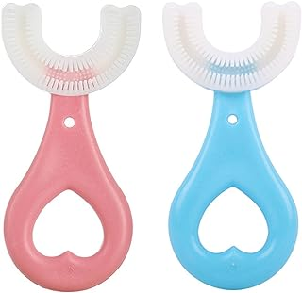
2 Pcs Toddler Toothbrush, Kids U Shaped Toothbrush Children Toothbrushes 360° Oral Tooth Cleaning Toothbrush Whole Mouth Teeth Brush for Toddlers Children Kids Baby Oral Cleaning : Amazon.co.uk: Health & Personal Care
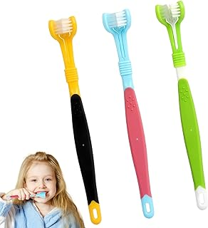
3 sided tooth brushes Amazon
LINXINS 3Pcs 3 Sided Autism Toothbrush 3 Bristle Toothbrush Three Bristle Portable Plastic Autism Toothbrush 3 Sided Toothbrushes Kids 3 Sided Sensory Toothbrush Autism for Kids : Amazon.co.uk: Health & Personal Care

Routine visuals of brushing teeth Amazon
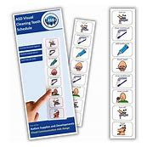
Autism Brushing Teeth Visual Aid –Teaches How to Brush your Teeth –SEN –Autism Learning Resources -Visual Timetable for Autistic Children –Flash Cards : Amazon.co.uk: Automotive

