Books for Practitioners to support with children who are EAL
Amazon.co.uk : supporting children with eal in the early years Also available from other suppliers
Supporting Children with EAL in The Early Years  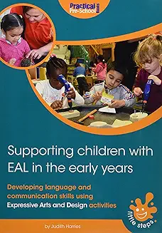 | This book aims to equip early years practitioners with the resources and skills required to create a stimulating learning environment and to fully include EAL children into their settings. It provides practical ways to show children and their families that their language and culture are valued and respected, so that they can feel secure and accepted. There are 49 activities included that focus on different areas of the Expressive Arts and Design goal and help practitioners to develop children's language and communication skills as they play. Listening and musical activities are used to help children distinguish between sounds and communicate non-verbally.
Practical ideas can be used successfully to enrich an EAL child's understanding of a new language, while, at the same time, allowing that child to bond with their peers? 50 Fantastic Ideas for Children with EAL is an invaluable resource to help integrate children with EAL into the classroom with fresh, exciting and engaging activities that are easy to resource, require little preparation and are fun to carry out.  The activities include simple speak-and-repeat games, visual ideas to support learning new words and phrases and activities that evoke feelings of being at home, allowing the children to feel welcomed and part of the school's diverse community. Traditional games are also featured to help children with EAL play with their peers, as well as feel that they can contribute to the learning of others. Perfect for promoting inclusion and self-esteem, | 50 fantastic ideas for children with EAL  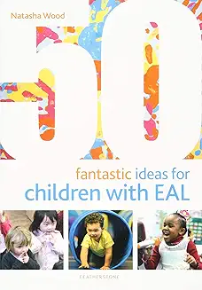
Supporting the Wellbeing of young children with EAL  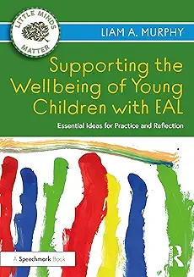 | This resource enables early years educators to support the wellbeing and development of children whose first language is not English.  Positioning language as a community entity, the book explores critical approaches to language development and, importantly, their practical application to planning, provision, professional development, and wellbeing. It provides context and evidence-based strategies to develop strong, child-centred practice in real-world settings, and offers an overview of how educators can work with families to ensure a consistent approach to early language development at home.
The book gives a focus on the prime area of communication and language and addresses each of the following topics in-depth: how children learn languages; helping children to settle-in; creating a suitable environment; adult-child interaction; building positive relationships with parents and carers; observation, assessment and planning; and working with children with communication difficulties. Parents and practitioners’ views and perspectives are included throughout the book to provide further insight, together with case studies from settings, to highlight real situations and share examples of good practice. The book also includes a resources section containing photocopiable home activity sheets and checklists, as well as lists of key words and phrases in some of the most commonly spoken languages in the UK. | English as An Additional Language (EAL ) in practice  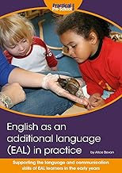
Supporting children with EAL 100 ideas  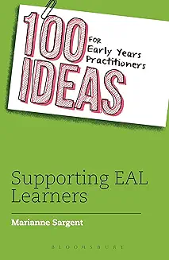 | The number of children in UK schools who speak English as an Additional Language (EAL) has doubled since 1997 to more than a million. There is no formal teaching specialism qualification in EAL, teacher training courses only briefly touch on the issue - and yet the EYFS requires practitioners to do all they can to provide for these children. This book offers guidance on how to welcome and provide for children and their families, whilst taking into consideration their unique identities and culture. Straight- forward activity ideas link to all areas of the curriculum and aim to support language acquisition. You will also find guidance on observation, assessment and planning that is specific to meeting the needs of EAL learners.
With the English as Additional Language (EAL) population growing rapidly, it is essential that settings and schools meet individual learner needs and provide an inclusive culture where different languages, cultures and religions are accepted and celebrated. Packed with essential information on key theories and best practice, and written in a highly readable style this book aims to raise awareness of main issues and offer practical support for practitioners working with children with EAL.  Covering a wide range of topic such as new arrivals, working with parents, assessment, planning, resourcing, play, communication and language, each chapter clearly lays out the key concepts, ideas and strategies alongside examples of good practice. Encouraging a reflective approach, the book features: | English as an additional Language in the Early years Linking theory to Practice  