Books for children using Puppets
Puppets appeal to children’s playful nature and encourage them to be more interactive and encourage listening and attention skills. Using puppets make story telling sessions come to life and leave a stronger impression, sometimes greater than just words. Being so visual, even our most disabled children can participate and enjoy the story. They enrich storytelling and encourage older children to use their imagination in their own story telling role-play.
Can't You Sleep Little Bear Book with Puppets  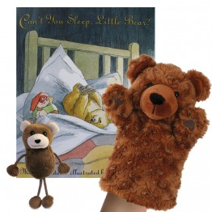 | - A wonderful story collection for any classroom or household  - Let story time come to life with children playing out the story whilst it is being read to them  - Written by Martin Waddell: Little Bear can't sleep because he is scared of the dark! Not even Big Bears biggest lantern can light up the darkness of night outside, but Big Bear soon finds a way to reassure Little Bear and help him fall fast asleep...  - Storytelling collection includes book, 1 hand puppet Bear, 1 finger puppet Bear and a zip top red velour storage bag  - Bag comes complete with a clear window at the front to illustrate the book and contents of the collection  - Puppets are not intended to be identical to the pictures in the book, but are merely representative of the characters involved  - Suitable from 12 months
- Let story time come to life with children playing out the story whilst it is being read to them  - This classic tale by Julia Donaldson is of a little old lady, a wise old man and a chaotic collection of larder-raiding, curtain-chewing, jig-dancing animals  - Storytelling collection includes book, 6 finger puppets of all the main characters and a zip top red velour storage bag  - The bag comes complete with a clear window at the front to illustrate the book and contents of the collection  - Puppets are not intended to be identical to the pictures in the book, but are merely representative of the characters involved  - Suitable from 12 months | A Squash and a Squeeze book with puppets  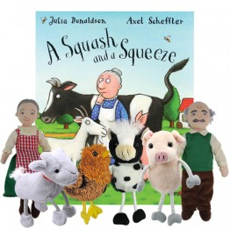
Albert's Tuneful Trunk Storytelling Collection  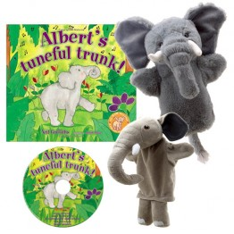 | - Let story time come to life with children playing out the story whilst it is being read to them  - Albert's Tuneful Trunk. Written and read by Neil Griffiths, illustrated by Judith Blake: With his curly trunk, Albert soon discovers he has an amazing and unexpected talent  - Storytelling collection includes book, CD, 2 Elephant glove puppets and a zip top red velour storage bag  - Bag comes complete with a clear window at the front to illustrate the book and contents of the collection  - Puppets are not intended to be identical to the pictures in the book but are merely representative of the characters involved  - Suitable from 12 months
- This is the story of a race between a grumpy bear and a turtle along the lake shore, it is based on a native American tale where the trickster turtle outwits the bear.  - This storytelling collection includes book, 2 finger puppets and a zip top red velour storage bag.  - The bag comes complete with a clear window at the front to illustrate the book and contents of the collection.  - Suitable for children 12 months and above.  - These puppets are not intended to be identical to the pictures in the book, but are merely representative of the characters involved. | Bear and Turtle and the Great Lake Race Finger Puppet Storytelling Collection  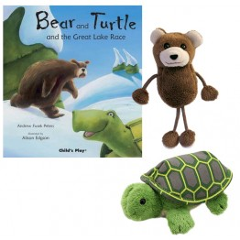 or 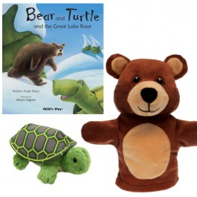
Did You See Them Too? Storytelling Collection  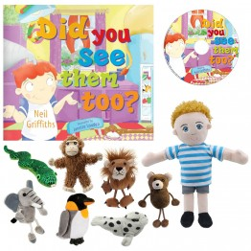 | - Let story time come to life with children playing out the story as it is being read to them  - Did you see them too? Written and read by Neil Griffiths, illustrated by Janette Louden: A brilliant rhyming story with animals appearing and disappearing before your eyes! A lovely book involving a young boy's vivid imagination  - Storytelling collection includes book, CD, 8 finger puppets of all the main characters and a zip top red velour storage bag  - Bag comes complete with a clear window at the front to illustrate the book and contents of the collection  - Puppets are not intended to be identical to the pictures in the book but are merely representative of the characters involved  - Suitable from 12 months
- Don't invite Dinosaurs to Dinner is written by Neil Griffiths, illustrated by Peggy Collins: It looks as if these colourful characters cause nothing but trouble, but are these Dinosaurs really so bad after all?  - Storytelling collection includes book, 4 dinosaur soft toys and a zip top red velour storage bag  - Bag comes complete with a clear window at the front to illustrate the book and contents of the collection  - Soft toys are not intended to be identical to the pictures in the book but are merely representative of the characters involve  - Suitable from 12 months | Don't invite Dinosaurs to Dinner Storytelling Collection  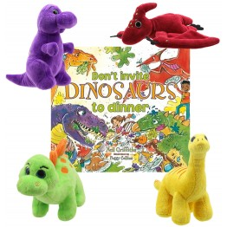
Handa's Surprise Book with Finger Puppets  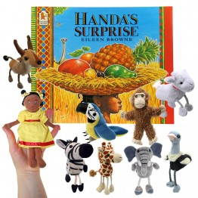 | - Let story time come to life with children playing out the story whilst it is being read to them  - This popular story by Eileen Browne tells of Handa visiting her friend Akeyo with a basket of fruit as a surprise. Little does she know that lots of animals are very interested in the fruit as well!  - Storytelling collection includes book, 9 finger puppets of all main characters and a zip top red velour storage bag  - Bag comes complete with a clear window at the front to illustrate the book and contents of the collection  - Puppets are not intended to be identical to the pictures in the book, but are merely representative of the characters involved  - Suitable from 12 months
More finger puppet Books  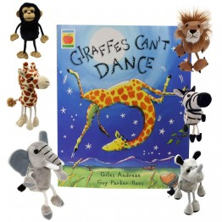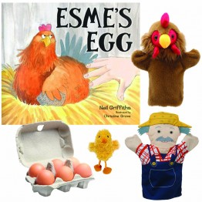 | Three Billy Goats Gruff Finger Puppets & Book Set Boxed  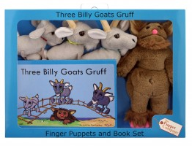  - Set contains hard back book and four finger puppets.  - Book 14cm x 20cm  - Goat finger puppets average size 10-12cm  - Troll finger puppet 21cm Suitable for 12 months and above.
Goldilocks Finger Puppets & Book Set Boxed  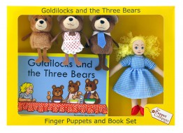  - Set contains book and 4 finger puppet characters.  - Book 14cm x 20cm  - Suitable for 12 months and above | Nursery Rhymes Finger Puppets & Book Set Boxed  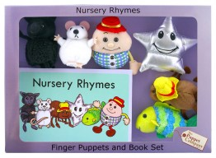  - Set contains 6 finger puppets & a hard back book in a decorative box.  - Book 14cm x 20cm  - Suitable for 12 months and above.  - Nursery Rhymes include: Baa Baa Black Sheep, Twinkle Twinkle Little Star, Hickory Dickory Dock, Humpty Dumpty, Incy Wincy Spider and Once I Caught A Fish Alive
Guess How Much I Love You  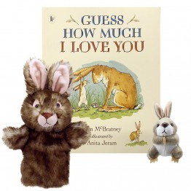  by Sam McBratney and illustrated by Anita Jeram | - "Guess how much I love you," is the story of Little Nutbrown Hare  - Let story time come to life with children playing out the story whilst it is being read to them  - Storytelling collection includes book, 1 soft toy Rabbit , 1 finger puppet Rabbit and a zip top red velour storage bag  - Bag comes complete with a clear window at the front to illustrate the book and contents of the collection  - Puppets are not intended to be identical to the pictures in the book, but are merely representative of the characters involved  - Suitable from 12 months.
More story telling collections books and puppets to motivate  If Only …  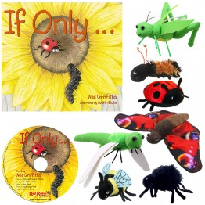  Hey, who's in the Loo? 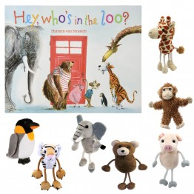  Noisy Farm Book with Finger Puppets Old Macdonald Book with Puppets  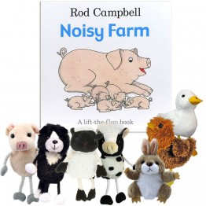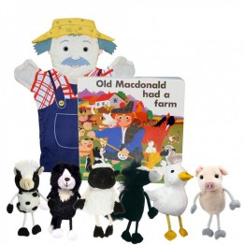 | 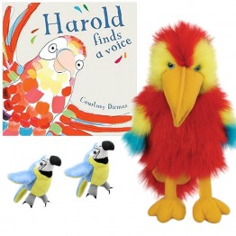  Harold Finds a Voice  MOG the forgetful cat 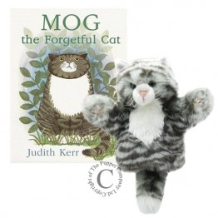  Rumble In The Jungle Book with Finger Puppets Itchy Bear  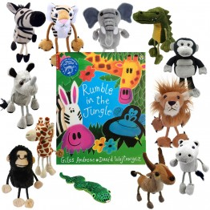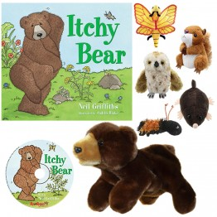
That’s not my……. Books with finger puppets
Explore these delightful, award-winning touchy-feely books complete with an adorable soft toy or finger puppet to compliment your story time fun!
- Meet five adorable Lions/chicks/dinosaurs/dragons elephants/hedgehogs in these delightful much-loved That’s not my... series.
- Babies love the best-selling That’s not my… books with their bold illustrations, patches to stroke, and a mouse to spot on every page, all designed to develop sensory and language awareness.
- Book comes with a Finger Puppet to add to the story time fun!
- Books are suitable from Birth. Finger Puppet is suitable from 12 months and above.
- Puppet is not intended to be identical to the pictures in the book, but merely representative of the characters involved

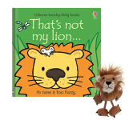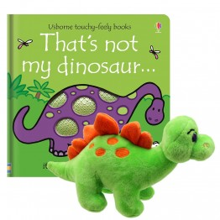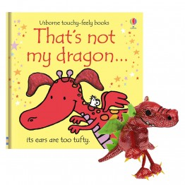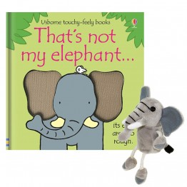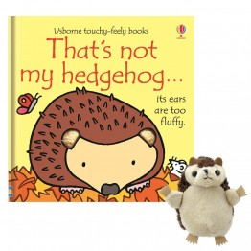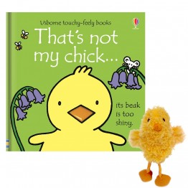
SONG TEACHING MITTS: COLOURFUL & EDUCATIONAL!
Let's have a sing-a-long! A wonderful array of beautifully designed, colourful Song Teaching Mitts featuring expressions, Old Macdonald, five current buns, little ducks, little monkeys and little spacemen, ten green bottles and ten in a bed. Plus a vibrant Hungry Caterpillar teaching mitt for the bath! Perfect for sing-song fun and imagination play.
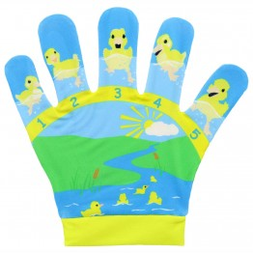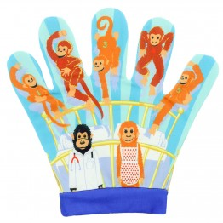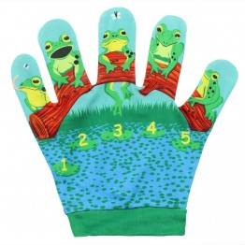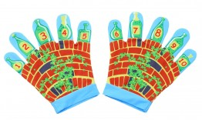
All books shown are available from the puppet store at www.puppetsbypost.com but are available from other retail outlets.

